Veterans Benefits Certification
Student Guide
To be completed after enrolling into your courses.

- Log into MyCSUSM, navigate to your student center.

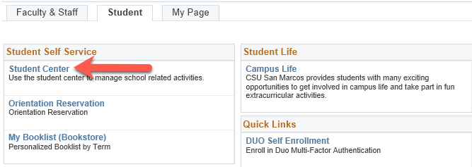

- Select Veterans Benefit from the dropdown menu in the Academics section, click the circle next to the dropdown.

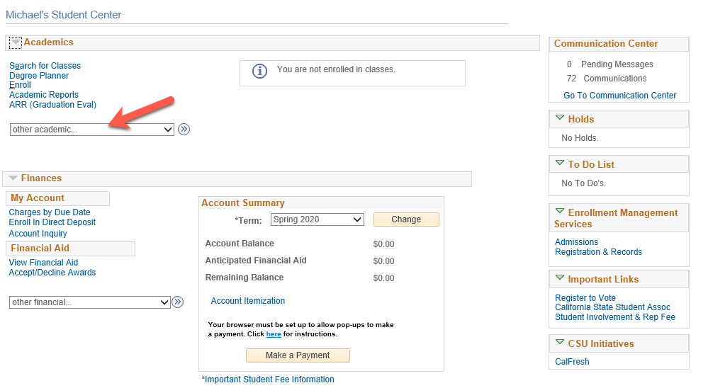
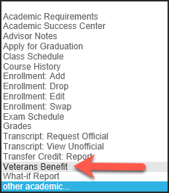

- After reading the information on the landing page, click Certification Request.

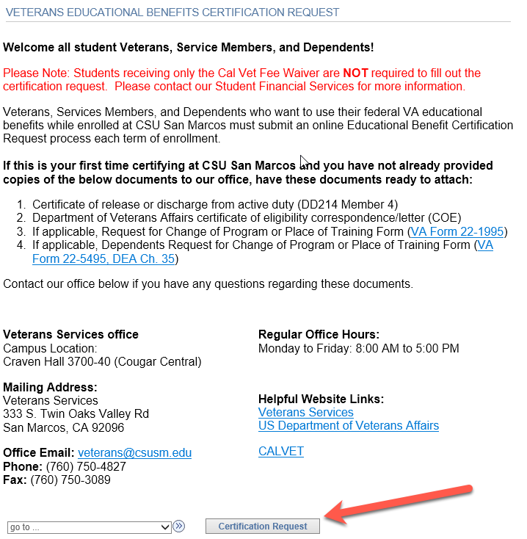

- The next page is broken into 3 sections, and each must be completed before progressing to the next.
Begin by selecting the term that you are certifying for.

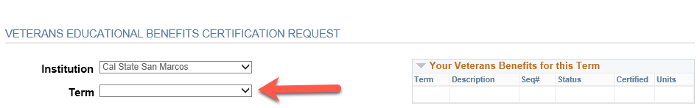

- Once a term is selected, the next section will unlock. Fill in your information, any comments/questions, then click Initiate Request.

NOTE: If submitting VA benefits along with CALVET, only input the VA benefit, then submit CALVET paperwork to Student Financial Services.

NOTE: If choosing Chapter 35, an additional field Chapter 35 File Number will reveal. This field is required if using this benefit.

NOTE: If using Chapter 33, indicate the percentage from your COE in the Questions block.

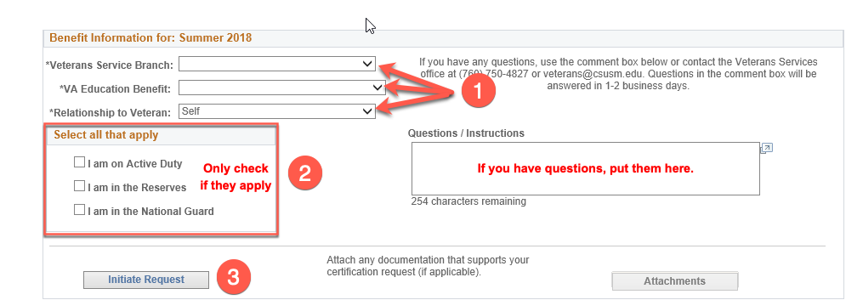

You will receive a pop-up message, click OK and proceed to next step.

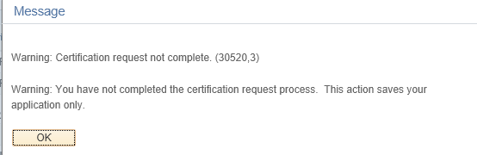

- After closing the pop-up message, if you have documents to provide (DD214, COE, etc.), click Attachments.

NOTE: First term students MUST submit DD214 (Veterans only) and COE. Continuing students MUST submit a new COE each year.

Once there, you will need to choose a document type from the drop-down menu, after which an Add Attachment button will appear, allowing you to choose a file from your computer to upload.

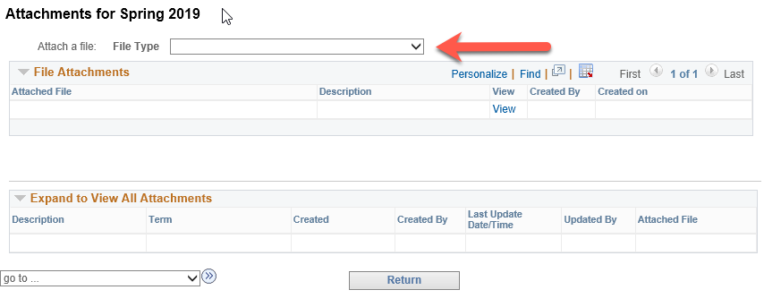

The page will show all files that you have uploaded for the certifying term. Once finished, click Return.

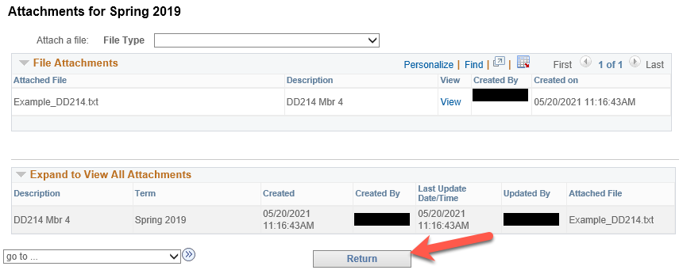

- The third section will now be unlocked. You will see a list of all classes in which you have enrolled, even if you have since dropped them. Click Select Classes to Certify.

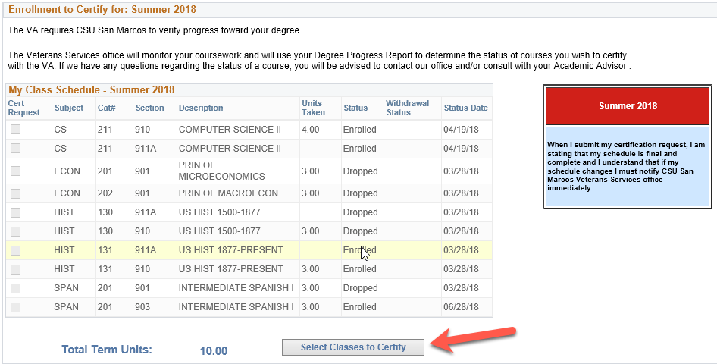

- After reading the messages, acknowledge by clicking the checkbox. Then select the courses that you are requesting certification for. Once selected, click Submit Request.

Warning: The list includes courses that you have dropped, if any. Please only select courses that you are enrolled into for certification. Do not select waitlisted courses. Refer to the Status column to determine which courses you are enrolled in.

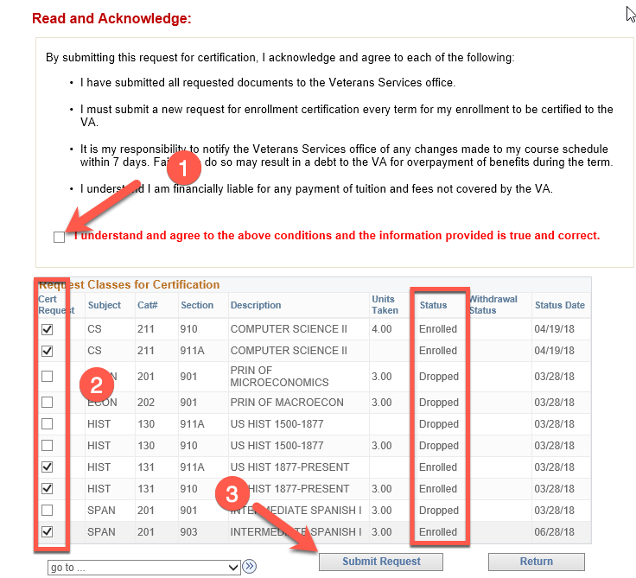

- You will receive a pop-up message confirming completion, then you are done.

