Concerned about your scientific writing
and research skills?

Come Join Us!!

Julie Jameson, Dept of Biology and Talitha Matlin, STEM / Interim Outreach Librarian
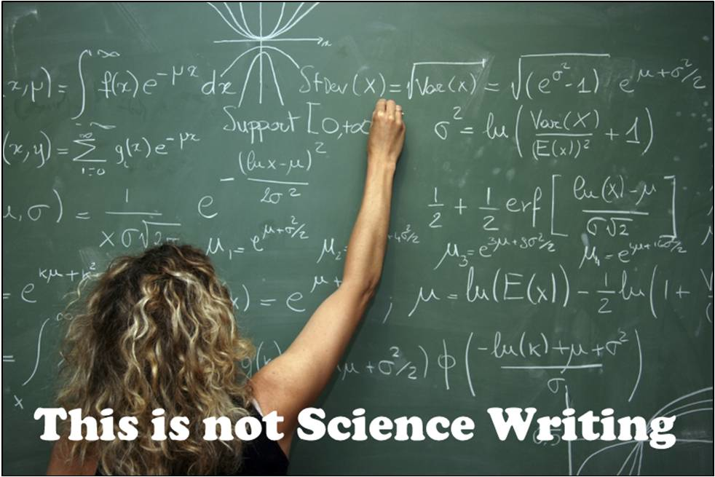

http://ksj.mit.edu/tracker/2011/12/huffpo-critic-fires-unfair-shots-science

Wednesdays from 12-1 pm
Academic Success Center
(Starting January 31st)

Come with a current project you are working on!
Get help with: Research reports, master’s theses, statements of purpose, essays, manuscripts, proposals, graduate school research and more!

