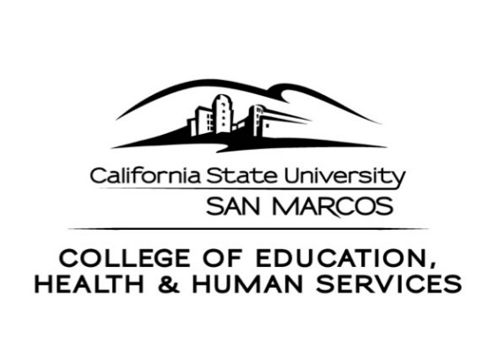
CEHHS Student Services
333. S. Twin Oaks Valley Road
San Marcos, CA 92096-0001 USA

760-750-4277 / 760-750-3539 (fax)
www.csusm.edu/cehhs/studentservices/

SCHOOL OF EDUCATION
Credential & Graduate Programs

OVERVIEW OF THE ON-LINE RECOMMENDATION PROCESS

First Step
When we receive your application packet (Credential Evaluation Request Form) and confirmation of fee payment, we will review your file to make sure all requirements have been met. After our verification that requirements have been met, CSU San Marcos, CEHHS Student Services recommends you for your credential via the California Commission on Teacher Credentialing’s (CTC) on-line recommendation system.

Second Step
CTC will notify you via email that you have been recommended for your credential. CTC will also send you a link to use where you will then provide or confirm your contact and credential information. You will be asked to pay for the credential document on-line; payment by MasterCard or VISA debit/credit card is the only option for on-line recommendation.

Next, CTC notifies CSU San Marcos, CEHHS Student Services that all fees have been paid and notifies you a credential will be issued to you. The payment confirmation issued by the Commission may be used to verify your recommendation status with an employer.

Third Step
The Commission does not issue paper documents. Your credential is issued by CTC and posted to their official document web site. You may view and download document information at http://www.ctc.ca.gov/.

If you have any questions about the on-line process, please do not to hesitate to call us.

CREDENTIAL EVALUATION APPLICATION & ON-LINE RECOMMENDATION REQUEST

SB 2042 MULTIPLE SUBJECT, MIDDLE LEVEL, SINGLE SUBJECT

$25.00 Credential Recommendation Fee
(Refer to Credential Evaluation Fee Payment Form for payment information)

INSTRUCTIONS: Form is fill-in enabled. Download copy to your own computer, open and complete form using computer’s tab key to navigate from field to field.
If filling out by hand, please print.

I am in the following credential program:
Multiple Subject Middle Level Single Subject ICP

SS#: CSUSM Student ID#: Date of Birth:

Legal Name: ( )
Last First Middle Former/Maiden

Street address or P.O. Box City State Zip

Home Ph.: Cell Ph.: Work Ph.:

A current Email address is required for the on-line recommendation. Please provide an alternate Email address in case you do not have a university Email at the time of credential recommendation. An Email will be sent after grades are available and all requirements are verified.

Current email address:

Alternate email address:

Permanent/Credential Mailing Information:

Street address or P.O. Box City State Zip

PLEASE SIGN, DATE AND RETURN COMPLETED APPLICATION TO:

CEHHS Student Services
Teacher Credentialing - UNIV 221
CSU San Marcos
San Marcos, CA 92096-0001

I authorize CSUSM to release information concerning my credential application to appropriate inquiring school districts and offices and to forward my credential application and supporting materials to the California Commission on Teacher Credentialing for issuance of the credential I have requested.

Signature: Date:

I am requesting an evaluation for the following credential and authorizations:

Credential Type (check all that apply):

SB 2042 Multiple Subject

SB 2042 Single Subject:

Subject area:

Education Specialist

Mild/Moderate Moderate/Severe

OPTIONAL AUTHORIZATIONS:

Bilingual Emphasis - Spanish: Yes No

Please complete worksheet for each SMA or SA requested. Additional information and worksheets are located at http://www.csusm.edu/cehhs/studentservices/graduate/sasmaworkshops.html

Subject Matter Authorization (SMA): (completed worksheet must be included)

Introductory: Specific:

Supplementary Authorization (SA): (completed worksheet must be included)

Introductory: Specific:

FILE CHECKLIST

Please indicate below whether the requirement listed is in progress or complete. You may use the comments section at the bottom of the page to provide additional information.

NOTE: if you have had test scores reported electronically to CSU San Marcos, you do not need to submit official exam results again.

CREDENTIAL REQUIREMENTS | Completed | In progress
OFFICIAL TRANSCRIPT(S)
including transcript with DEGREE POSTED if not already on file with CSUSM
SUBJECT MATTER COMPETENCY:

Original Subject Matter Waiver Letter
(this option is only available to Single Subject candidates)
OR
CSET
Date taken:
Subject Area:
RICA (if applicable) Date taken/registered:
U.S. Constitution: course,
exam or graduate of CSU (check one)
HEALTH EDUCATION COURSE
CPR CARD (including infant, child & adult)
Must provide a copy of both sides of your CPR card
All cohort classes including student teaching
(must be successfully passed to be recommended for credential)
Teacher Performance Assessments (TPA’s)
FOR BILINGUAL CANDIDATES ONLY – Bilingual Assessment
(Date(s) assessment(s) taken: )

Comments/Additional Information:

