CFS & Data Warehouse Login
Training Manual
9.2

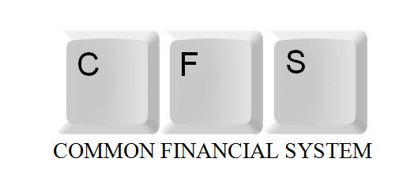






Log into MyCSUSM
Click on CO Portal/CFS
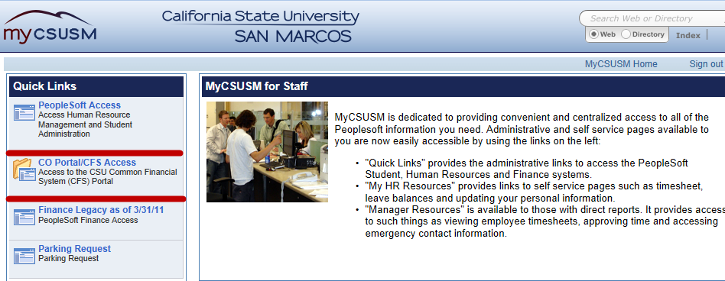
Select the San Marcos Campus
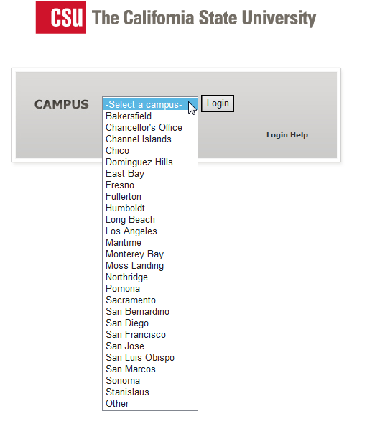
Enter your campus user name and password
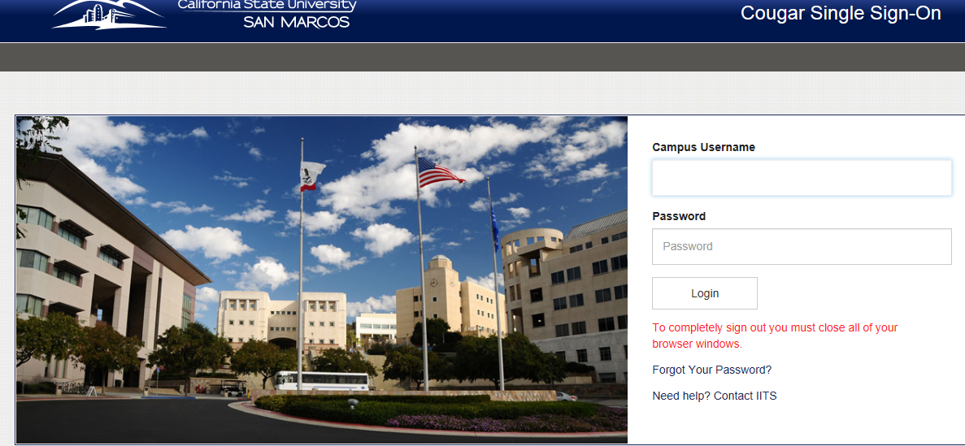
Log into CFS
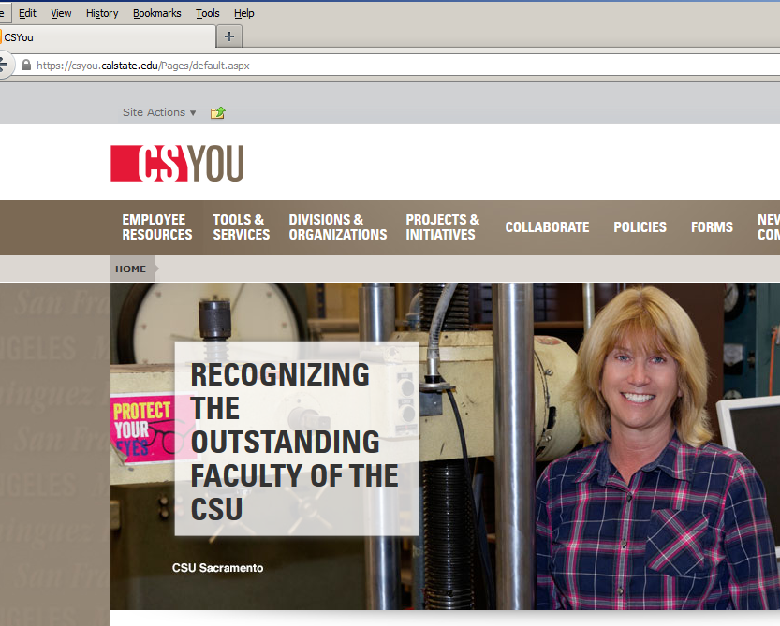

Click on Tools & Services > Financial Tools > Common Financial System (CFS)
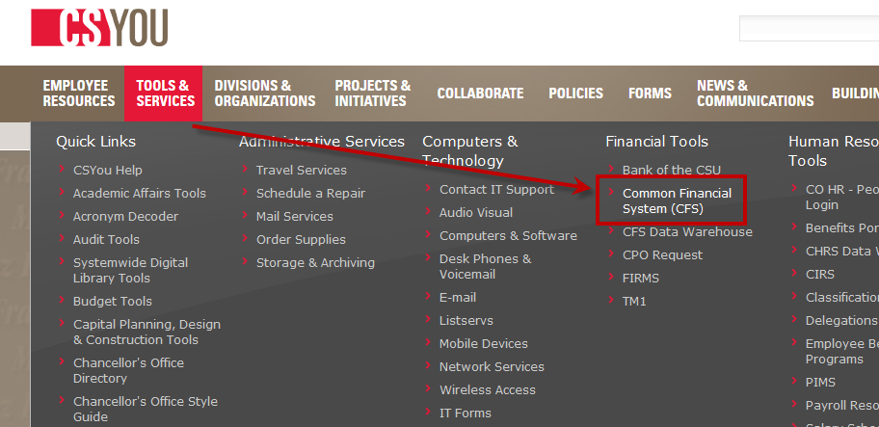

Click on CFS Login
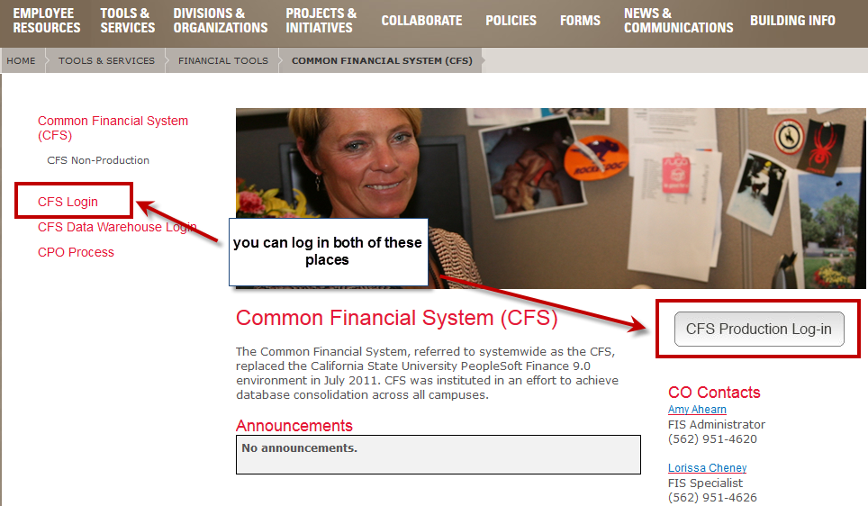

You will see the CFS home page. To view the items that you have access click on the main menu
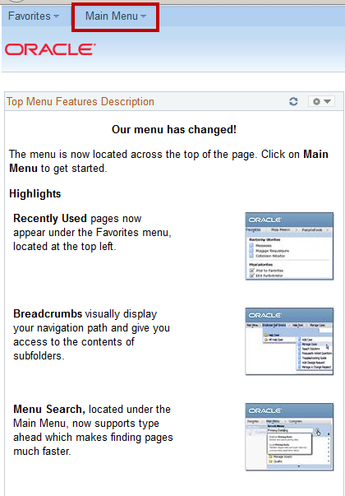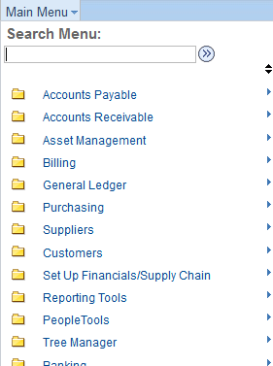

Log into the Data Warehouse
Click on Tools & Services > Financial Tools > CFS Data Warehouse
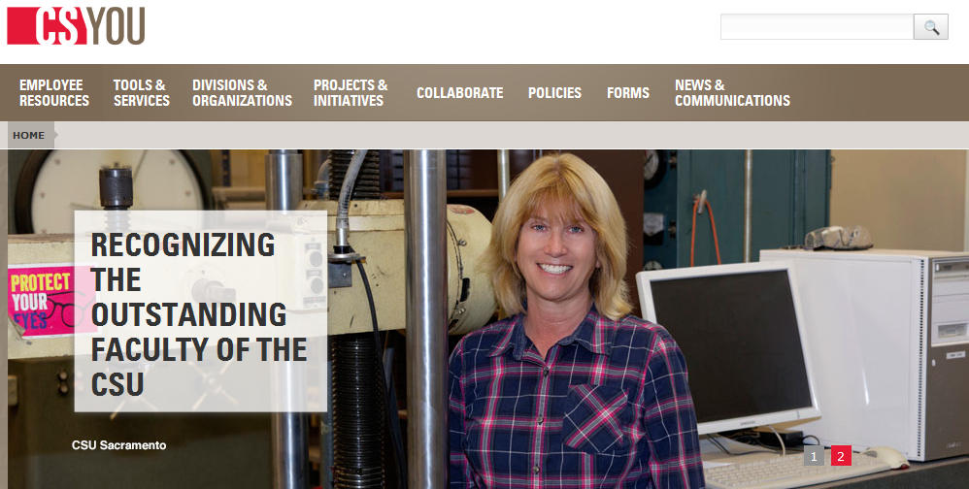
Click on Tools & Services > Financial Tools > CFS Data Warehouse
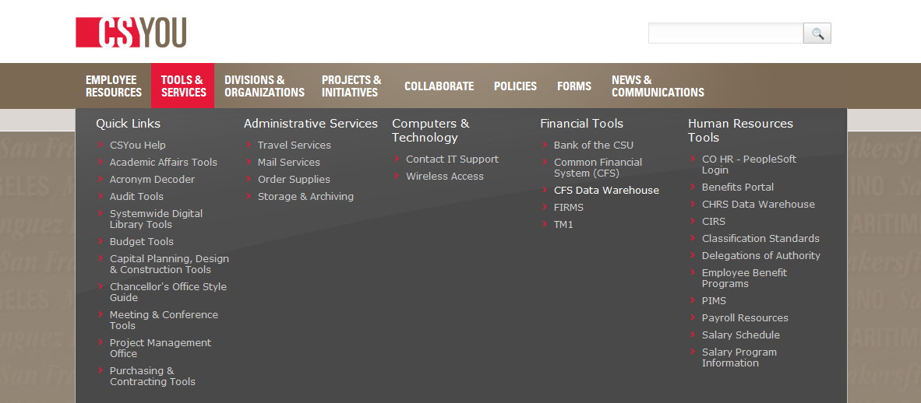

On the CFS Data Warehouse page click on the CFS Data Warhouse – 11g link to access the Data Warehouse.
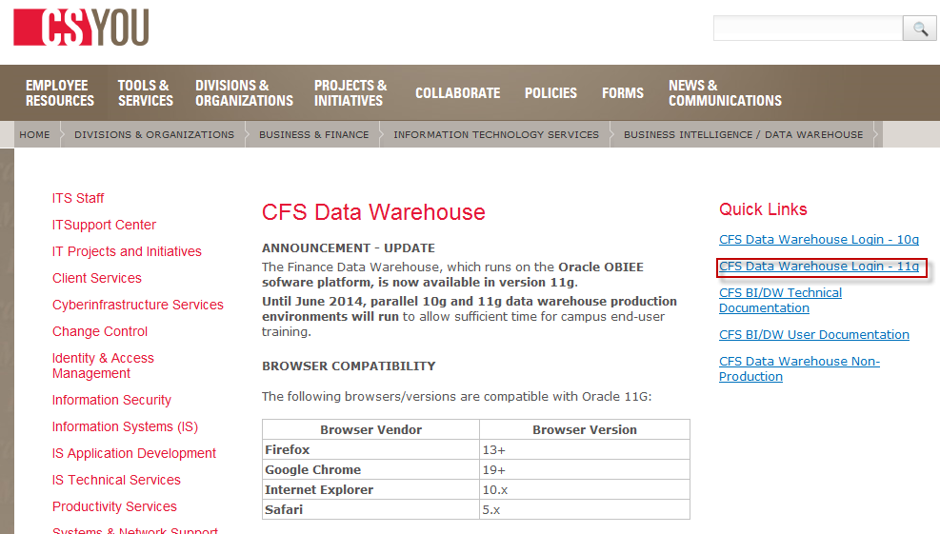
The Data Warehouse home page will open


