1.) LOG INTO CFS > my.csusm.edu > CSYou & CSU CFS Login > Finance Data Warehouse Login > Dashboards > Financial Reporting
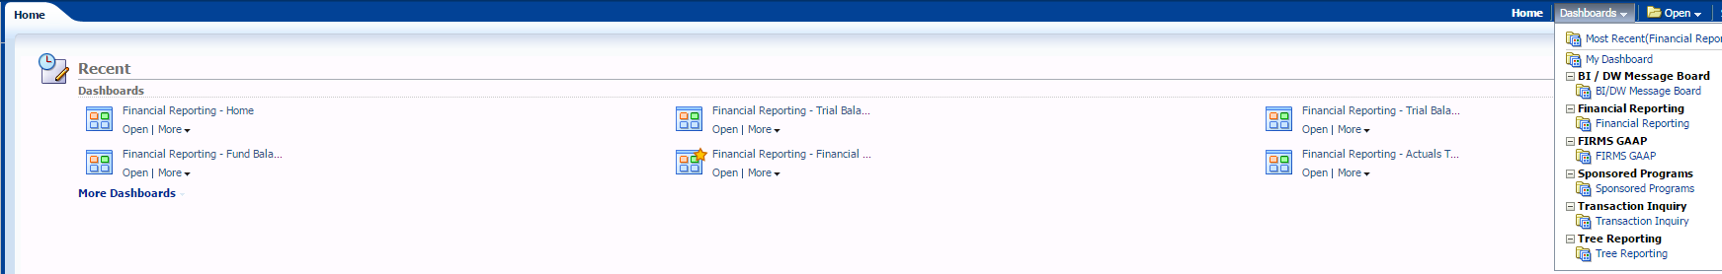
2.) SELECT Trial Balance tab > SELECT Trial Balance (6 Columns)
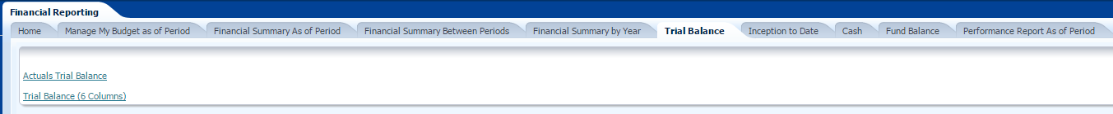
Report Criteria & Format
Fiscal Year = 2015
Period = 10
Fund = remove “x” enter fund number XXXXX
Apply Filters
Column 1 = Fund Fdescr
Column 2 = Acct Type Fdescr
Column 3 = Acct Fdescr
GO
Report View = Trial Balance
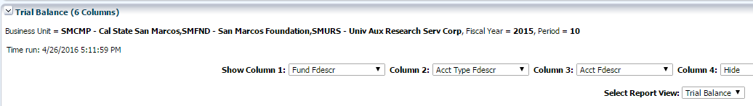
To Download to Excel
Click Export then Select Excel
