HIST 460 Seminar in Latin American History
A social and cultural history of Mexico from 1500-1900, considering the Conquest
and post-Conquest era, the colonial period, and the nineteenth century. Students
will complete a research paper, including the historical interpretation of visual
primary documents. Various seminar activities will involve digital history.
T-Th 1030-1145

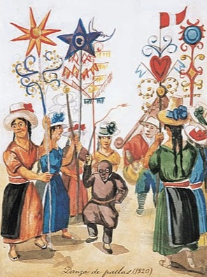 | 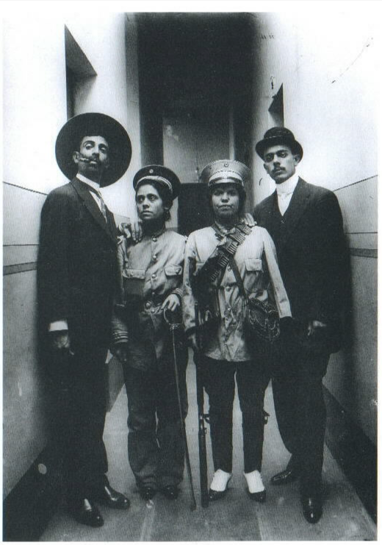 | 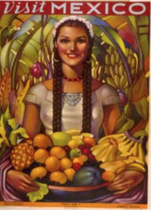

HIST 355 Women in Latin America
Focuses on women and gender in Latin American history. Students will explore the evolution of the historiography, recent research and primary sources both written
and visual. Connections between gender, race, and class will guide the discussion. This course is an upper-division elective course, and satisfies the gender
requirement in the History Major.
T-Th 1-2:15

Questions? cnava@csusm.edu

