A Profile of First Time Full-Time Freshmen in Fall 2013:
Key Findings from the Freshman Survey

During the Summer 2013 orientation sessions for new students at California State University San Marcos, time was set aside for entering freshmen to complete the comprehensive Freshman Survey distributed annually by the Higher Education Research Institute at UCLA; 1,919 prospective students completed the survey.
This report provides an overview of the survey responses and also points out key differences between CSUSM and two comparison groups (13,787 students from similar 4-year colleges and 33,635 students at other public four-year colleges). In addition, the report looks at the following groups on our campus:
- First-generation college students
- Students who plan to live in our on-campus student housing
- Males vs. Females
Finally, because we administer the survey every year, we are able to look at changes over time.

Overview
Choosing College
Much like respondents elsewhere, The Fall 2013 incoming class of first-year students at CSUSM were focused on preparing for the future and considered the following as their most important reasons for attending college:
- To be able to get a better job
- To be able to make more money
- To get training for a specific career
- To learn more about things of interest
CSUSM was first or second choice for 77% of students and two-thirds of respondents say they were admitted to more than one university-- primarily other CSU’s. They were, however, less likely to say they were accepted by their first choice than respondents at other campuses (58% vs. 70% & 77%).
More than 80% of our students come from areas within 50 miles of campus and are much more likely than respondents elsewhere to say they enrolled at their current campus because they “wanted to live near home” (37% vs. 26% of respondents at other 4-year public universities), a percentage that dropped a bit from last year but had been increasing since 2006. The percentage of students who plan to live on campus also dropped from 45% last year to 39% in 2013 but is still higher than earlier years.

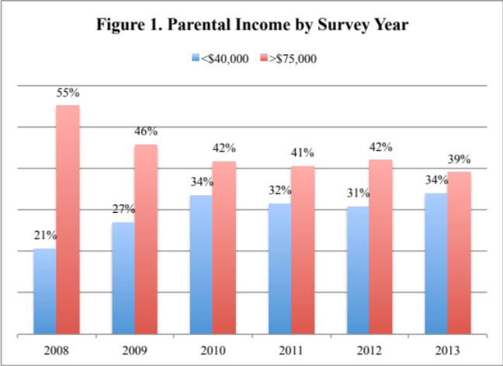
Paying for College
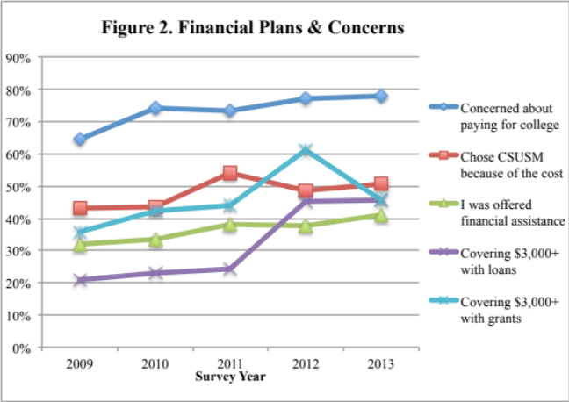
The cost of a college education continues to be a factor in college choice and in students’ concerns. The economic status of our students has changed over time (Figure 1) with a greater proportion of our students coming from low-income households. Three-quarters of CSUSM respondents say the current economic situation significantly affected their college choice and a majority chose CSUSM because of the cost and the financial assistance they received. More than three-quarters of our incoming freshmen have at least some concern about their ability to pay for college. Fewer students report receiving at least $3,000 in grants this year (Figure 2) and three-quarters say they are relying on family or their own resources to pay for their first year of college expenses—a higher percentage than respondents elsewhere. More than half plan to work while in college to help cover college expenses and 16% say they plan to work full time.

High School Activities
Nearly one-third of CSUSM respondents report working at least five hours per week while in high school (a lower percentage than respondents elsewhere) and only 28% spent that much time studying. More than half say they came late to or skipped class or failed to complete homework on time. One-third reported they drank beer or skipped school “at least occasionally”. They were more likely than students elsewhere to say they frequently felt overwhelmed by all they had to do. Nevertheless, a majority of CSUSM respondents rate their drive to achieve, leadership ability, and academic ability as above average or in the highest 10% compared to their peers. They also give high ratings to their tolerance and ability to work with others and consider their ability to work well with a variety of people to be among their strengths.

Goals
The survey asked respondents about the importance of various personal objectives and a majority of respondents identified five activities as “essential” or “very important”:
- Being very well off financially (89%)
- Raising a family (73%)
- Helping others who are in difficulty (74%)
- Becoming an authority in their field (59%)

Views
Finally, freshmen were asked how they would characterize their political views and 27% describe themselves as left of center versus 21% who lean conservative. This political mix has remained fairly consistent over the years but when asked about their level of agreement with various issues and value statements, CSUSM respondents’ agreement with the following statements has become more “liberal” between 2010 and 2013:
- Gays and lesbians should have the legal right to adopt a child (72% vs. 83%)
- Wealthy people should pay a larger share of taxes than they do now (63% vs. 69%)
- A national health care plan is needed to cover everybody's medical costs (57% vs. 66%)

First-Generation Students
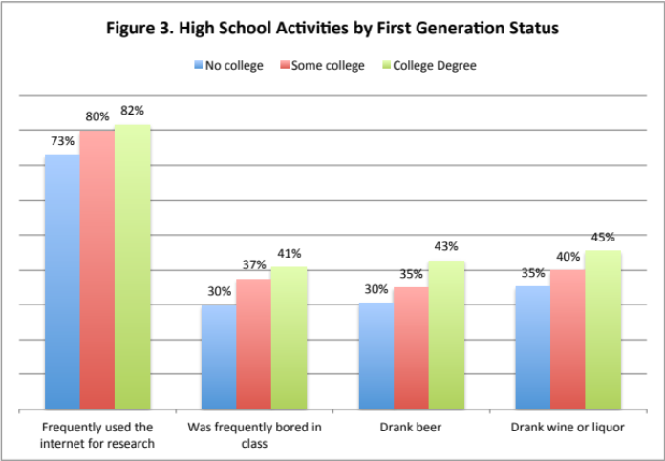
More than one-third (35%) of the CSUSM respondents are first-generation college students in the narrow sense (i.e., coming from families in which neither parent has more than a high school degree) and 53% come from families where neither parent has earned a college degree. These first-generation students are much more likely to be from an under-represented minority (74%), to speak English as a second language (46%), and to live with parents or relatives while attending CSUSM (57%). (Tables 9-15, Appendix A) They are much more likely to have considered the cost of attending and the financial aid offers as “very important” reasons for attending CSUSM. They are more likely to have major concerns about paying for college but are also much more likely to receive grants to help pay for their first year’s expenses. In addition, first-generation college students are more likely than students with a college-educated parent to plan to get a job to help pay their expenses.
First-generation students rate themselves lower in their writing and public speaking ability as well as their computer skills and are somewhat less likely to think they will maintain at least a “B” average in college. As shown in Figure 3, they are less likely than non-first-generation college students to have engaged in negative practices in high school; however, they were also less less likely to use the internet for research, an essential skill in college today.

On-Campus Housing Residents
Freshman respondents, who are planning to live in campus housing, though similar to commuter students in most respects, have a few distinct characteristics. (Tables 16 –18; Appendix A) They are much less likely than commuting students to live within 50 miles of campus, to be Hispanic or to be first-generation students. They are more likely to have applied to more than four colleges, to say they are relying on family resources and loans to pay for college, and just 13% said they came to CSUSM because they were not able to afford their first choice. They are also more likely than students who are living with family to report that they drank alcohol and spent at least five hours per week partying while in high school.

Gender Differences
Just as enrollment numbers and retention/graduation rates differ for male and female students, so do their experiences, concerns and expectations as they begin their college careers. (Tables 19 – 23; Appendix A) Female respondents report slightly higher high school grades and they differ greatly in the types of activities they engaged in while in high school. Women were significantly more likely than men to have engaged in community-oriented service activities and to plan to do so in college. They were more likely revise their papers to improve their writing, to seek feedback about their academic work, to study and work on projects with other students, and to belong to student clubs – all considered important academic practices. Male respondents were more likely to exercise/play sports, play computer games, take a risk because they felt they had more to gain, fail to complete homework on time or fall asleep in class. In spite of this, when asked to compare their academic skills to those of their peers, female respondents rated themselves the same or lower than male respondents on every trait on the survey and are more likely than men to say they will need tutoring or remedial work in Mathematics or science.
Finally, female respondents are more likely to be concerned about paying for college and more likely to plan on working while taking classes. Even so, women are more likely than men to say they plan to be involved in college activities and to say they expect to be satisfied with CSUSM (48% vs. 37%).

Retention and Graduation
The Freshman Survey asks several questions aimed at retention/graduation issues. Only one in four CSUSM respondents considered our graduation rates as a “very important” reason to enroll here. More than half (55%) of respondents say they expect to make at least a “B” average in college (85% report having grades of B or better in high school) and 76% say they expect to graduate within four years, with only 11% saying they will need extra time to complete their degree. Just over 10% say they plan to take courses from more than one college simultaneously, 13% say they plan to transfer to another college before graduating, and less than half (44%) said they expect to be satisfied here. These findings suggest that many of our freshmen enter college with unrealistic expectations and a low commitment to CSUSM—highlighting the importance of getting students (particularly men) engaged and involved early in their college careers.
In 2010, the Higher Education Research Institute developed an Expected Graduation Rate Calculator using responses to various items in the Freshman Survey. These predicted graduation rates can be compared with actual graduation rates and thus provide perspective on how we are moving students toward graduation i.e. are our rates higher (or lower) than expected given the characteristics of our students? Looking at historical data, we see that our expected rates have gradually decreased from 2004 – 2008 (except for a bump up for the Fall 2007 cohort) but our actual graduation rates have increased—an indication that we are providing support to students whose responses to the survey identify them as “at-risk”.
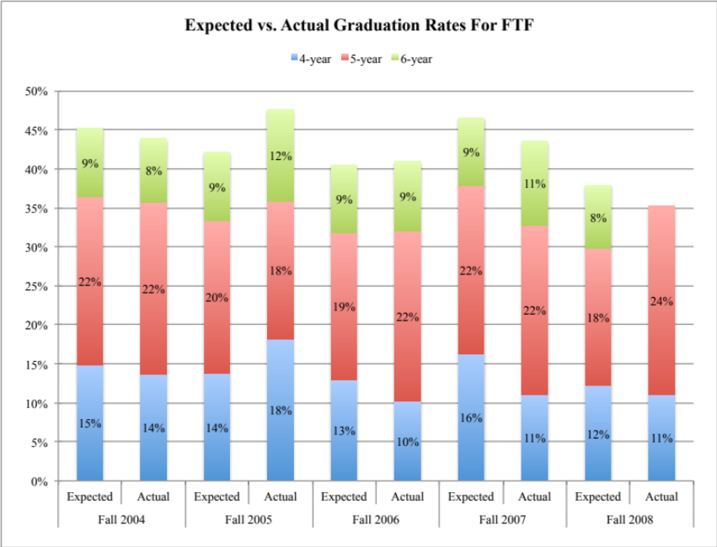

Looking forward, the 2010 through 2013 incoming freshman cohorts expected graduation rates remain low, indicating that our incoming freshmen are facing the same challenges but, based on the increases in our one-year continuation rates for this same period, we can expect our actual graduation rates to continue to improve.

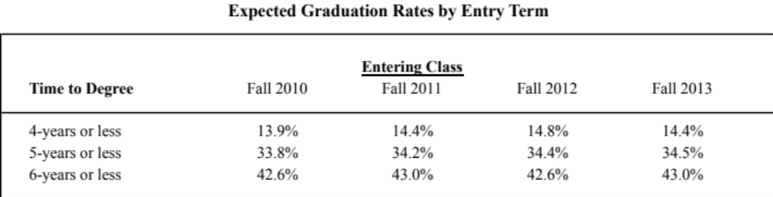
APPENDIX A

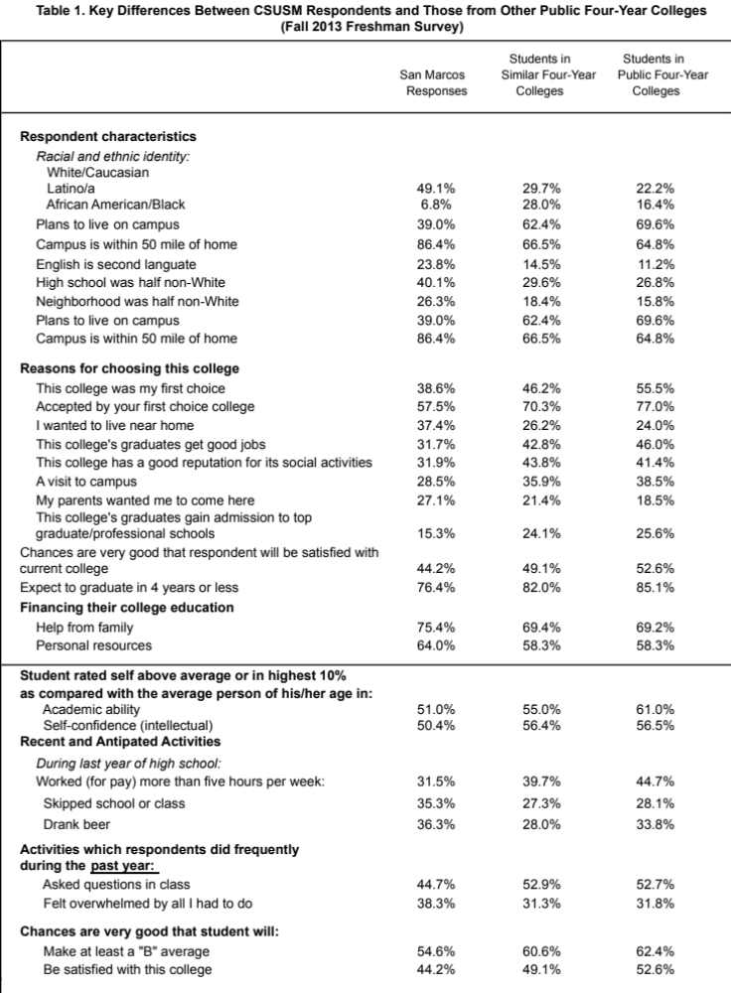

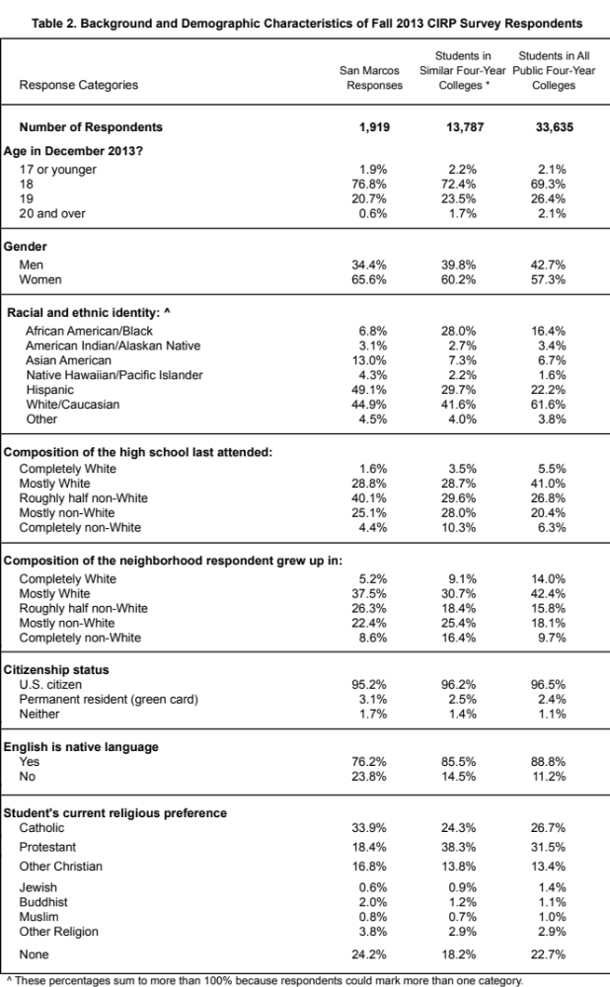

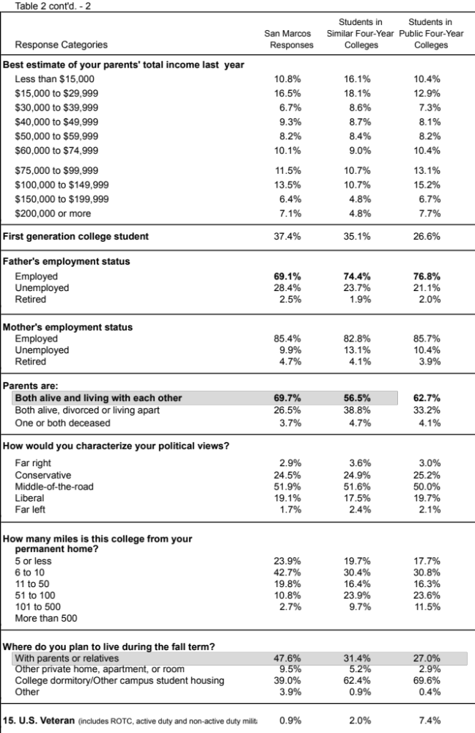

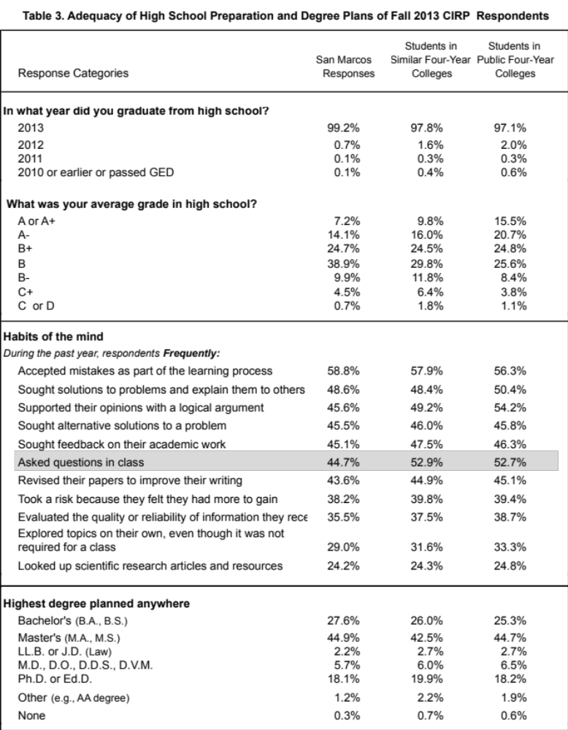

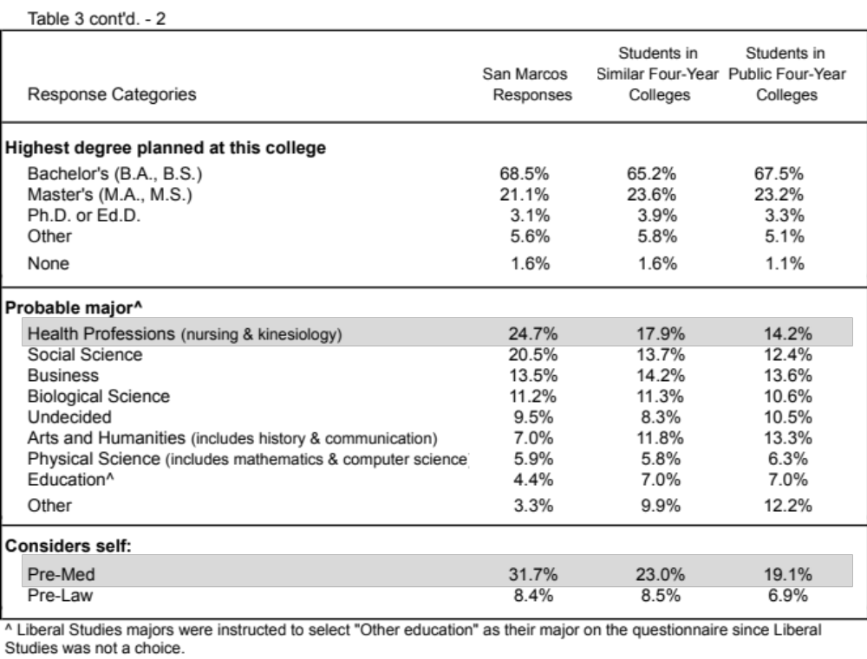

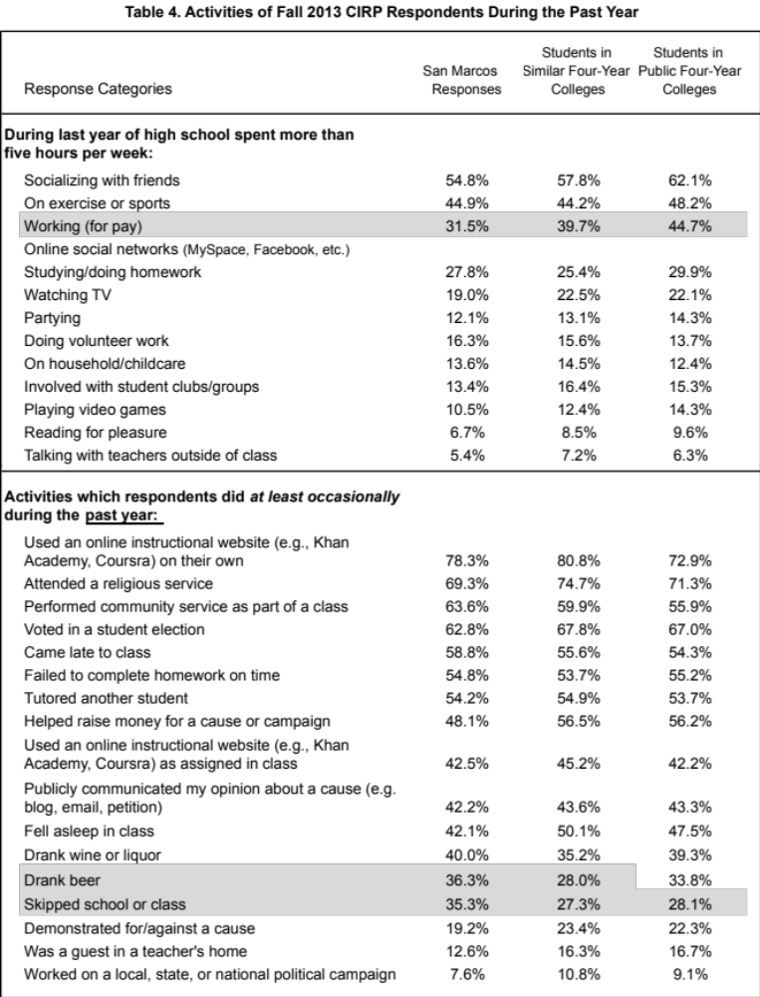

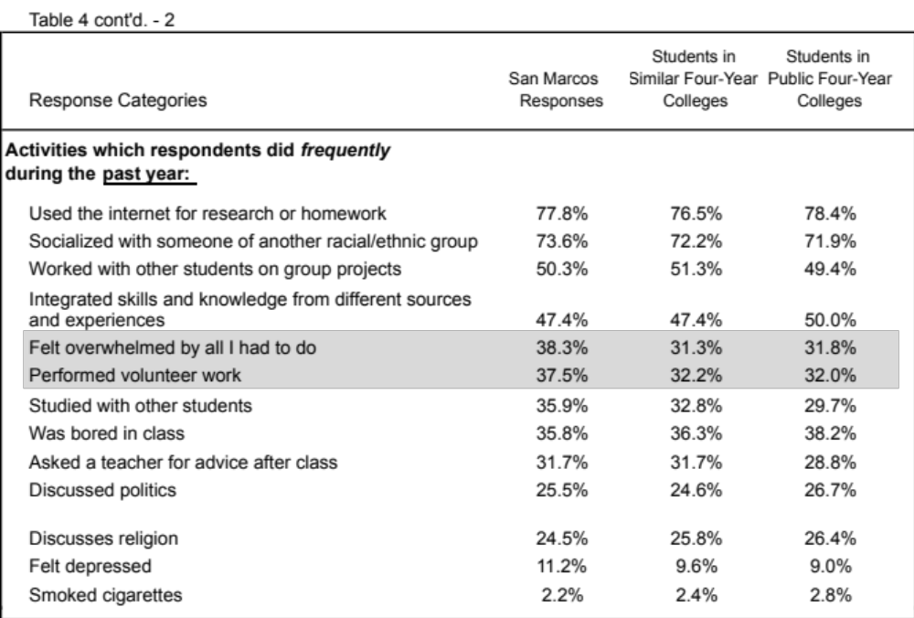

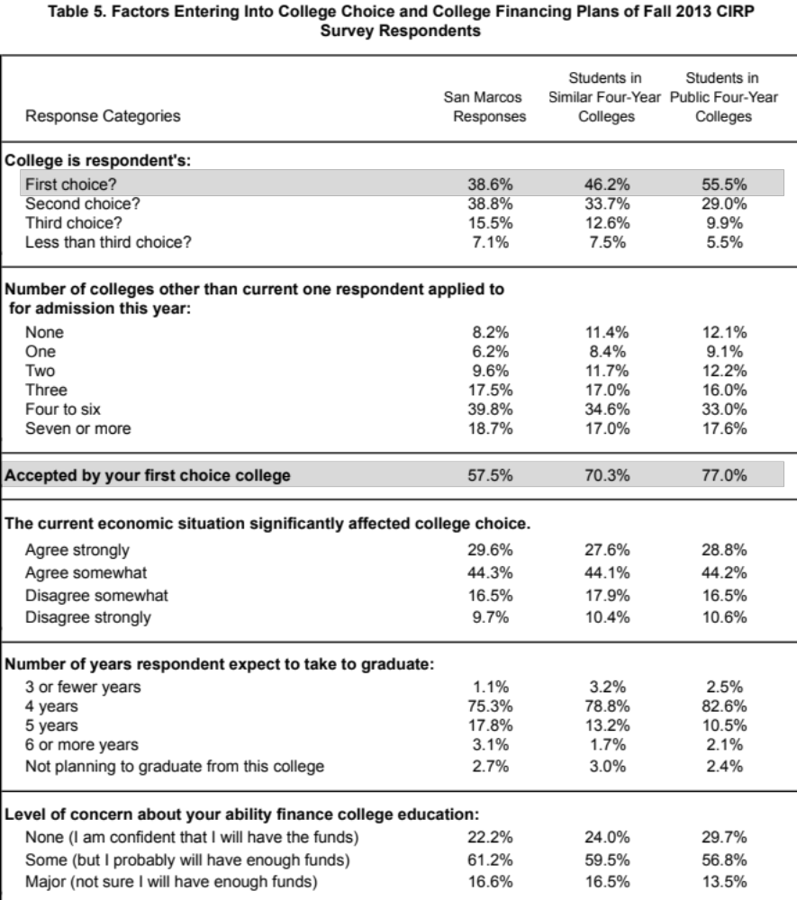

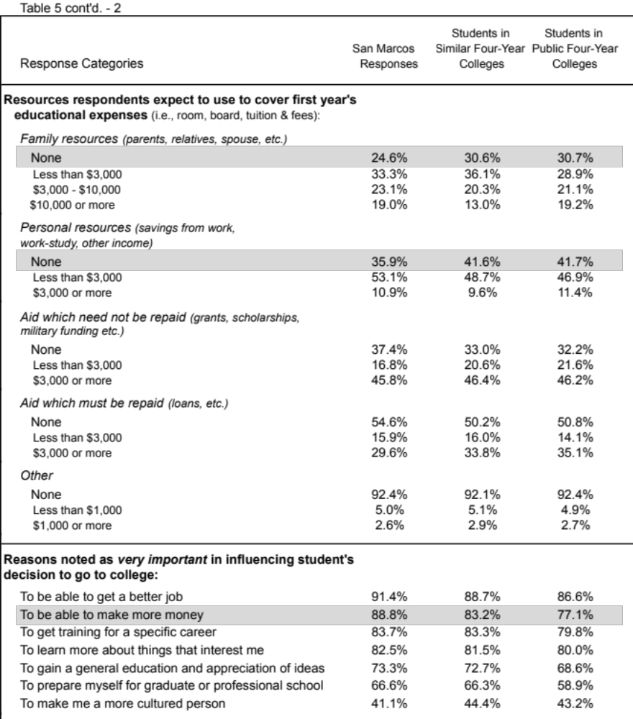

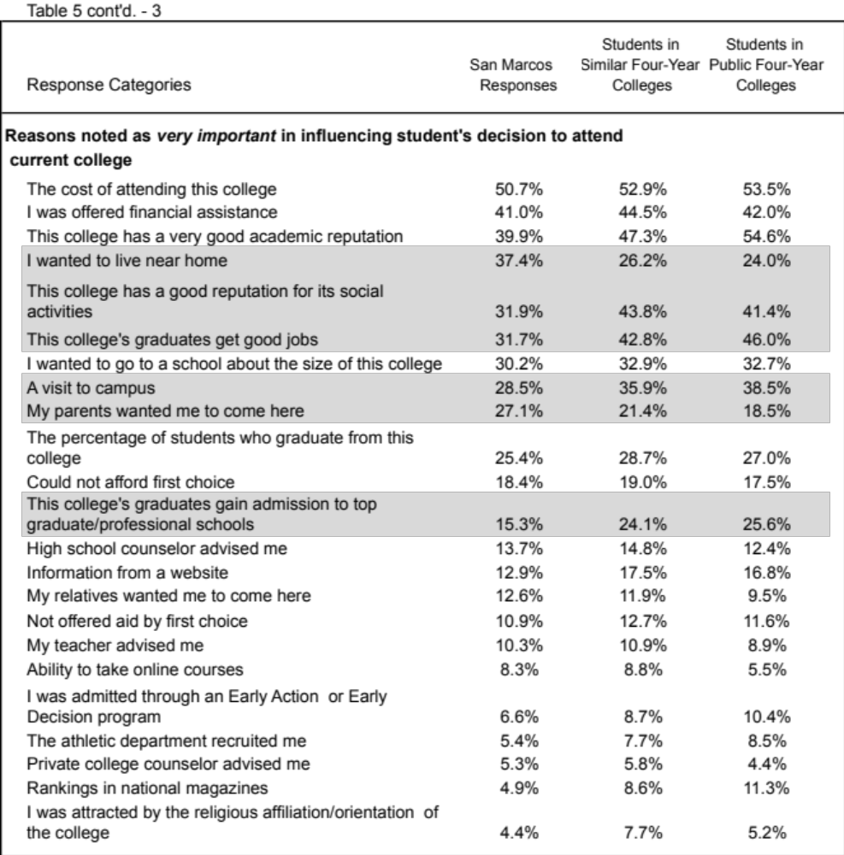

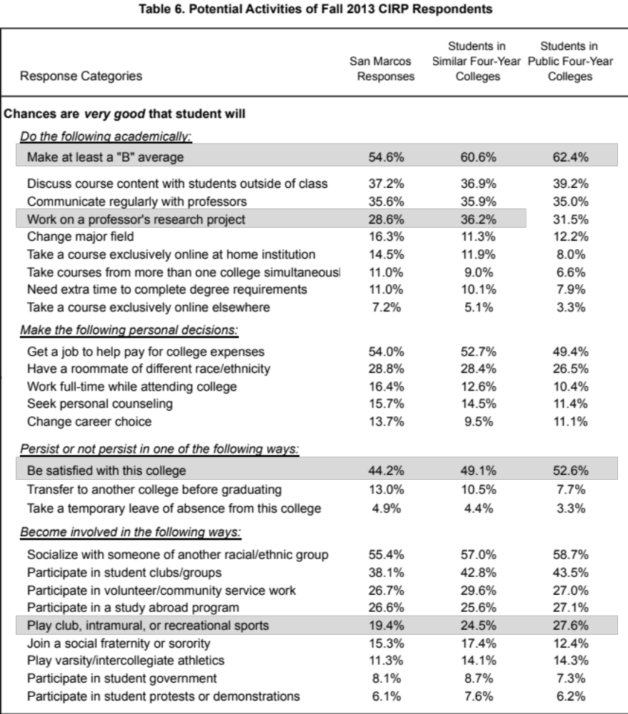

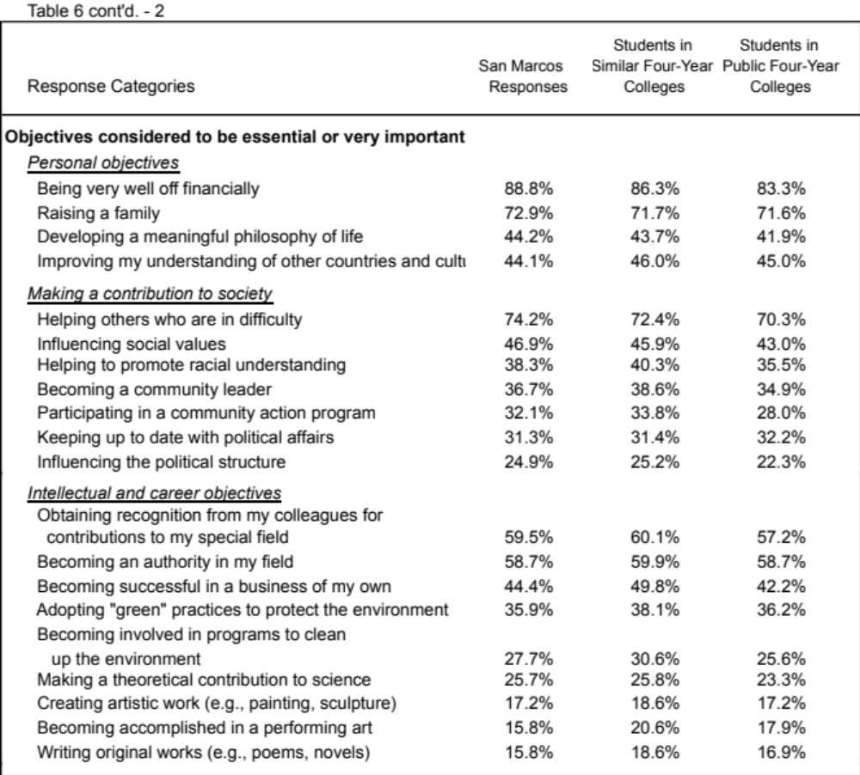

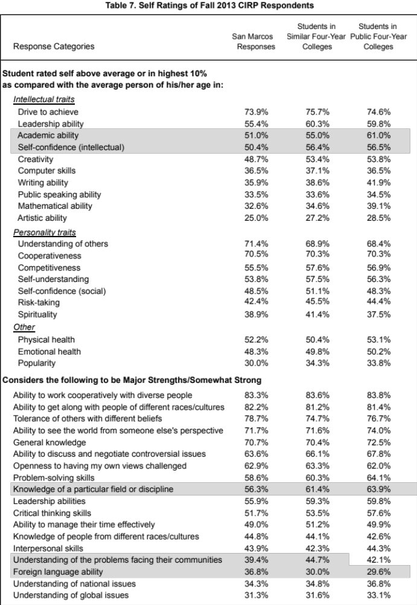

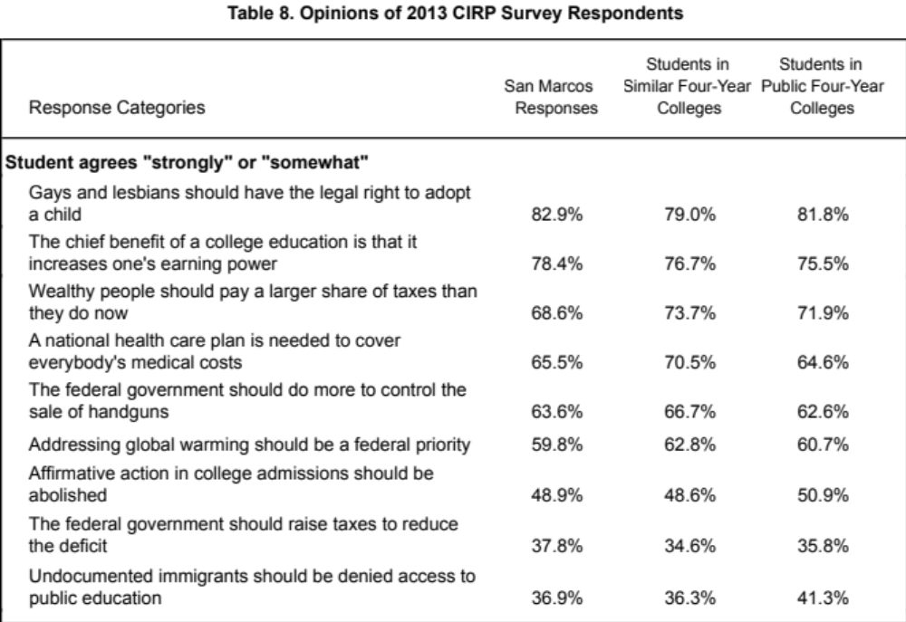
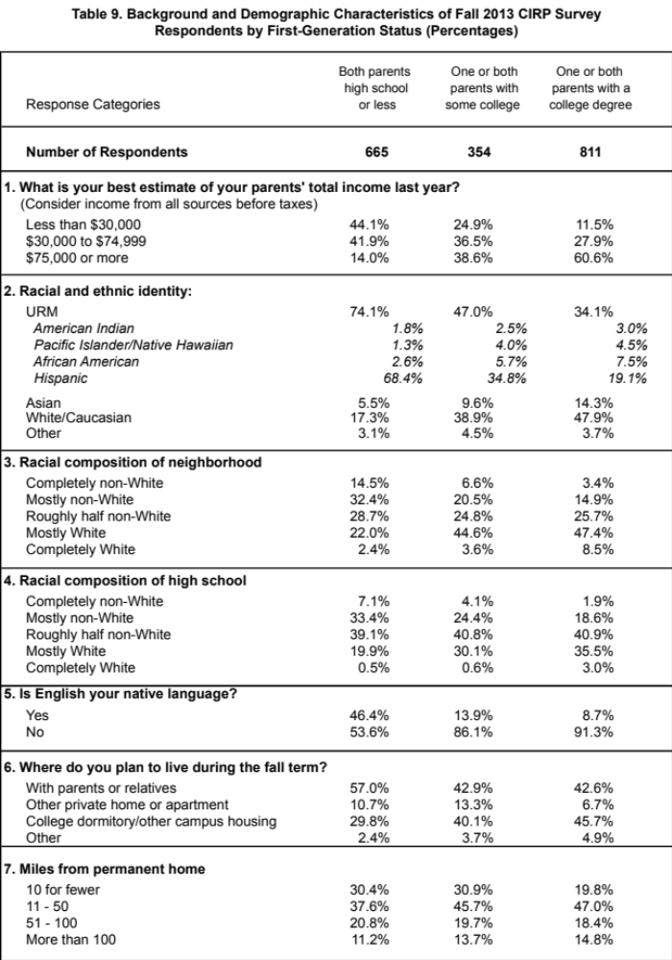

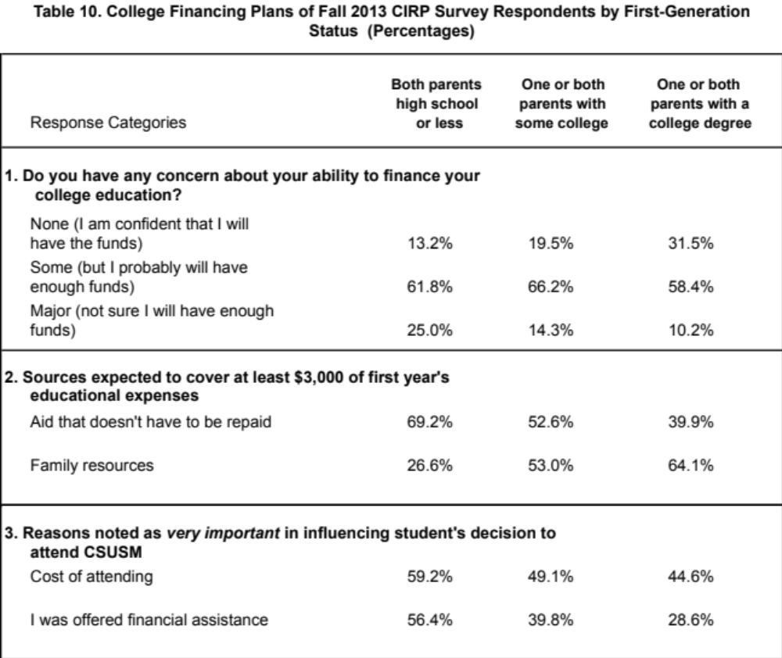

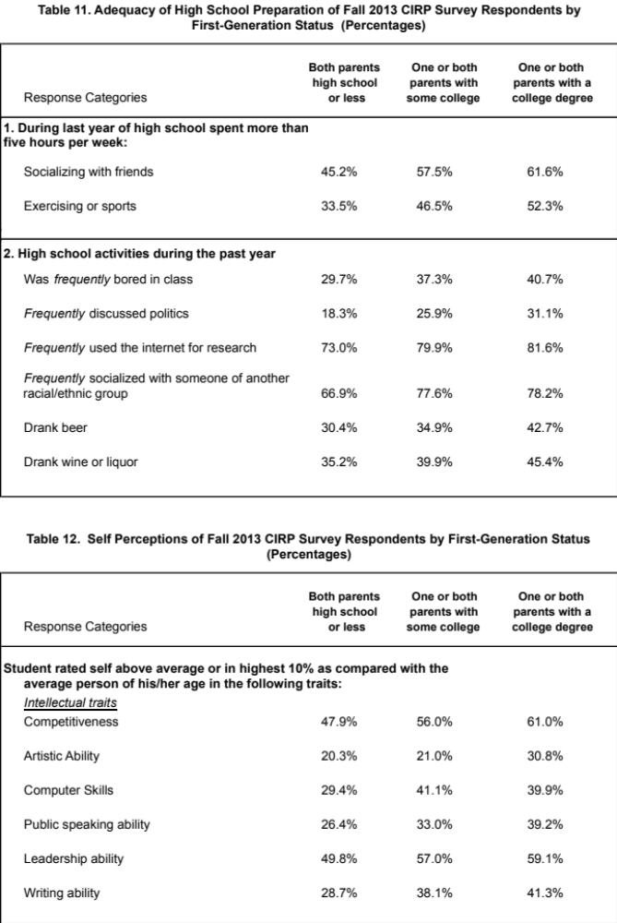

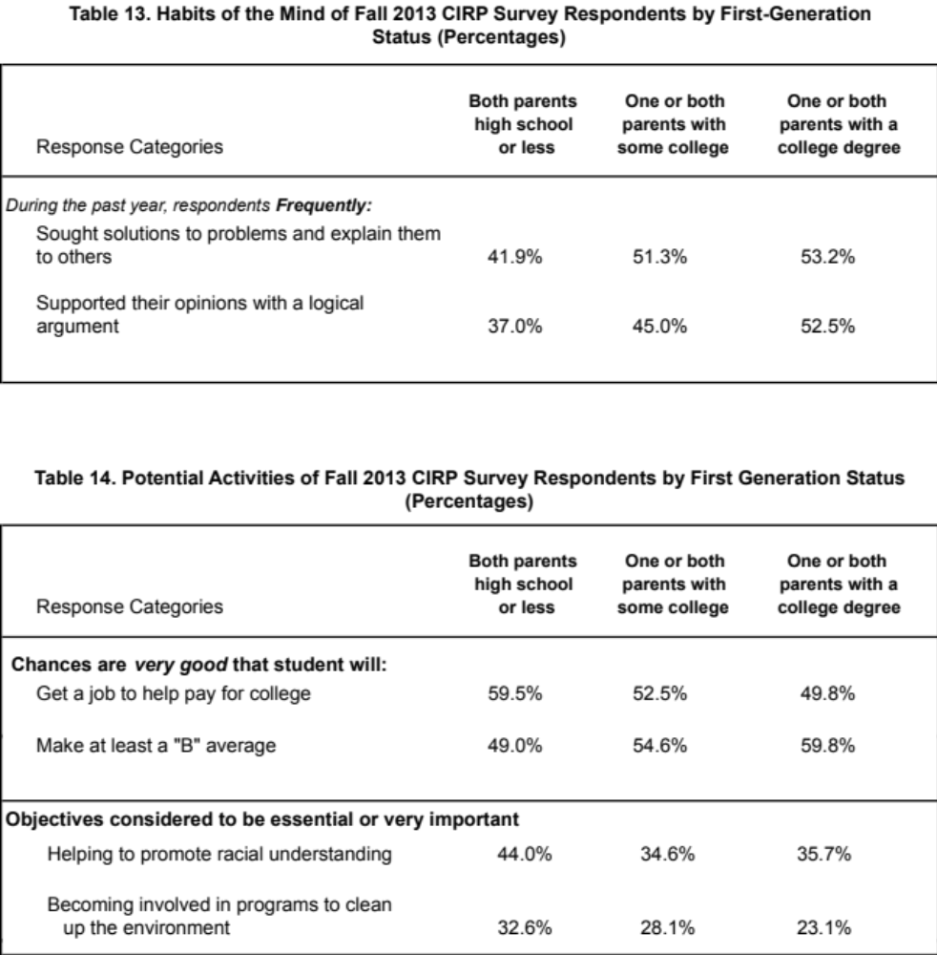

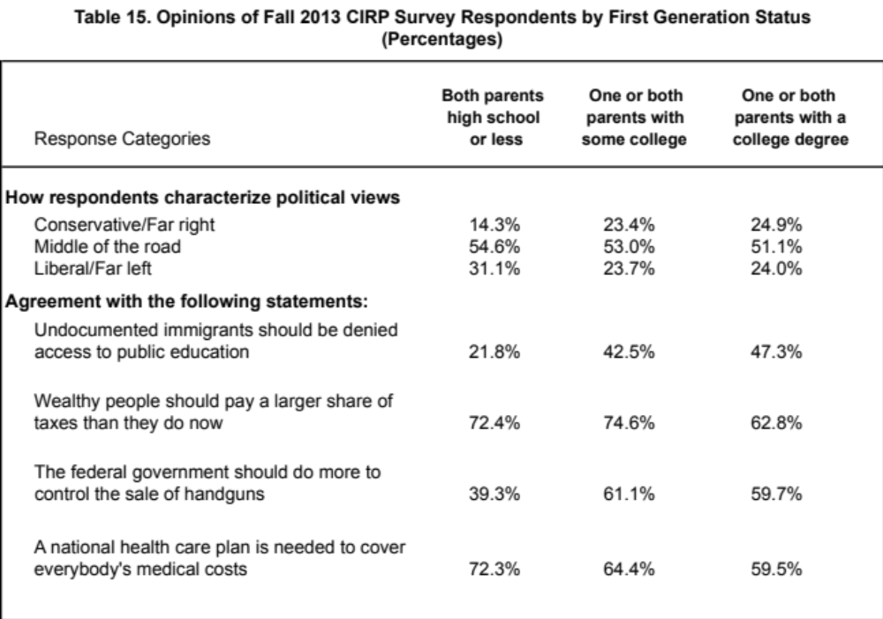

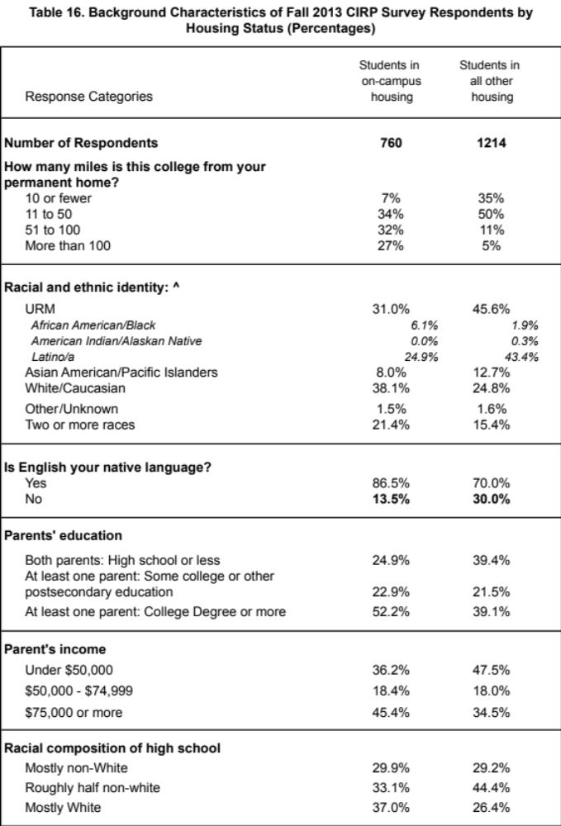

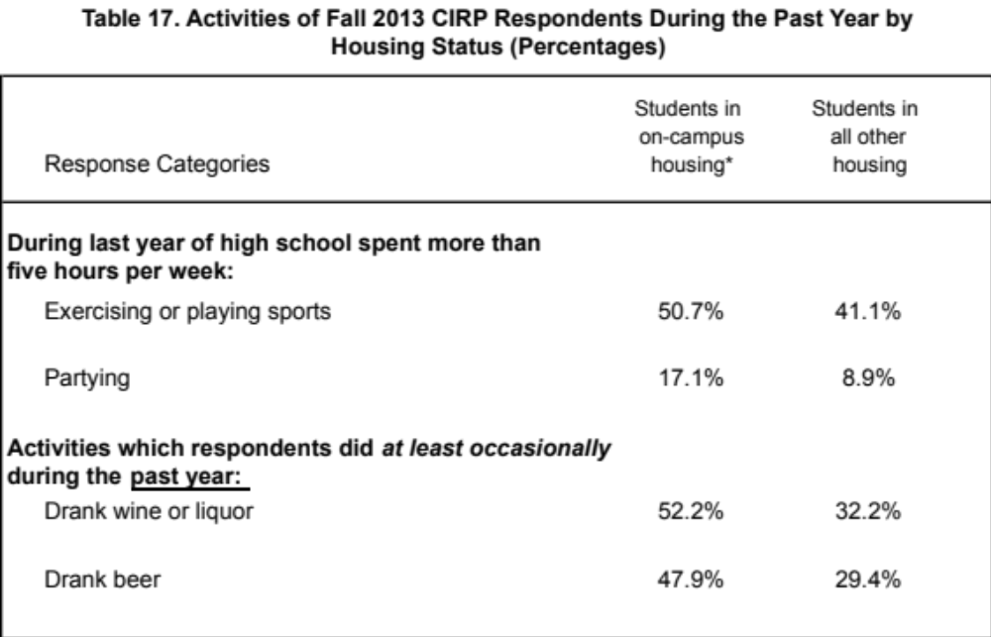

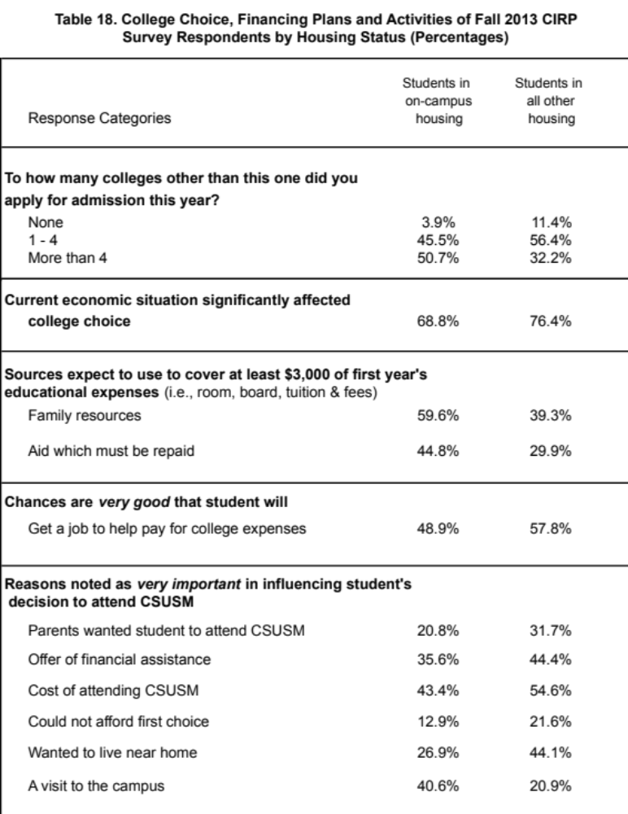

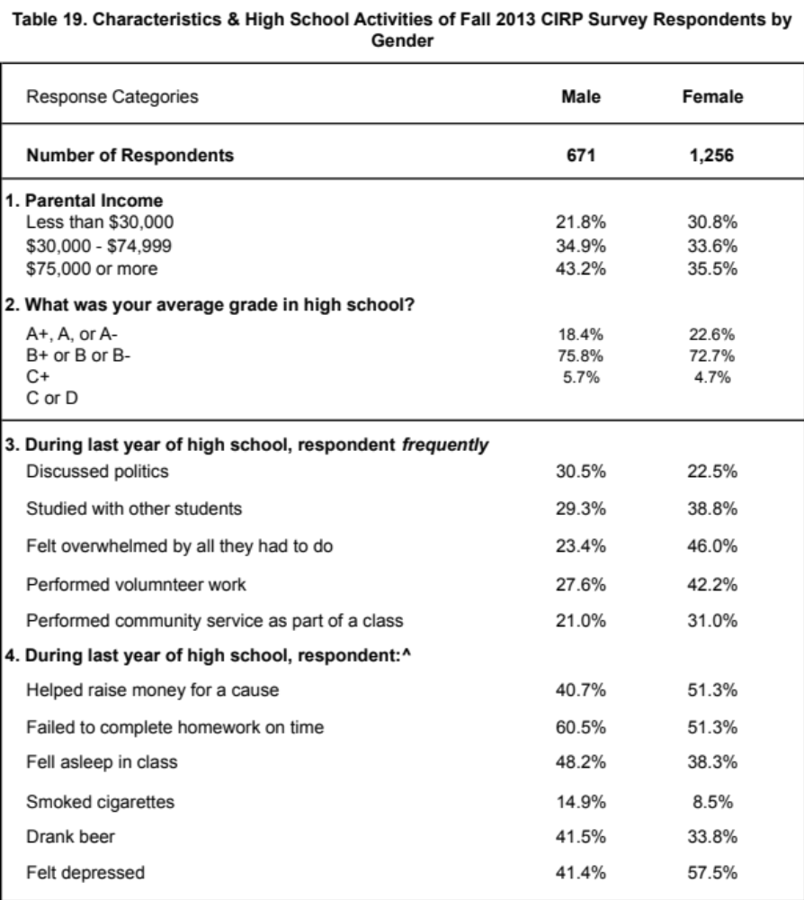

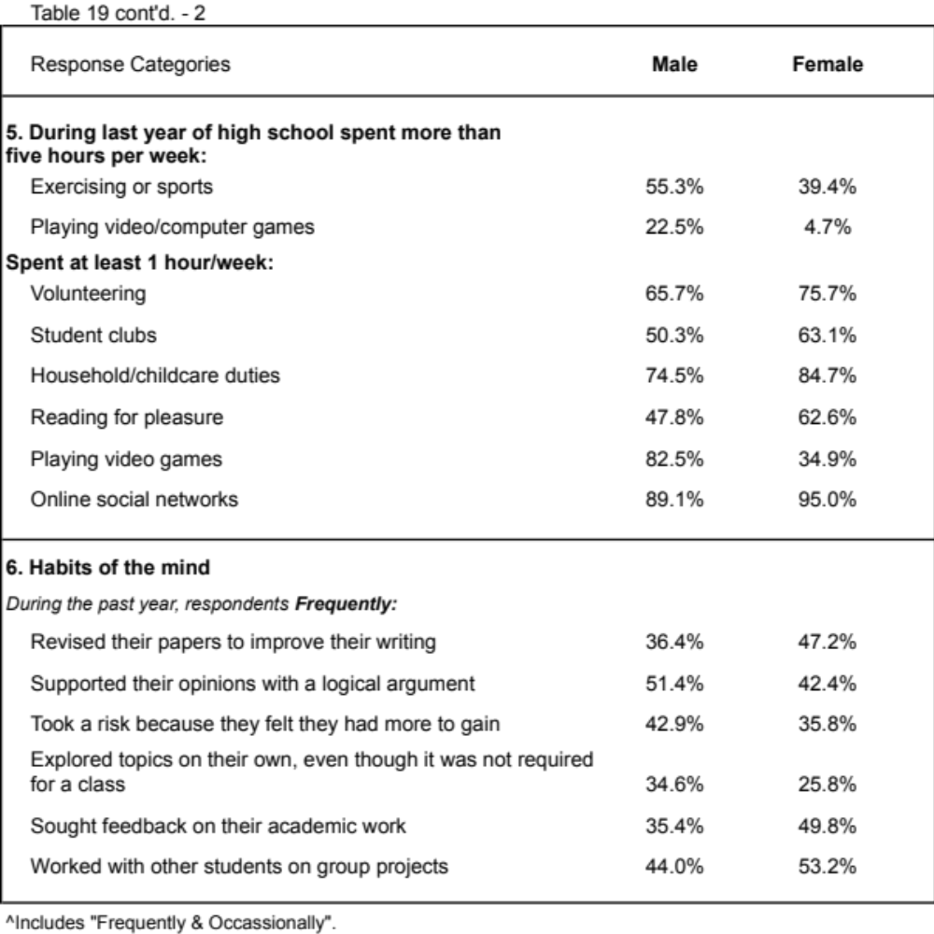
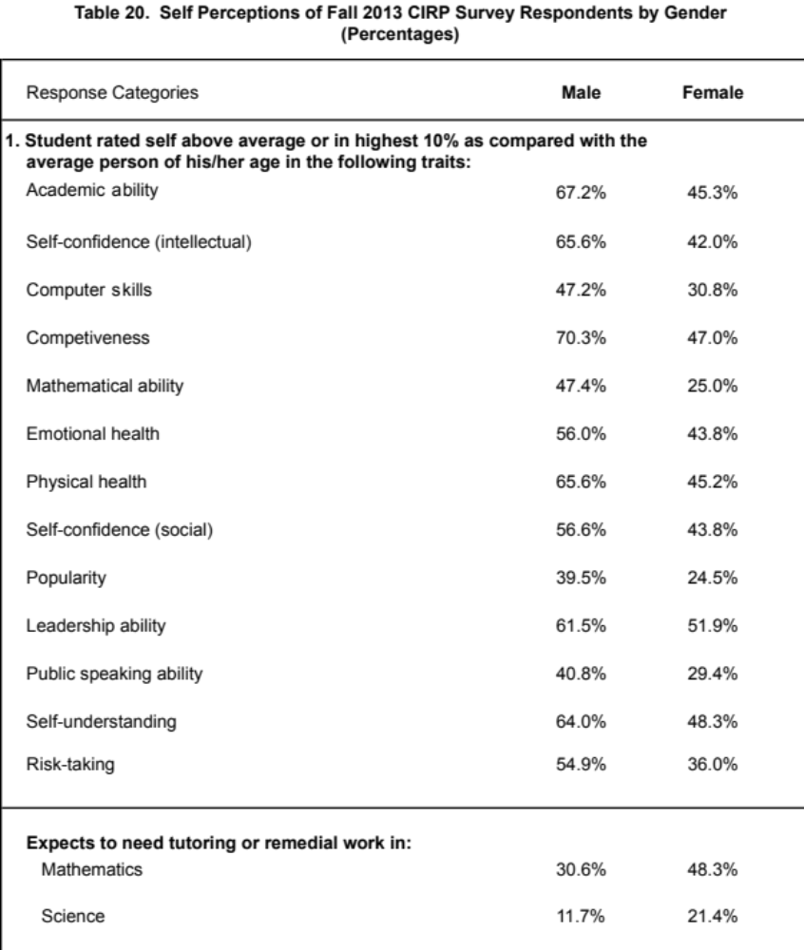

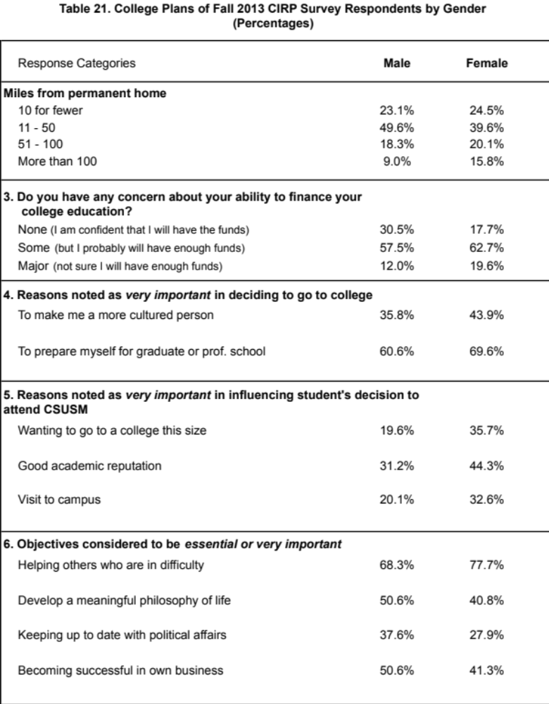

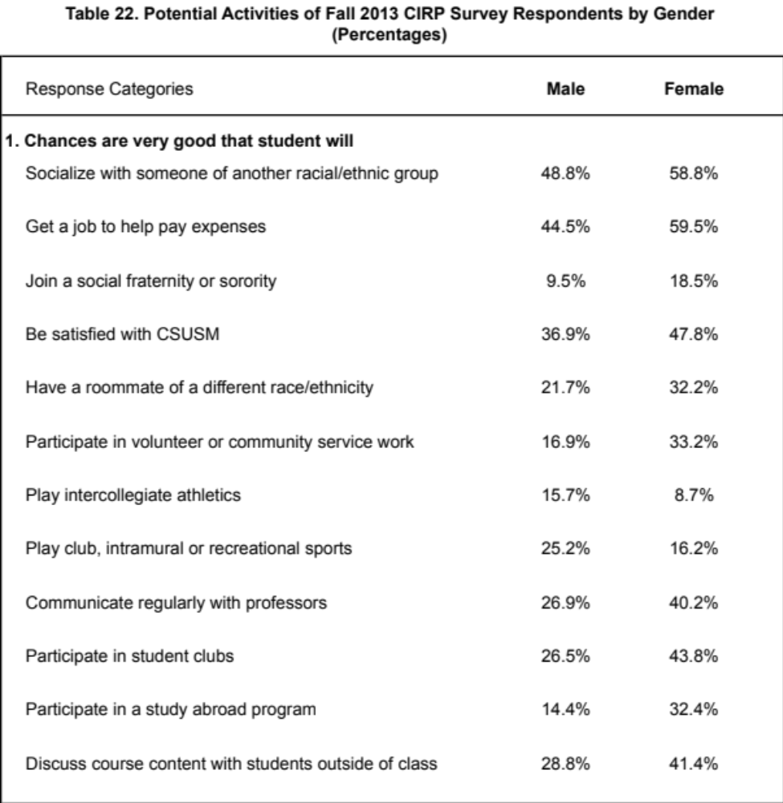

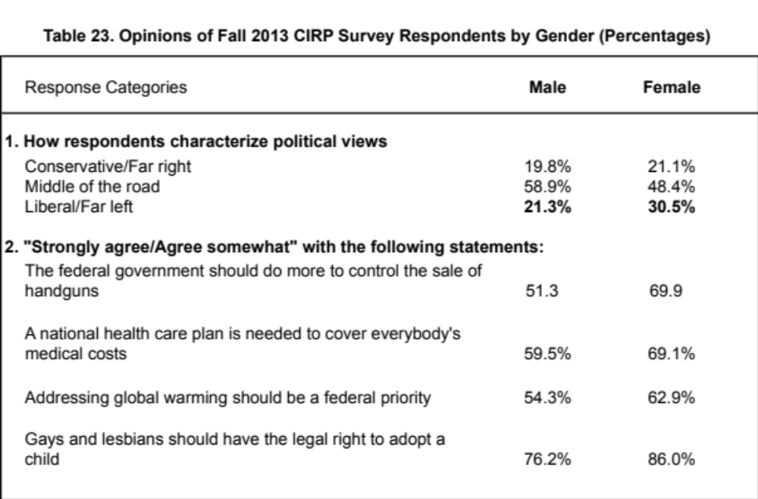

? A special thanks to Student Affairs, the Orientation leaders and the O-team for their help with this survey.
? Colleges similar to CSUSM are defined as those whose average SAT Composite Score (Verbal + Math) of entering class is less than 985 (as reported by the respondent).
? Such colleges are defined as institutions that offer an array of bachelor's degree programs and may offer post- baccalaureate programs, but few, if any, doctoral programs.
? Detailed results, including a summary of key differences, can be found in Appendix A, Tables 1 – 22.
? Historically, the majority of our students who graduate take five or six years to do so.

