A Profile of First Time Full-Time Freshmen in Fall 2011:
Key Findings from the Freshman Survey

During the Summer 2011 orientation sessions for new students at California State University San Marcos, time was set aside for entering freshmen to complete the comprehensive Freshman Survey distributed annually by the Higher Education Research Institute at UCLA; 1,313 prospective students completed the survey.
This report provides an overview of the survey responses and, when relevant, points out key findings related to:
- CSUSM and two comparison groups (10,546 students from similar 4-year colleges and 34,972 students at other public four-year colleges )
- First-generation college students
- Students who plan to live in our on-campus student housing
- Gender
- Changes in our entering freshman classes over time by comparing the 2011 responses with similar data gathered during the 1999-2010 period

Overview
The Fall 2011incoming class of first-year students is somewhat different from that of other public 4-year universities as shown in Table 1. We continue to enroll predominantly women and are increasing our enrollment of students who are traditionally underserved in higher education.
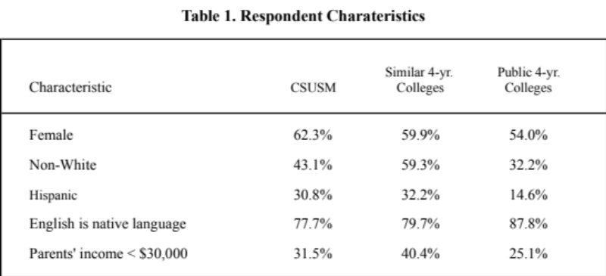
Much like respondents elsewhere, four of five CSUSM respondents cited the following as “very important reasons” for attending college:
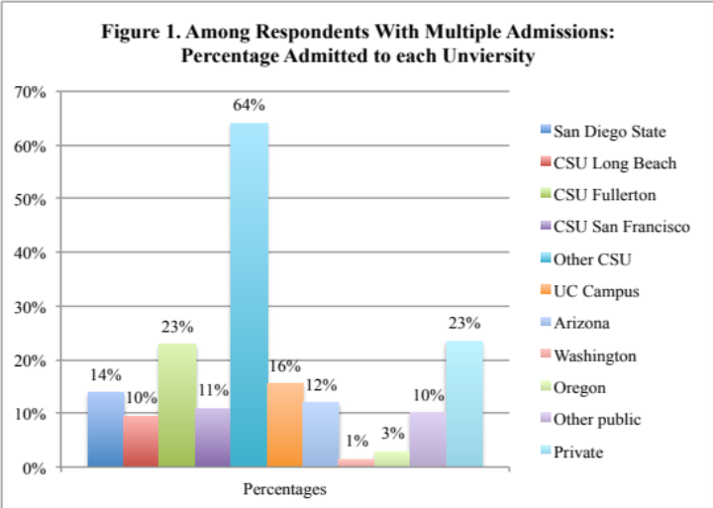
- To be able to get a better job
- To get training for a specific career
- To learn more about things of interest
- To be able to make more money
CSUSM was first or second choice for 81% of students even though a majority applied to three or more campuses. And, although two-thirds were admitted to other universities--primarily other CSU’s—they chose to come to CSUSM (see Figure 1).
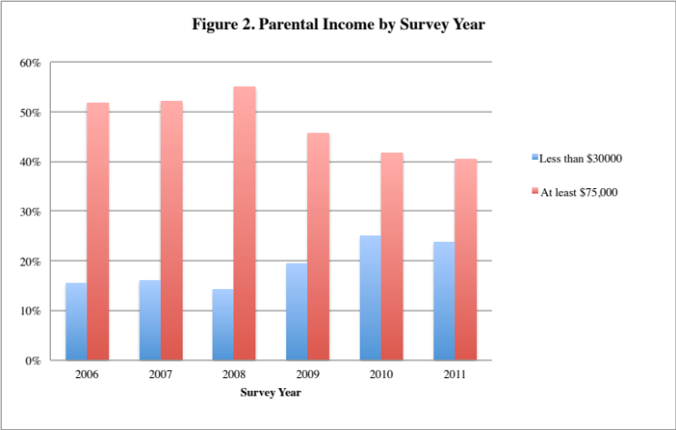
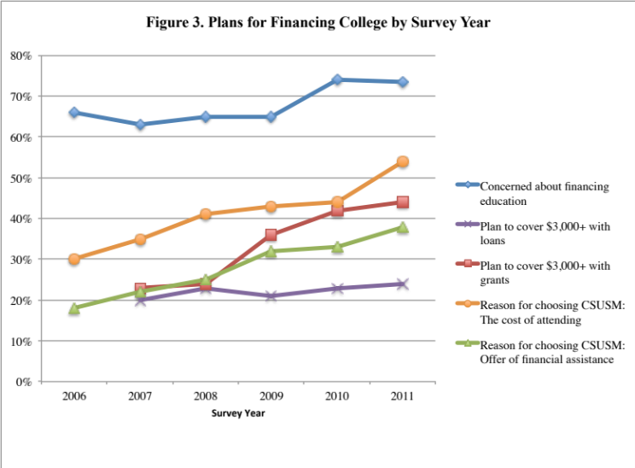
The vast majority of students come from areas within 50 miles of campus and only one-quarter of our incoming freshmen live in on-campus housing, compared with two-thirds of respondents at other public universities. In addition, a smaller proportion of first-year students are living in campus housing than in the past. They are much more likely than respondents elsewhere to say they enrolled here because they “wanted to live near home” (45% vs. 32% of respondents at similar universities) and this percentage has been steadily increasing since 2006. Although one-third of CSUSM respondents chose CSUSM because it has a “very good academic reputation”, this is a much lower percentage than respondents at similar campuses (47%) or other public four-year colleges (53%)
This incoming class is economically diverse with 32% of respondents’ parents earning less than $30,000 last year and 41% of parents earning at least $75,000. In addition, the economic status of our students has changed over time as shown in Figure 2. Three-quarters say they are relying on family resources to pay for college and 64% are using their own resources—a higher percentage than respondents elsewhere. As shown in Figure 3, more than three of four respondents say the current economic situation significantly affected their college choice. Furthermore, the strategies used to pay for college and the importance of college costs has been changing over the years. As parental income has declined, the percentage of respondents receiving grants to cover at least $3,000 of college expenses has increased; however, the percentage getting loans has remained steady at under 25%. The “cost of attending” and “offers of financial assistance” continue to be very important reasons for choosing CSUSM (selected by 54% and 38% of respondents, respectively).
A majority of respondents rate their academic ability, leadership ability, tolerance and drive to achieve as above average or in the highest 10% compared to their peers. However, about only one-third of San Marcos respondents considered their mathematical, computer or public speaking skills to be above average. They are less likely than respondents at other universities to say they frequently asked questions in class or revised their papers while they were in high school and more likely to say they felt overwhelmed by all they had to do and to have consumed alcohol, at least occasionally, while in high school.
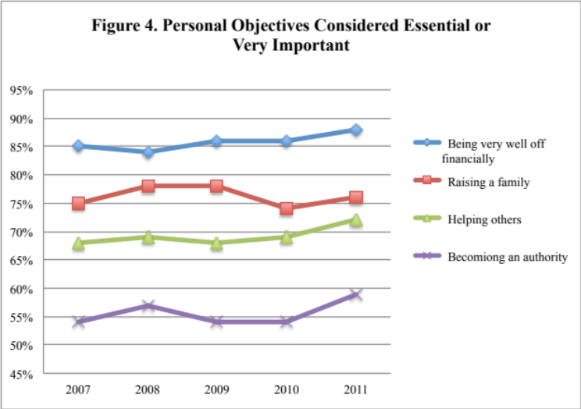
Nearly one-third of CSUSM respondents report working at least five hours per week while in high school (a lower percentage than respondents elsewhere) and only 24% spent that much time studying. More than half plan to work while in college to help cover college expenses and 16% say they plan to work full time (a somewhat higher percentage than respondents elsewhere). In addition, 13% say they plan to take courses from more than one college simultaneously and only 44% say there is a very good chance they will stay at CSUSM (a percentage that has been increasing slowly but steadily since 2009). More than half (57%) of respondents say they expect to make at least a “B” average in college (80% had a high school GPA of B or better) and just 9% anticipate needing extra time to complete their degree.
The survey asked respondents about the importance of various personal objectives and a majority of respondents identified five activities as “essential” or “very important” (Figure 4).
Finally, freshmen were asked about their level of agreement with various issues and value statements. CSUSM respondents were less likely than respondents at similar campus agree that:
- Students from disadvantaged social backgrounds should be given preferential treatment in college admissions (47% vs. 56%)
- Addressing global warming should be a federal priority (57% vs. 69%)
- A national health care plan is needed to cover everybody's medical costs (58% vs. 74%)

First Generation Students
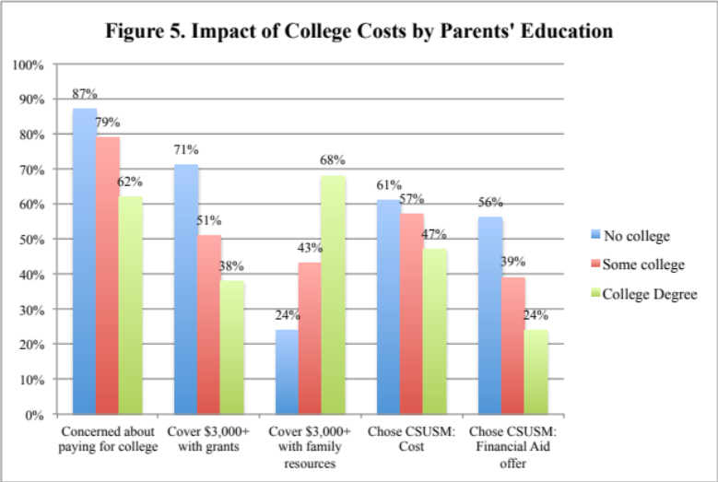
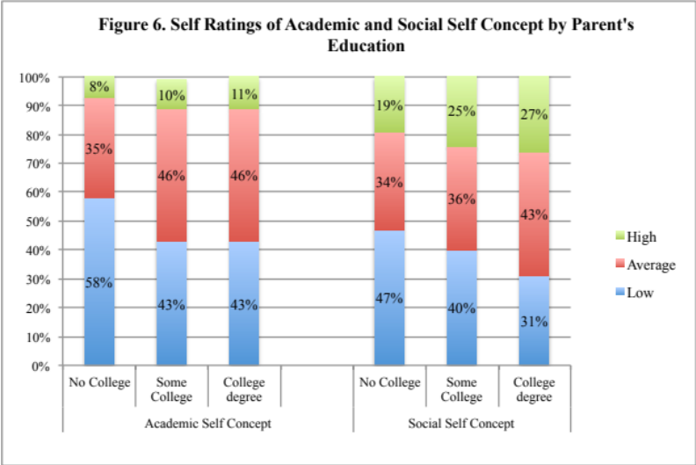
Nearly one-third of the CSUSM respondents are first-generation college students in the narrow sense (i.e., coming from families in which neither parent has more than a high school degree) and 54% come from families where neither parent has earned a college degree. These true first-generation students are much more likely than respondents from families where at least one parent has a college degree to be Hispanic (74%), to speak English as a second language, and to live within 10 miles of the campus. As shown in Figure 5, they have greater concern about paying for college and these concerns contributed to their college choice. They are more likely to plan to live with family and to have a family income below $30,000. First generation college students are slightly more likely to plan to get a job to help pay for college expenses.
First-generation students report making the same average grades in high school as non first-generation students but are less likely to think they will maintain at least a “B” average in college. They are more likely to believe they will need tutoring in basic courses and are also less likely to have spent at least five hours per week in high school socializing with friends or exercising/participating in sports. When comparing themselves to their peers, they are more likely to rate their academic and social abilities as lower than that of the average person their age (Figure 6.) .

University Village Apartments Residents
Freshman respondents, who are planning to live in the University Village Apartments, though similar to commuter students in most respects, have a few distinct characteristics. They are much less likely than commuting students to live within 50 miles of campus, to be students of color or to be first generation students. They are more likely to have applied to multiple colleges, to come from families making more than $74,000/year and to rely on family resources and loans to pay for college. In high school, they were more likely to have spent time socializing with friends, playing sports, partying and drinking alcohol than students who are living with family.

Gender Differences
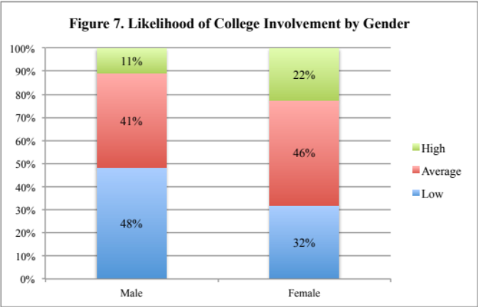
Just as enrollment numbers and retention/graduation rates vary between male and female students, so do their experiences, concerns and expectations as they begin their college careers. Female respondents are more likely to have major concerns about paying for college and more likely to plan on working while taking classes. However, they are also more likely to say they plan to be involved in college activities as shown in Figure 7—an activity that is linked with retention.
Male and female respondents report similar high school academic performance, including self-reported SAT scores and high school grades, yet they vary greatly in the types of activities they engaged in while in high school. Women were significantly more likely than men to report they engaged in academically oriented activities such as:
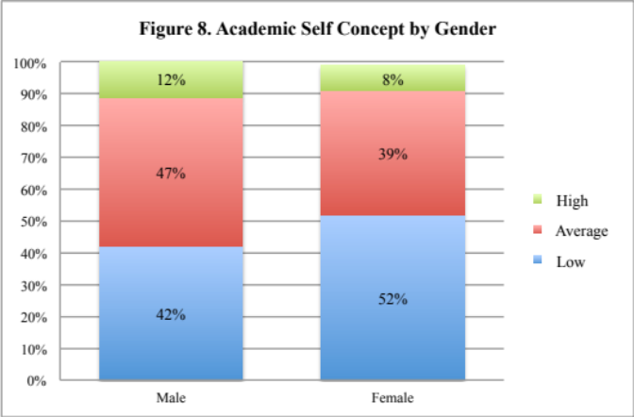
- Working with other students on group projects
- Revising their papers to improve their writing
- Asking questions in class
- Seeking feedback about their work
- Taking notes in class
They are also more likely than male respondents to say they plan to communicate regularly with their professors (37% vs. 24%) and discuss course content with other students (42% vs. 30%). In spite of this, when asked to compare their academic skills to those of their peers, female respondents rate themselves the same or lower than male respondents on every trait on the survey and are more likely to anticipate needing tutoring or remediation. These ratings are reflected in the CIRP concept Academic Self Concept as shown in Figure 8. Finally, male respondents are much less likely to say they expect to be satisfied with CSUSM and, as a result, start their college career with lower expectations than women.

Expected Graduation Rates
In 2010, the Higher Education Research Institute developed an Expected Graduation Rate Calculator using responses to various items in the Freshman Survey.
These predicted graduation rates can be compared with actual graduation rates and thus provide perspective on how we are moving students toward graduation i.e. are our rates higher than expected given the characteristics of our students? Looking at historical data, we see that our expected rates have gradually decreased from 2004 – 2006 and our actual graduation rates increased. Fall 2006 showed a drop in 4-year graduation rates but a higher than expected 5-year rate.
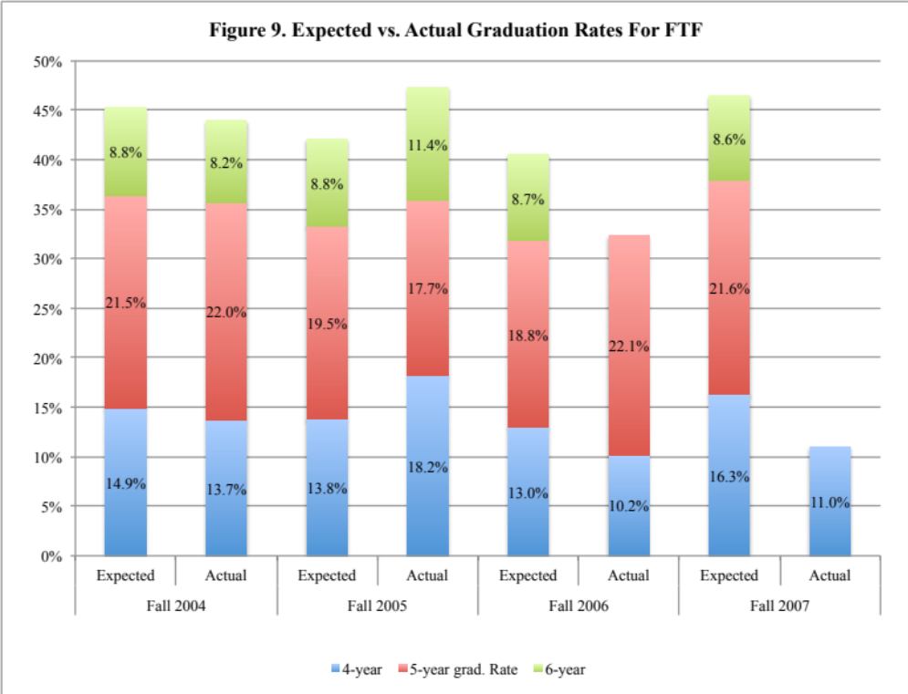

Data for students entering in 2007 shows an increase in expected rates possibly because they report higher high school GPA and SAT scores than earlier classes—factors positively associated with graduation rates. However, going forward, the 2010 and 2011 incoming freshman classes show expected rates returning to 2005 levels (Table 2).
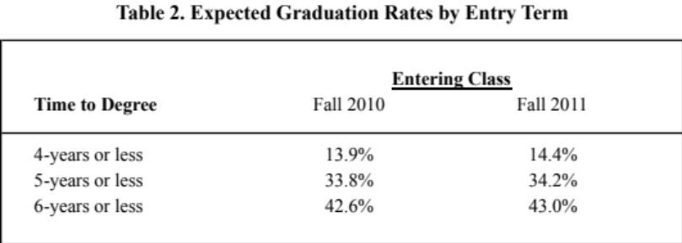

? Actual enrollment figures for Fall 2011 indicate that 1,450 new students enrolled as first time freshmen and respondents are representative of the 2011 incoming class
? For detailed survey findings, please contact Pat Morris in Institutional Planning & Analysis at pmorris@csusm.edu.
? Colleges similar to CSUSM are defined as those whose average SAT Composite Score (Verbal + Math) of entering class is less than 985 (as reported by the respondent).
? Such colleges are defined as institutions that offer an array of bachelor's degree programs and may offer post- baccalaureate programs, but few, if any, doctoral programs.
? The percentage of respondents who plan to work full-time while attending college has been increasing over the years (9% in 2004 to 16% in 2011).
? CIRP developed seven constructs that combine individual survey items into global measures. The Academic Self Concept construct measures the students’ beliefs about their abilities and confidence in academic environments; the Social Self Concept construct measures students’ beliefs about their abilities in social situations.

