A Profile of First Time Full-Time Freshmen in Fall 2012:
Key Findings from the Freshman Survey

During the Summer 2012 orientation sessions for new students at California State University San Marcos, time was set aside for entering freshmen to complete the comprehensive Freshman Survey distributed annually by the Higher Education Research Institute at UCLA; 1,645 prospective students completed the survey.
This report provides an overview of the survey responses and also points out key differences between CSUSM and two comparison groups (11,308 students from similar 4-year colleges and 36,533 students at other public four-year colleges). In addition, the report looks at the following groups on our campus:
- First-generation college students
- Students who plan to live in our on-campus student housing
- Males vs. Females
Finally, because we administer the survey every year, we are able to look at changes over time. This report focuses primarily on changes in our incoming classes since Fall 2008, roughly the beginning of the economic downturn.

Overview
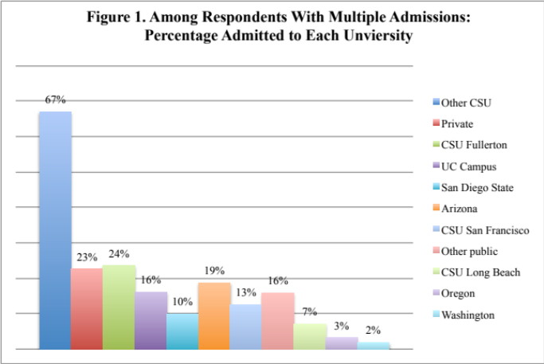
Much like respondents elsewhere, The Fall 2012 incoming class of first-year students at CSUSM cited the following as “very important reasons” for attending college:
- To be able to get a better job
- To be able to make more money
- To get training for a specific career
- To learn more about things of interest
CSUSM was first or second choice for 77% of students (down from 81% in 2011) even though 91% applied to more than one college. Two-thirds of respondents say they were admitted to more than one university-- primarily other CSU’s--as shown in Figure 1.
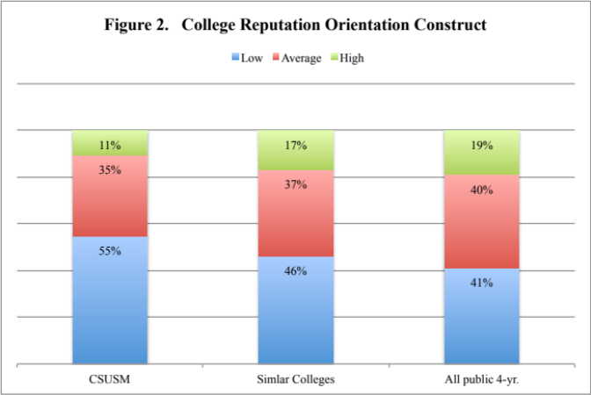
Unlike respondents at comparison campuses, the vast majority of our students come from areas within 50 miles of campus. Our students are much more likely than respondents elsewhere to say they enrolled at their current campus because they “wanted to live near home” (41% vs. 27% of respondents at other 4-year public universities) a percentage that has been increasing since 2006. Even so, the percentage of students who plan to live on campus has been steadily increasing from 26% in 2010 to 45% in 2012.
One-third of CSUSM respondents chose CSUSM because it has a “very good academic reputation”; however, this is a much lower percentage than respondents at similar campuses (46%) or other public four-year colleges (54%) and was not as big of a factor as the “cost of attending” (49%). When compared with other participating campuses, CSUSM respondents score much lower on the construct related to the College Reputation Orientation. (Figure 2)

Paying for College
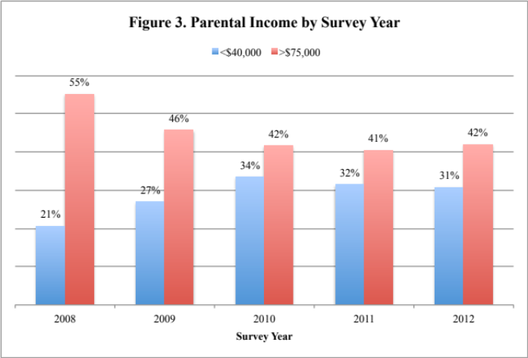
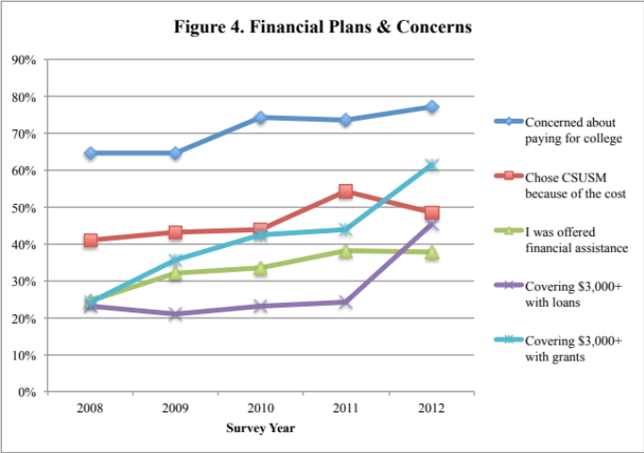
The 2012 incoming class is economically diverse with 31% of respondents’ parents earning less than $30,000 last year (a lower percentage than elsewhere) and 42% of parents earning at least $75,000 (a higher percentage than elsewhere). In addition, the economic status of our students has changed over time (Figure 3), as have their plans for paying for college. (Figure 4) Three-quarters of CSUSM respondents say the current economic situation significantly affected their college choice and 77% have at least some concern about their ability to pay for college. Nearly half say they are relying on family resources to pay for at least $3,000 of their first-year college expenses and 64% are using their own resources—a higher percentage than respondents elsewhere. As parental income has declined, the percentage of respondents receiving grants and loans to cover at least $3,000 of college expenses has increased with the sharpest increase between Fall 2011 and Fall 2012. The “cost of attending” and “offers of financial assistance” continue to be very important reasons for choosing CSUSM (selected by 48% and 38% of respondents, respectively) although somewhat less so than last year. More than half plan to work while in college to help cover college expenses and 23% say they plan to work full time (a higher percentage than respondents elsewhere).

High School Activities
One-third of CSUSM respondents report working at least five hours per week while in high school and only 25% spent that much time studying. They are more likely than respondents at other universities to say that, during the past year, they came late to or skipped class, were bored in class, and frequently felt overwhelmed by all they had to do. They are also more likely to say they drank wine or beer while they were in high school. Although a majority of respondents rate their drive to achieve, leadership ability, academic ability, tolerance and ability to work with others as above average or in the highest 10% compared to their peers, only one-third considered their writing, mathematical, computer or public speaking skills to be above average.

Goals
The survey asked respondents about the importance of various personal objectives and a majority of respondents identified five activities as “essential” or “very important”:
- Being very well off financially (86%)
- Raising a family (74%)
- Helping others who are in difficulty (73%)
- Becoming an authority in their field (56%)
- Obtaining recognition for accomplishments (58%)

Views
Finally, freshmen were asked how they would characterize their political views and 29% describe themselves as left of center versus 21% who lean conservative. When asked about their level of agreement with various issues and value statements, CSUSM respondents were much less likely than respondents at other public 4-year universities to agree that:
- Students from disadvantaged social backgrounds should be given preferential treatment in college admissions (46% vs. 57%)
- Wealthy people should pay a larger share of taxes than they do now (63% vs. 74%)
- A national health care plan is needed to cover everybody's medical costs (64% vs. 80%)
First-Generation Students
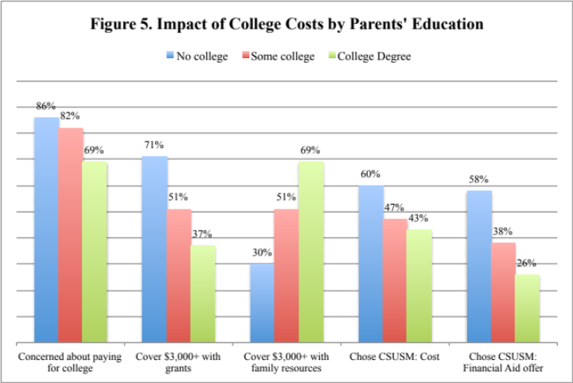
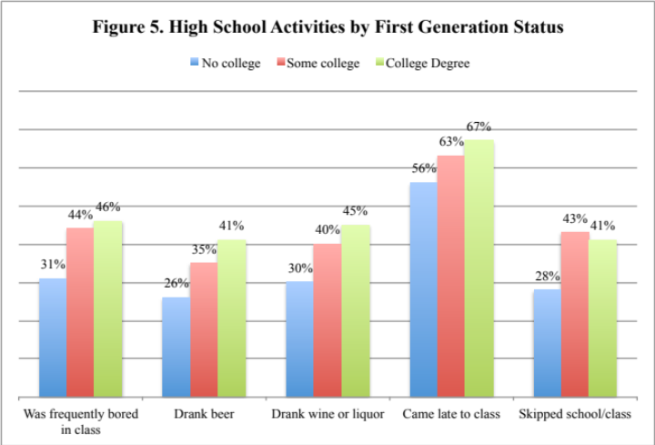
More than one-fourth (28%) of the CSUSM respondents are first-generation college students in the narrow sense (i.e., coming from families in which neither parent has more than a high school degree) and 46% come from families where neither parent has earned a college degree. These first-generation students are much more likely to be Hispanic (75%), to speak English as a second language (54%), and to live within 10 miles of the university (29%). (Tables 8-14, Appendix A) They are also more likely to plan to live with family and 44% report a family income below $30,000. As shown in Figure 5, they have greater concern about paying for college and these concerns contributed to their college choice. First-generation college students are more likely than students with a college educated parent to plan to get a job to help pay for college expenses even though they were less likely to have worked during their last year in high school.
First-generation students report making somewhat lower grades in high school than non first-generation students and are somewhat less likely to think they will maintain at least a “B” average in college. However, as shown in Figure 6, they are less likely than non-first-generation college students to report engaging in a number of activities that can negatively affect high school performance.

University Village Apartments Residents
Freshman respondents who are planning to live in the University Village Apartments, though similar to commuter students in most respects, have a few distinct characteristics. (Tables 15 –17; Appendix A) They are much less likely than commuting students to live within 50 miles of campus, to be students of color or to be first-generation students. They are more likely to have applied to more than four colleges, to say they are relying on family resources and loans to pay for college, and just 14% considered their parents’ desire that they attend CSUSM or the cost as a “very important” factor in their decision to come here. They are also more likely than students who are living with family to report that they came late to class, fell asleep in class, or drank alcohol while in high school.
Gender Differences
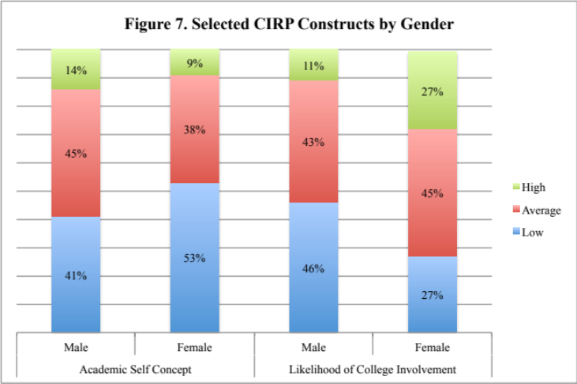
Just as enrollment numbers and retention/graduation rates differ for male and female students, so do their experiences, concerns and expectations as they begin their college careers. (Tables 18 – 22; Appendix A) Although male and female respondents report similar high school academic performance, including self-reported SAT scores and high school grades, they vary greatly in the types of activities they engaged in while in high school. Women were significantly more likely to spend time studying, revising their papers, volunteering, performing community service, or on household duties than men and also report frequently feeling overwhelmed by all they had to do. They are less likely than men to say they smoked, drank beer or fell asleep in class in high school. In spite of this, when asked to compare their academic skills to those of their peers, female respondents rated themselves the same or lower than male respondents on every trait on the survey.
Finally, female respondents are more likely to have major concerns about paying for college and more likely to plan on working while taking classes. Even so, women are more likely than men to say they plan to be involved in college activities and to say they expect to be satisfied with CSUSM (51% vs. 37%). These ratings are reflected in the CIRP Concepts Academic Self Concept and Likelihood of Social Involvement as shown in Figure 7.

Retention and Graduation
The Freshman Survey asks several questions aimed at retention/graduation issues. One in four CSUSM respondents considered our graduation rates as a “very important” reason to enroll here. More than half (59%) of respondents say they expect to make at least a “B” average in college (84% had a high school GPA of B or better) but less than half (47%) say chances are “very good” that they will be satisfied with CSUSM. Nearly all CSUSM respondents say they expect to graduate within four years (26% expect to take fewer than 4 years) and only 11% say they will need extra time to complete their degree. Just over 10% say they plan to take courses from more than one college simultaneously and 14% say they plan to transfer to another college before graduating. As shown below, both the graduation rates for first-time freshmen at CSUSM are quite different from what our students expect.
In 2010, the Higher Education Research Institute developed an Expected Graduation Rate Calculator using responses to various items in the Freshman Survey. These predicted graduation rates can be compared with actual graduation rates and thus provide perspective on how we are moving students toward graduation i.e. are our rates higher (or lower) than expected given the characteristics of our students? Looking at historical data, we see that our expected rates have gradually decreased from 2004 – 2006 and our actual graduation rates increased. Fall 2006 rates showed a drop in 4-year graduation rates but a higher than expected 5-year rate. (Figure 8) Data for students entering in 2007 showed an increase in expected rates possibly because respondents reported higher high school GPA and SAT scores than earlier classes on the survey—factors positively associated with graduation rates.
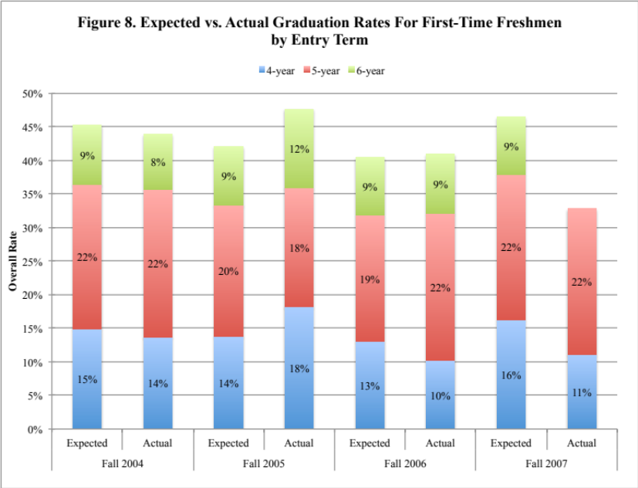

Looking forward, the 2010 through 2012 incoming freshman classes show expected rates returning to previous 2006 levels (Table 1).
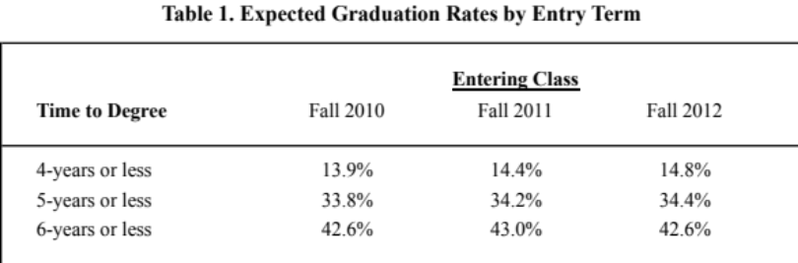
APPENDIX A

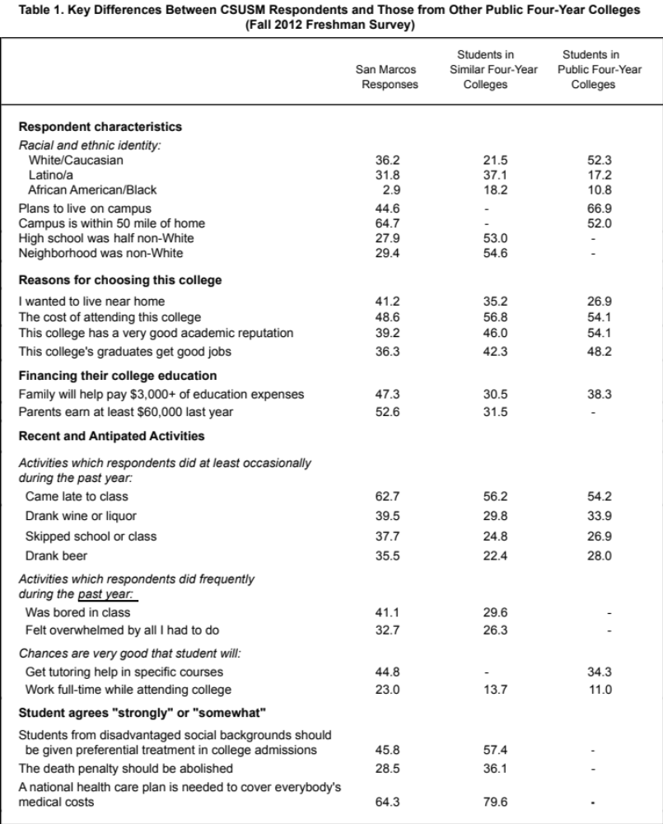

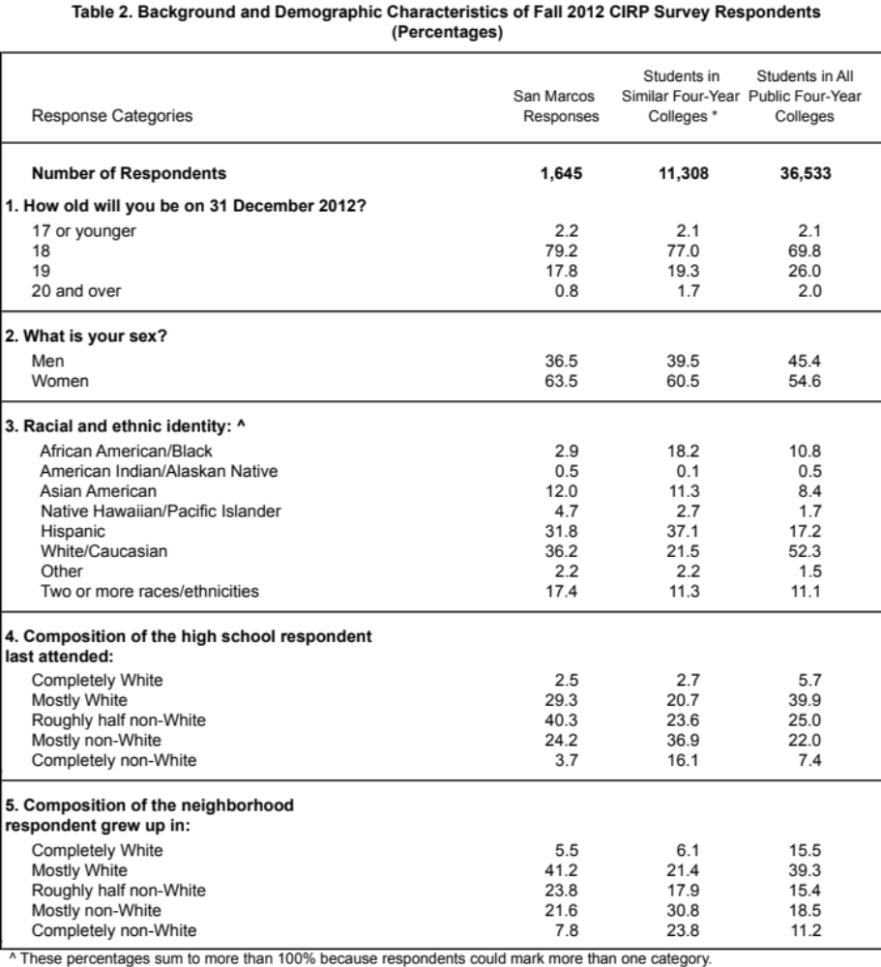

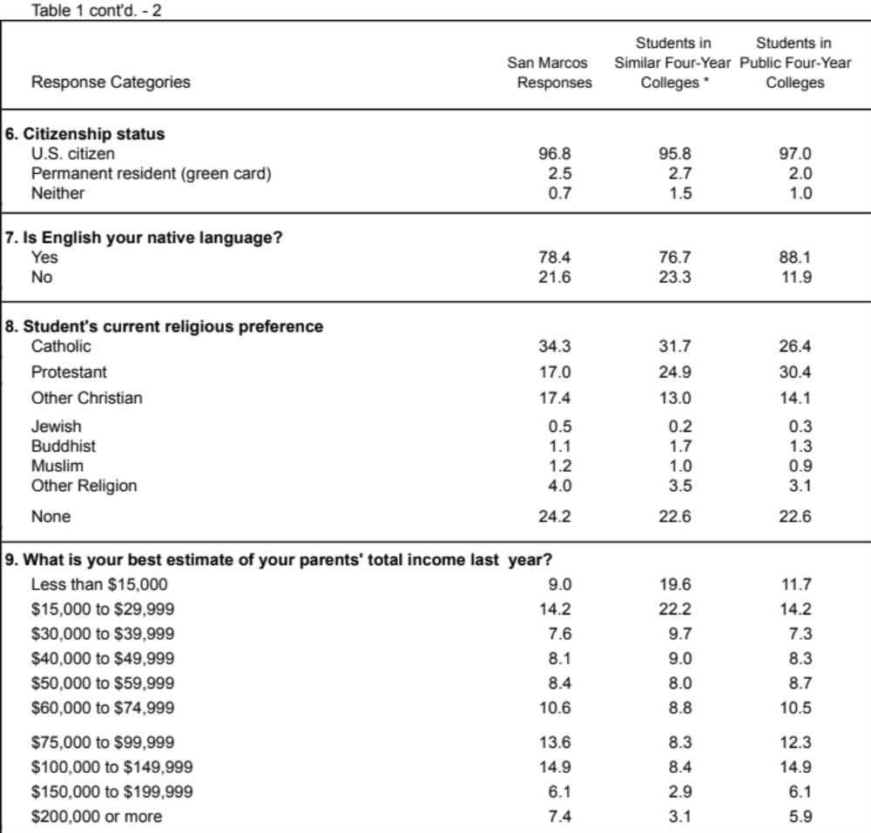

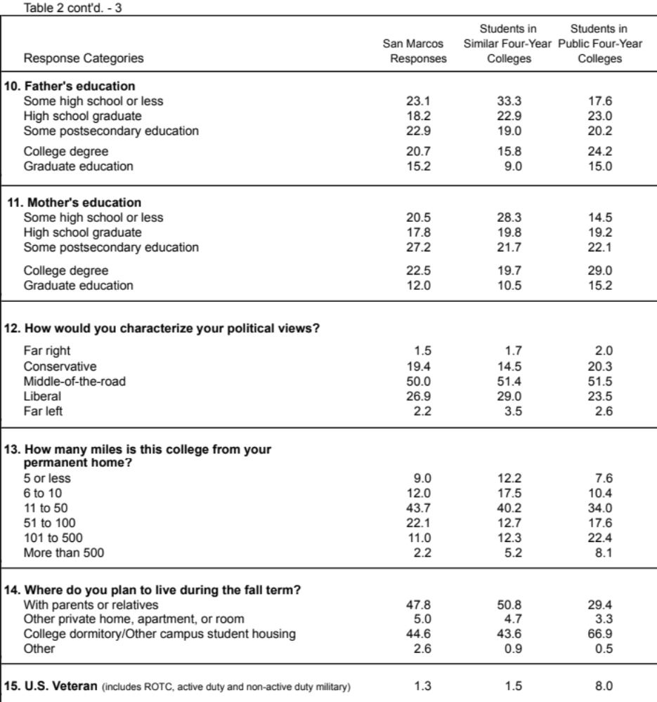

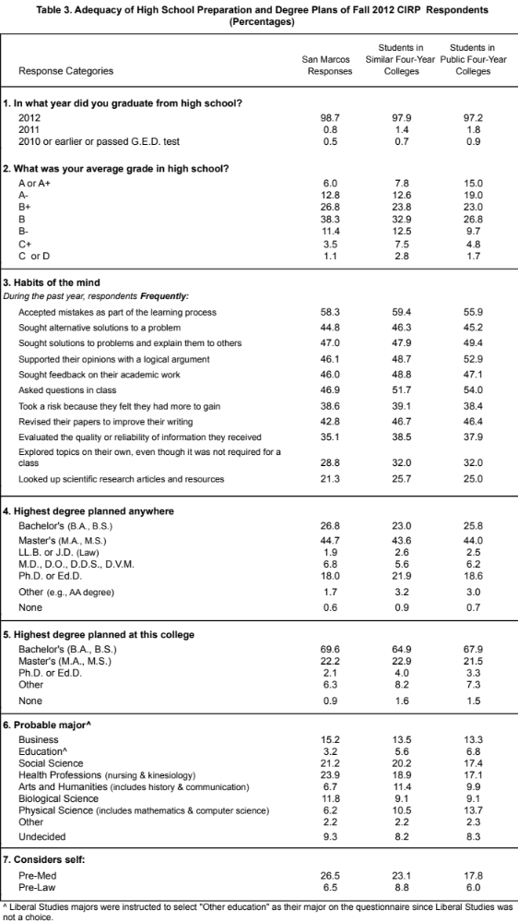
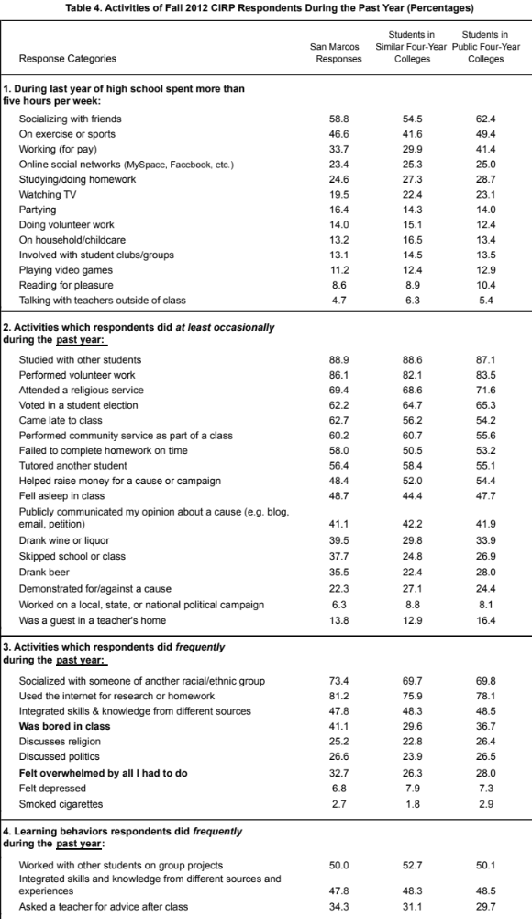
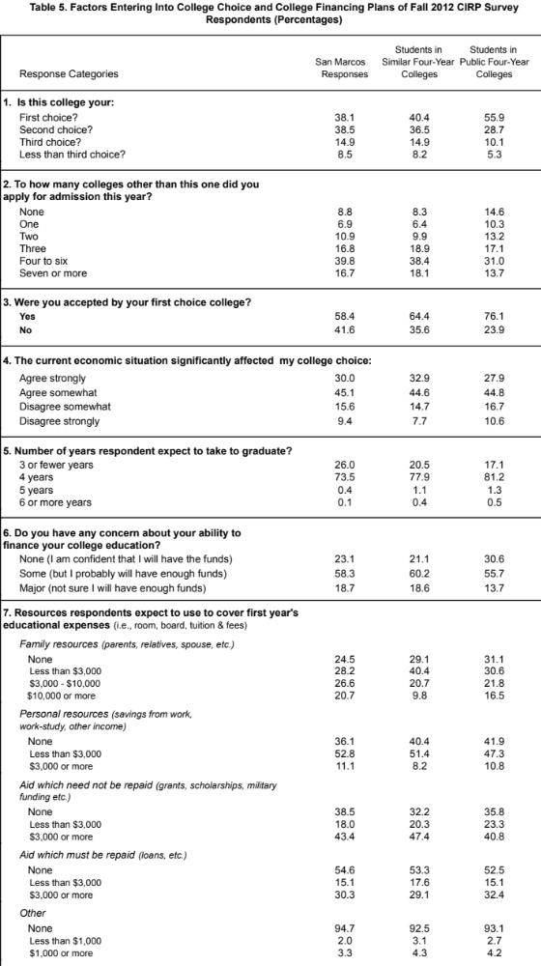

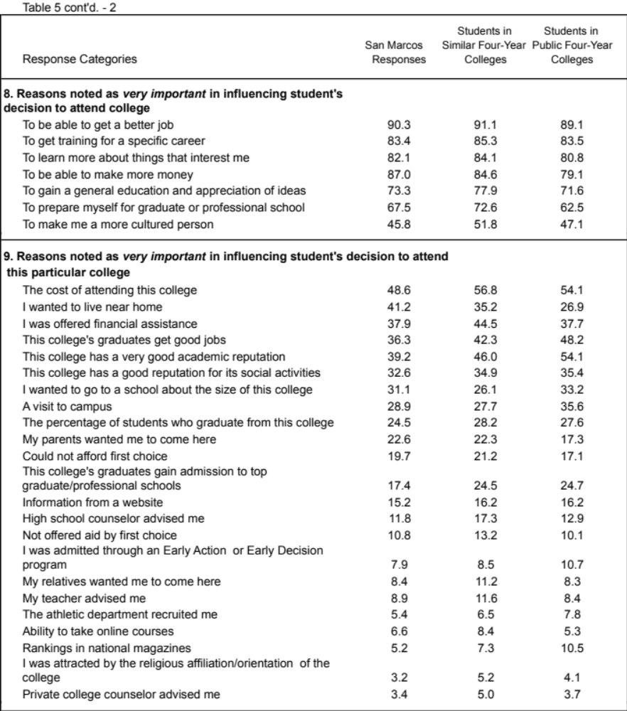

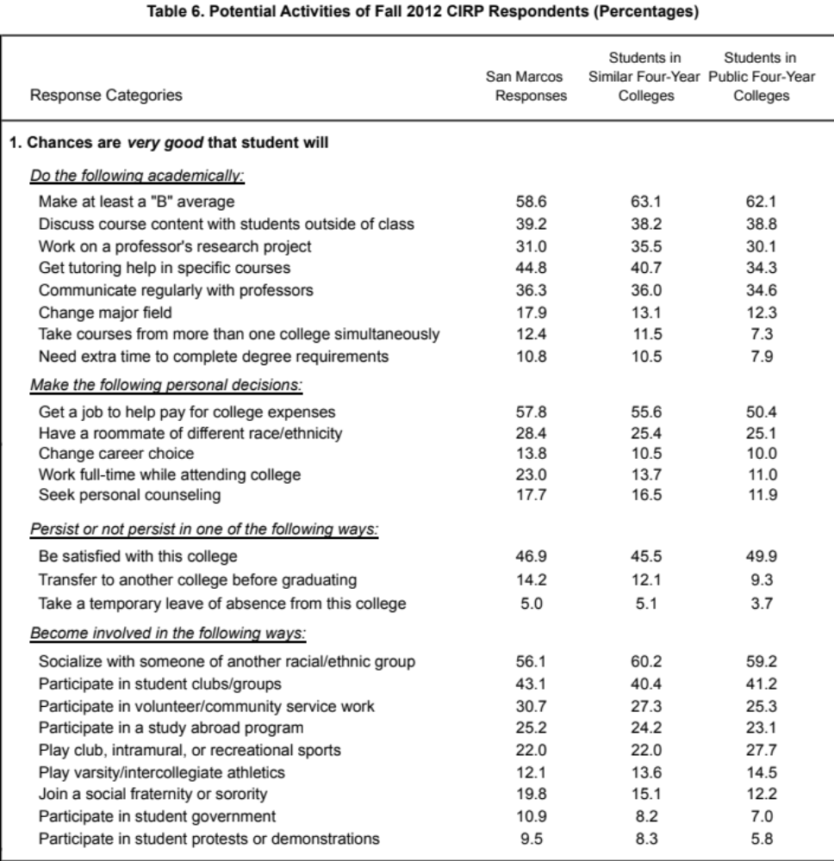

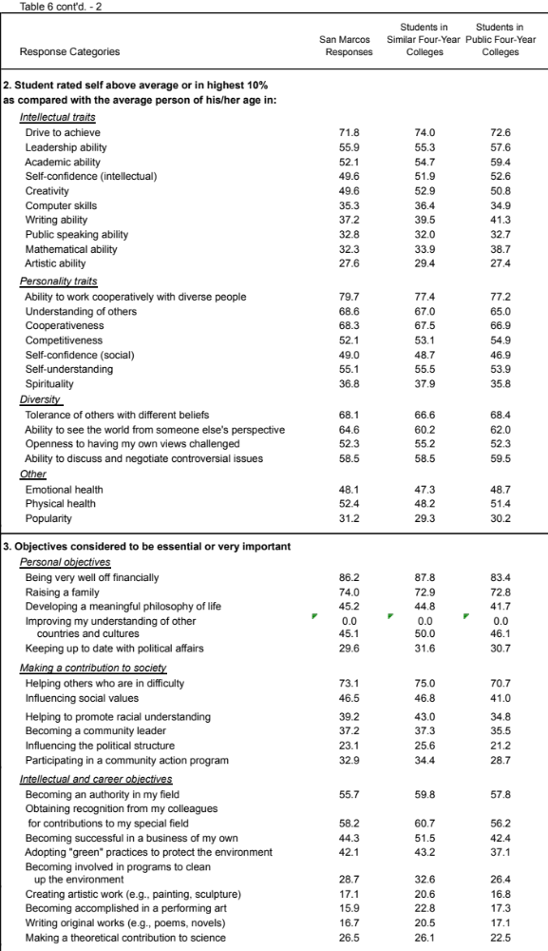

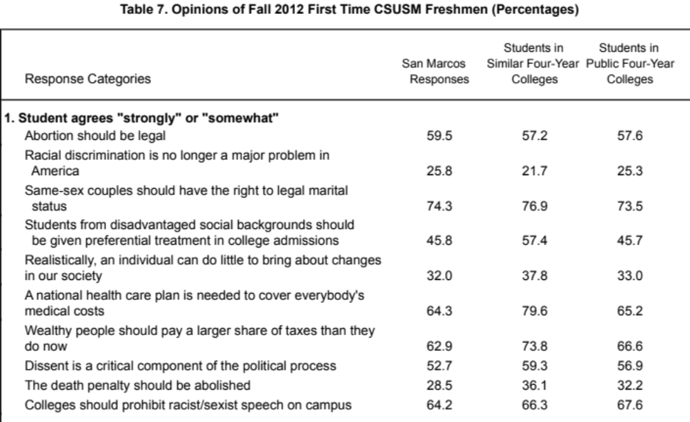

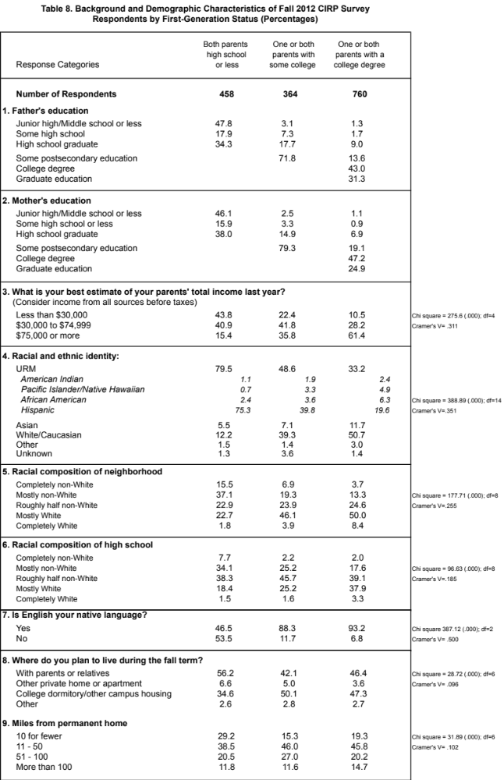

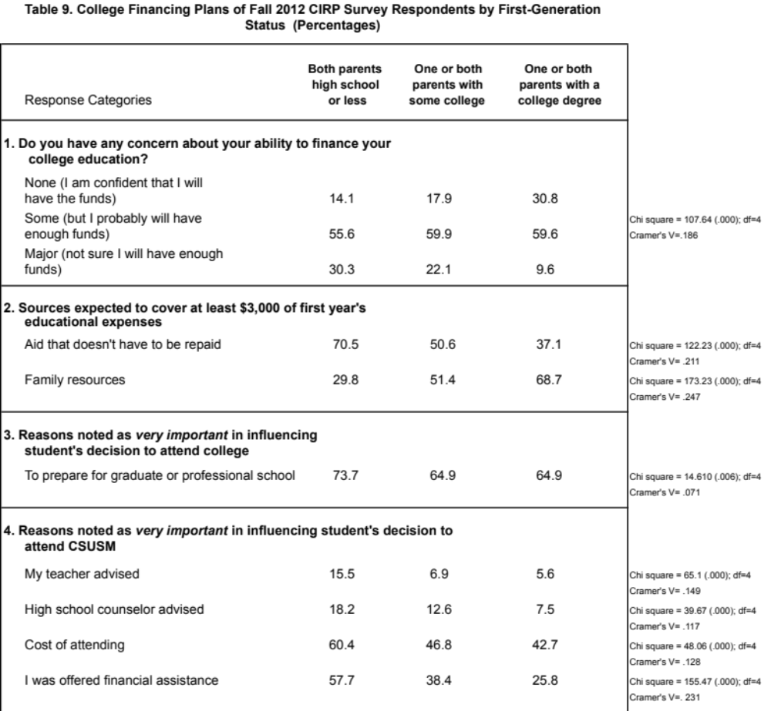

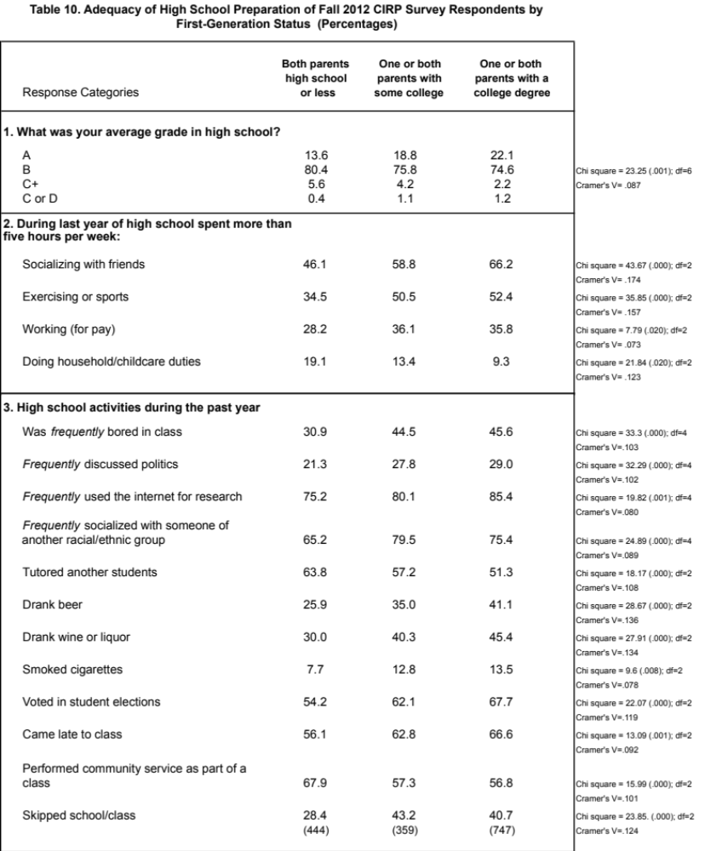

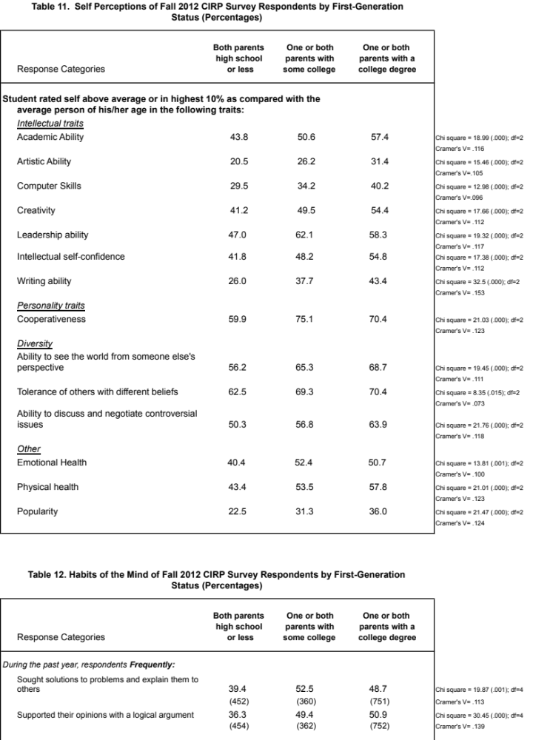

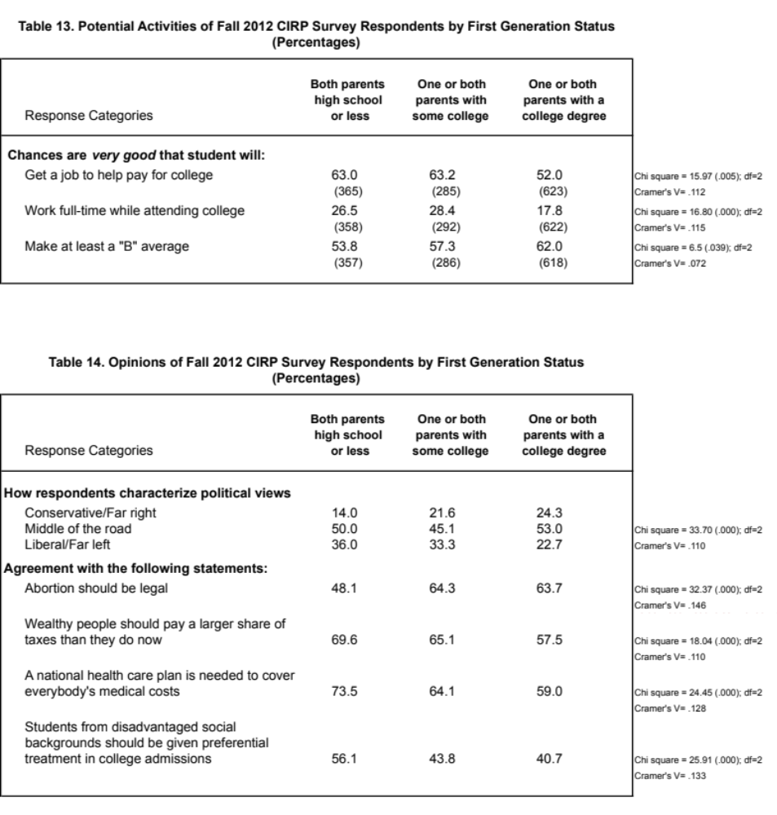

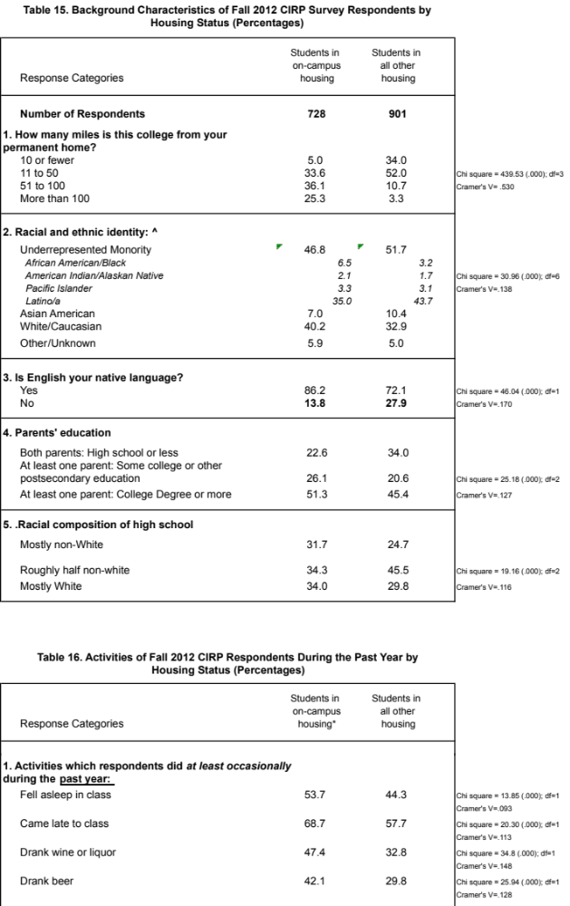

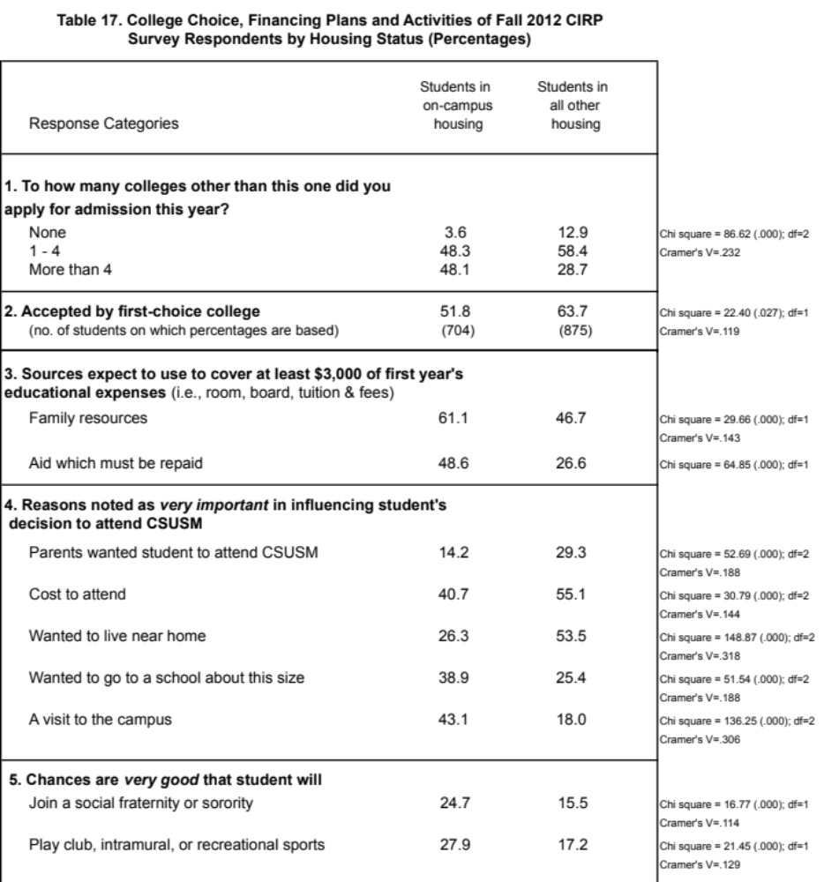

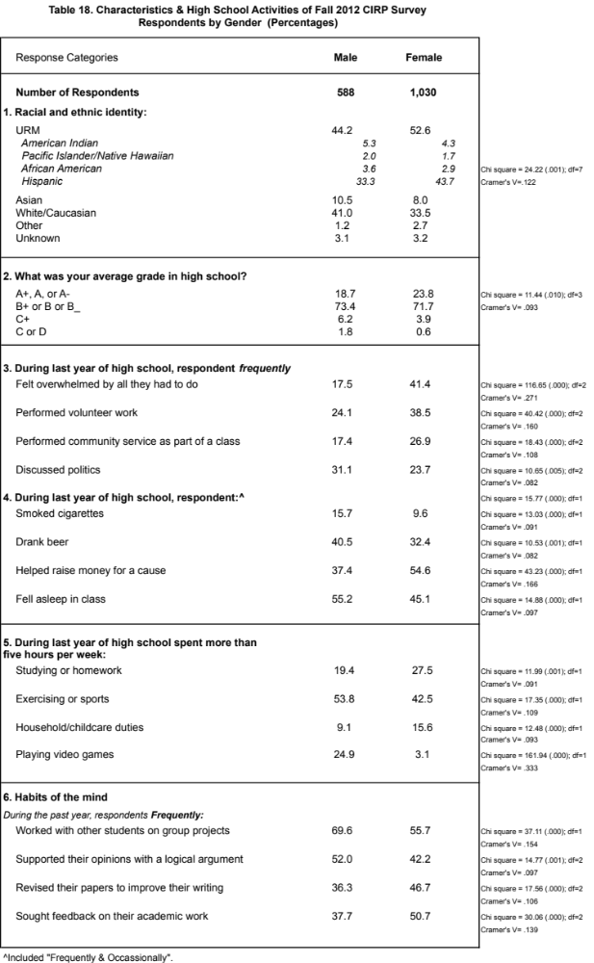

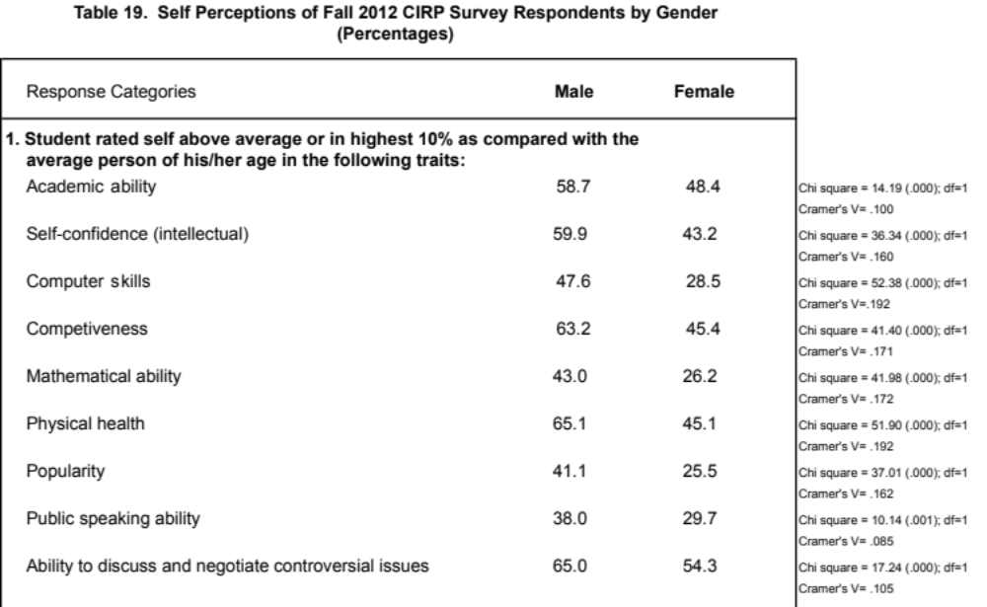

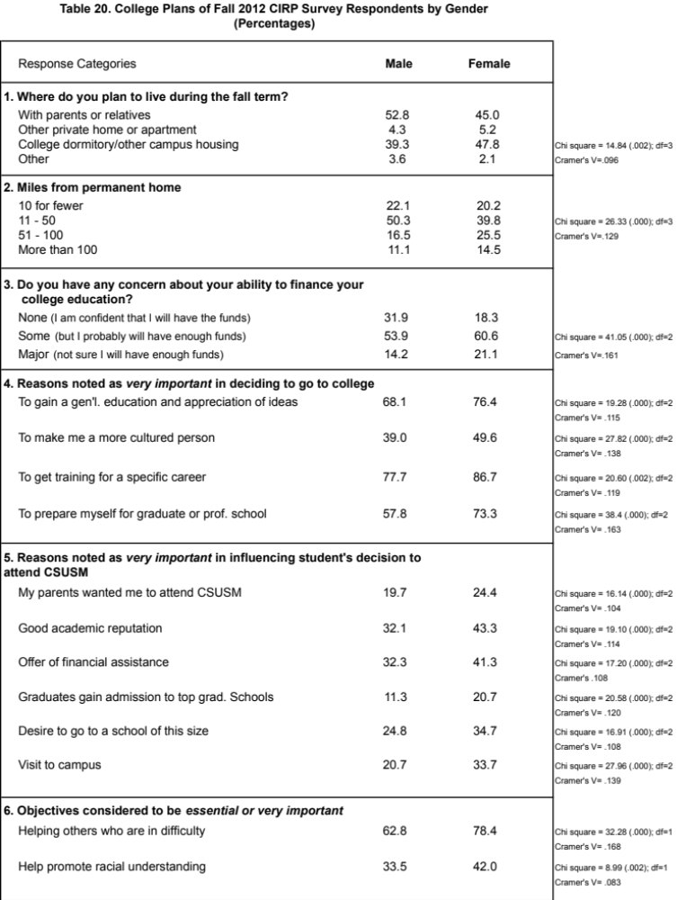

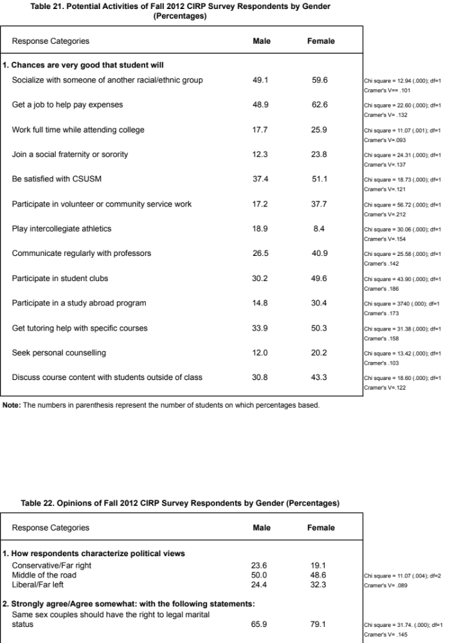

? Actual enrollment figures for Fall 2012 indicate that 1,783 new students enrolled as first time freshmen and respondents are representative of the 2012 incoming class
? Colleges similar to CSUSM are defined as those whose average SAT Composite Score (Verbal + Math) of entering class is less than 985 (as reported by the respondent).
? Such colleges are defined as institutions that offer an array of bachelor's degree programs and may offer post- baccalaureate programs, but few, if any, doctoral programs.
? Detailed results, including a summary of key differences, can be found in Appendix A, Tables 1 – 7.
? CIRP developed seven constructs that combine individual survey items into global measures. The College Reputation Orientation construct measures the degree to which students value academic reputation and future career potential as a reason for choosing this college.
? The percentage of CSUSM respondents who plan to work full-time while attending college has been increasing over the years (9% in 2004 to 23% in 2012).
? The Academic Self Concept construct measures the students’ beliefs about their abilities and confidence in academic environments; the Social Self Concept construct measures students’ beliefs about their abilities in social situations.
? Historically, the majority of our students who graduate take five or six years to do so.
Self-reported SAT scores: 510 verbal; 511 Math. Actual SAT scores: 456 verbal; 466 Math

