Requisition Training Manual Version 9.2

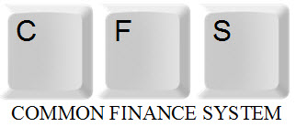

TABLE OF CONTENTS

Requisition Overview 3
Purchasing Processes 4
Components of a Requisition 5
Creating a Requisition 6
Requisition Entry 7
Header Info 9
Line 16
Requisition Schedule 20
Distribution 21
Approval and Budget Check 23
Deleting a Requisition 24
Canceling a Requisition 27
Requisition Inquiries 34
Requisitions 34
Document Status 35
Requisition Reports 36
Reconciling Requisitions 39
Appendix A - Inquiries Matrix 40
Appendix B - Reports Matrix 41
Appendix C - Category Codes 42

Requisition Overview

Requisitions are entered into the Peoplesoft Purchasing module as needed by departments. This is the only mechanism available for requesting goods and services. Procurement will run daily processes to identify all new requisitions. The buyer assigned will review and process the requisition accordingly.

Objectives:

In this training guide you will learn how to:
- Enter a requisition
- Approve a requisition
- Budget Check a requisition
- Delete a requisition
- Cancel a requisition
- Run Requisition Inquiries and Reports

Purchasing Processes

- Requisition
- End User creates a Requisition
  - General Information
  - Header Information
    - Requisition Defaults
    - Add Comments
    - Add Attachments
  - Line Information
  - Schedule Information
  - Distribution Information
- Approve, Budget Check
- If applicable email a copy of the quote to procurementservices@csusm.edu. Reference the Requisition # in the Subject line.

- Procurement Sourcing
- Validates Buyer
- Review Category Code and the Account Chartfield
- Validate/Assign Supplier
- Source Requisition

- Purchase Order
- Review, validates & changes data as required
- Budget Check - Creates Encumbrance / Reverses Pre-encumbrance
- Dispatch – email PO to Supplier & copy to requestor
- Reconciliation and Close

- Materials Management
- Receive shipments and enter into PeopleSoft

- Accounts Payable
- Enters Vouchers (Invoice) against Purchase Order
- Match for approvals
- Post Voucher – Creates Actuals / Reverses Encumbrance
- Pay Voucher

- Procurement
- Reconcile and Close the Requisition (remaining Pre Encumbrance balance)

Components of a Requisition

This manual explains how to enter each component of a requisition and how the components relate to each other.

In PeopleSoft requisitions consist of four components:

- Header - Defines the Business Unit, the Requestor, Date, and Status.
- Line - Contains the line item information. For each line item the quantity, category, UOM, description, Supplier, and price.
- Schedule - Defines when (due date) and where you want the line items delivered.
- Distribution - Where accounting information (i.e. the general ledger Chartfield string) is entered. The Chartfield string includes the account, fund, department ID, program, class and project.

Each component of a requisition has a one-to-many relationship, starting with the header information and ending with the distribution information. For example, every requisition has a header, but a header can have several lines. Each line can have several schedules and each schedule can have several lines of distribution information.

Creating a Requisition

This function is used to enter a requisition in the PeopleSoft Purchasing Module.

The Add/Update Requisition process consists of the following steps:

- Enter the Requisition
- Put the requisition on Hold
- Validate/enter requisition data
- Remove Hold
- Approve
- Budget Check the requisition
- If applicable email a copy of the quote to procurementservices@csusm.edu. Reference the Requisition # in the Subject line.

Requisition Entry

The following navigation is used to access the requisition page:
Purchasing > Requisitions > Add/Update Requisitions > Select Business Unit
Add – Requisitions dialog box displays.

The Business Unit for Cal State San Marcos Campus is always SMCMP. Accept default.

Accept the “NEXT” Requisition ID number assigned. This defaults the Requisition ID to the NEXT available number when the requisition is saved. Do not change this field.

Click Add

Business Units:

CSUSM – SMCMP
San Marcos University Corporation – SMCOR
UARSC – SMURS
ASI – SMASI
Foundation - SMFND

Requisitions
The following Page will display. The Requisitions page contains General Information, Header and Line information as well as other links.
General Information  Requisition Header Info  Requisition Line Info | 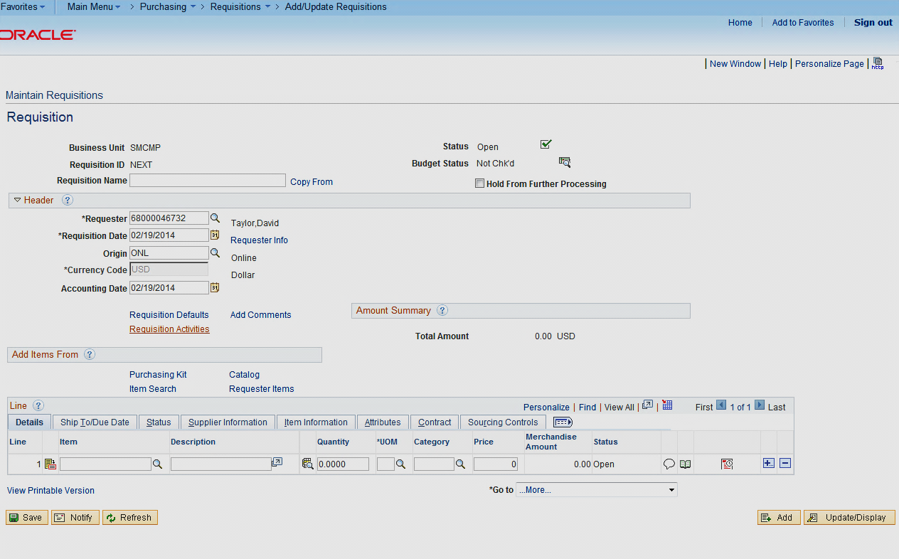

Requisition
Review/Update the following:  General Information  - Status Displays the requisition status. Defaults to Open.  - Budget Status Displays the requisition budget checking status. Defaults to Not Chk’d.  - Hold From Further Processing Check until you are ready to approve the Req.  Header Info  - Requestor Defaults to user id and can be changed.  - Req Date defaults to today’s date.  - Origin DO NOT CHANGE.  - Accounting Date DO NOT CHANGE.  - Requisition Defaults link– See the Requisition Defaults section.  - Add Comments link- See the Add Comments section. | 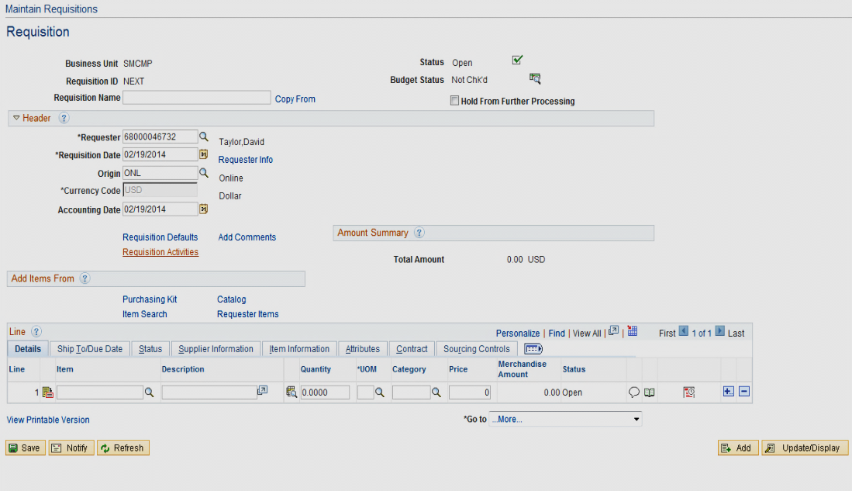

Requisition Defaults

Requisition Defaults is used for two primary reasons:
- If you have a specific Supplier you want to use, you identify it here.
- If the requisition contains multiple lines, and the lines contain either the same Due Date, Category Code, or Accounting Distribution.

It is recommended that you access this page prior to entering Line information. Once Lines/Schedules have been entered and this Page is accessed, you will be prompted as to whether you want to retrofit the changes in the already established Lines/Schedules.

From the Requisitions page click on Link.

The Requisition Defaults page displays.  The following fields can be added if the values are applicable for all lines on the Requisition. All fields have a to use to look up valid values.  Override Select this. All default values entered on this page override the default values found in the default hierarchy.  Buyer Leave blank. Do not select.  Supplier If you have a recommended Supplier enter it here. (See the Supplier Search section for how to search for a Supplier) If the Supplier does not exist in PS, use the Header Comments Link to specify the Supplier Name and information.  Category Category of Good or Service you are requesting. See Appendix C for a complete list.  Unit of Measure The Unit of Measure.  Due Date For Goods this is the date when you need or expect the goods to be received by. For a Service this is the last day of the contract.  Distribution How you want the Good or Service charged (ChartField String). Do not use the Account, as it will default in based on the Category that has been selected. Also, leave the DeptID blank if the Req is to be charged to the requestors default department. Otherwise specify. | 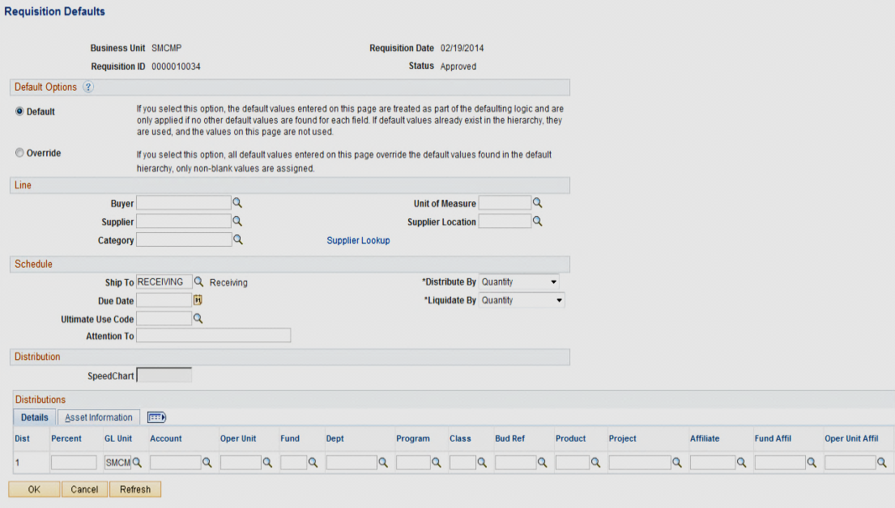  DO NOT USE ANY OF THE OTHER FIELDS.

Supplier Search

There are two ways to search for a Supplier. The first way is from the Requisition Defaults Link. Use the drop-down list next to the Supplier field .

Supplier drop-down list to search for a Supplier

Select the Supplier drop down list next to the Supplier field.  The following screen displays.  Fill in the first few letters of the Supplier in the short Supplier name (Not Case Sensitive and no spaces).  Click Look Up. If the Supplier you are looking for appears, select it. If it does not, click Cancel. | 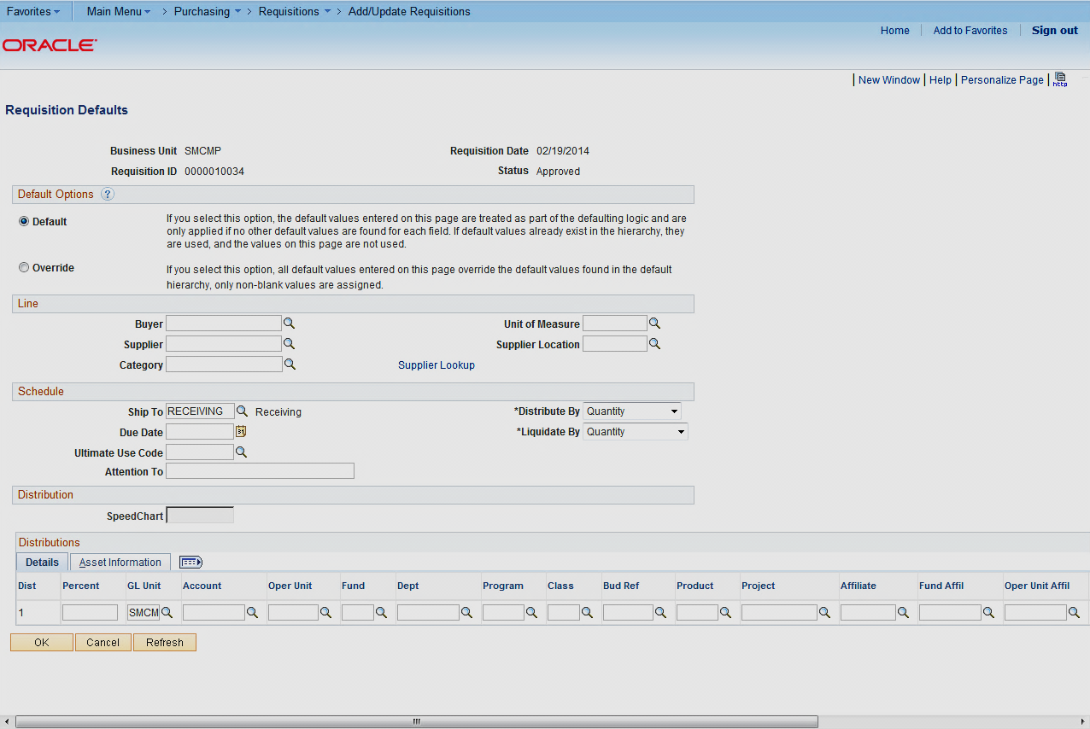

The second way is from the Review Supplier Page. This page provides a wide variety of search fields for locating Suppliers and enables you to view a Supplier's address.

Review Supplier Page to search for a Supplier
The following navigation is used to get to the Review Suppliers page:
Suppliers > Supplier Information > Add/Update > Review Suppliers

The following screen displays.  Fill in the first few letters of the Supplier name you are searching for. Or you can fill in any of the other fields if you know the information.  Note: Make sure to select Contains.  Click to get all Suppliers meeting your criteria.  Make note of the Supplier ID to use on the Requisition. | 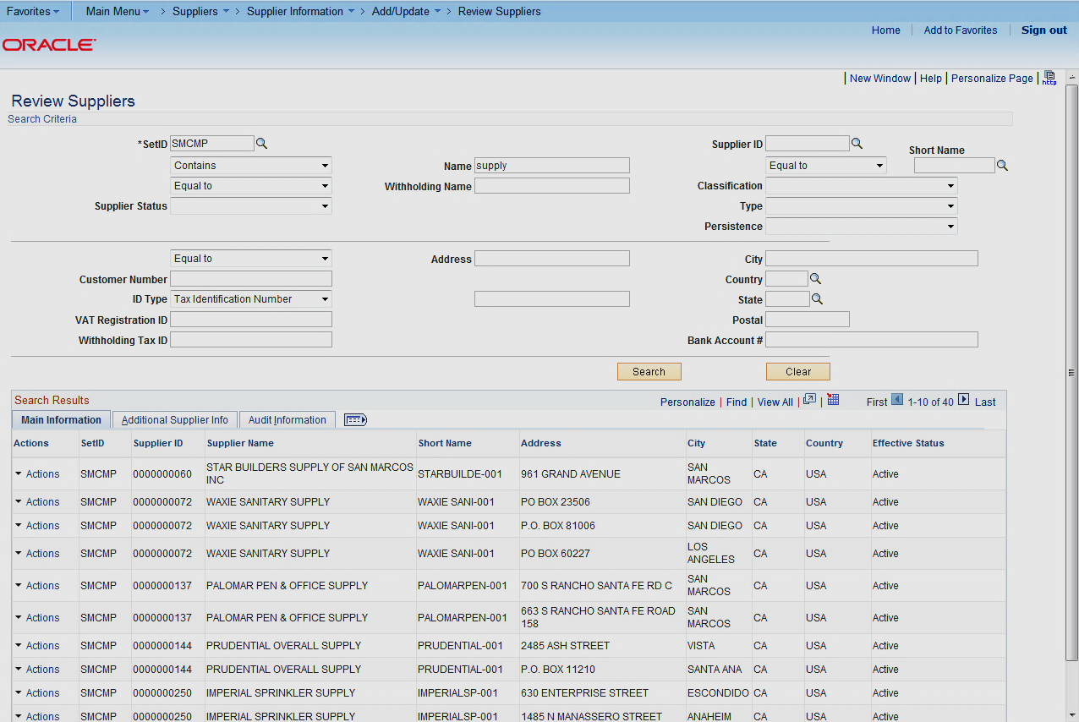

Add Comments

This is where comments or information pertaining to the requisition is entered. These comments are used for the following reasons:
- Specify where the Materials Management/Receiving Department needs to deliver the goods.
- Special instructions you wish to send to the buyer and/or receipt of goods.
- If a Supplier was not entered on the Header Defaults page you can enter it here. Include the Supplier name, address, email address, phone number, fax number, Supplier contact person and their extension.

Click on Link.

Add your Comments. Your first comment should be the instructions to the Materials Management department on where you want the goods delivered to. Make sure to check .  If you have other comments insert a row by selecting the . Notice you will now have multiple comments.  Click OK to return to the Requisition page. | 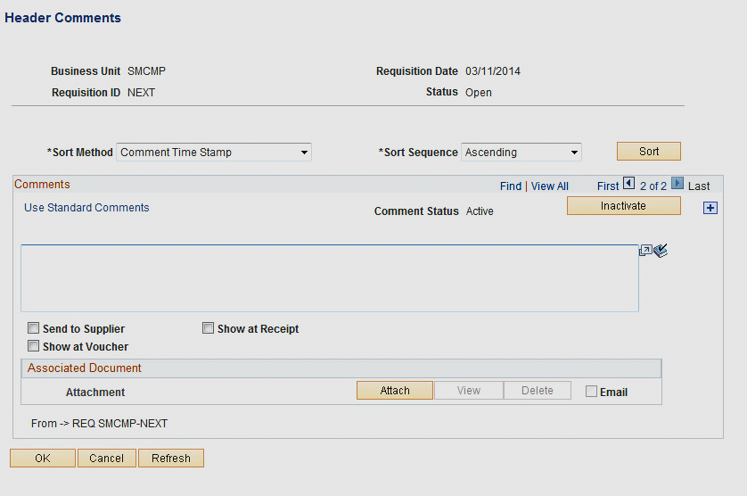
When applicable Header Comments should include the following:

- Contact information for the Requestor
- Contact information for the supplier
- Pertinent information for the buyer
- Attachment with Requisition Backup Documents
- Specifications/Quote/Proposal

Line  - Description Enter the description of the Good or Service you are requesting.  - Req Qty  - UOM  - Category Classification of Goods/Services. (Determines the account number in your chartfield string as well as the buyer assigned to the goods/service requested.) See Appendix C  - Price (per unit)  - Due Date The date you would like the goods/services to be completed. If this is an extended service time request, enter the date you expect the service to expire by.  - Ship To Location DO NOT CHANCE. Can be overwritten if not correct. | 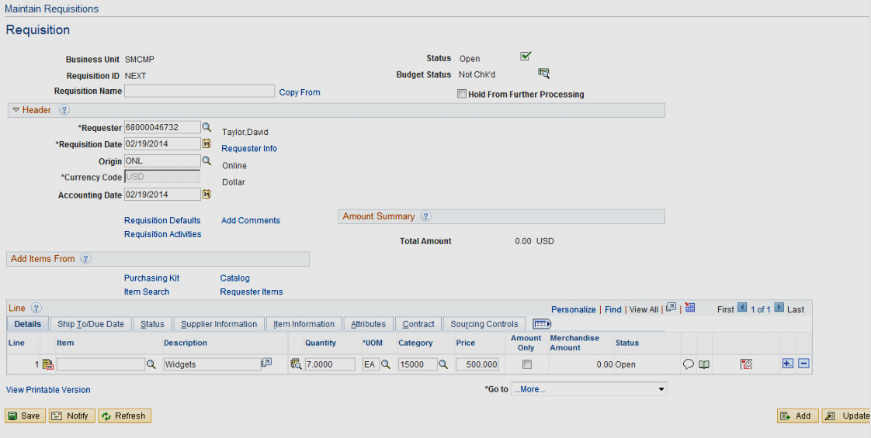  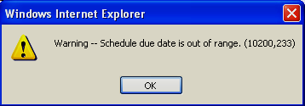  If the due date you entered is greater than 30 days from the Requisition Date, you will receive a warning message. Once validated, click OK.

Note: If you specified either the UOM, Category, or Due Date on the Requisition Defaults page, you will not need to enter these fields. They will default in.
Additional Notes:

Commodities/Goods Req Qty = 1 Service Agreements Req Qty = 1
UOM = EA UOM = Lot
Price = $$$.$$ Price = $$$.$$

Sales Tax and Freight

For Requisitions, DO NOT ADD Sales Tax. Sales Tax will be added to the Purchase Order. If there is Freight, add it as a separate line. The Category Code for freight should be the same as the item that has the additional Freight Charge.

Category Code will assign a Buyer automatically. Do not change the Buyer.
Additional Features

Details for Line

Note: If the Line description is longer than what is displayed, you can see the complete description by selecting the Details for Line button . Also, when typing the description, it will automatically wrap, no carriage return required.  The Details for Line displays additional information. You can also see the entire description.  Click OK to return to the Requisition page. | 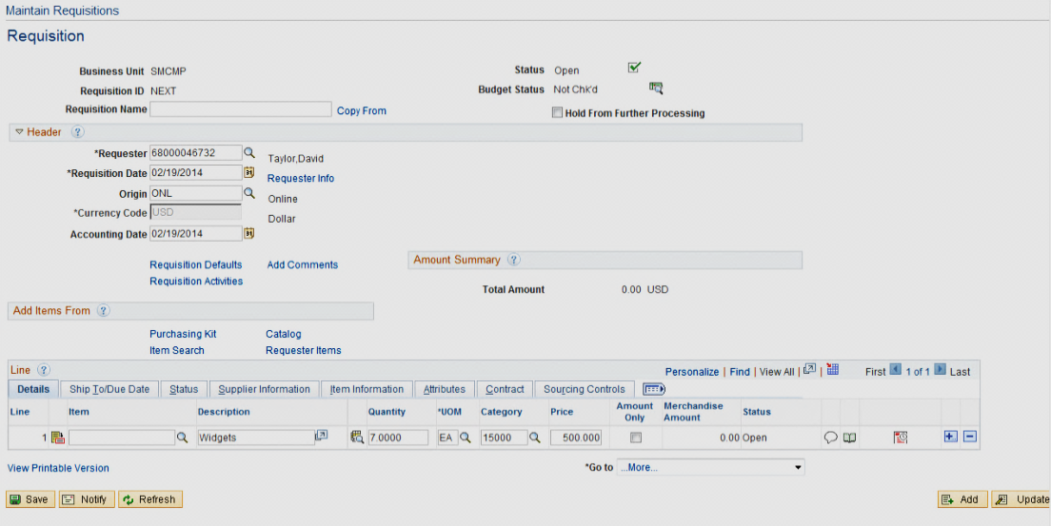  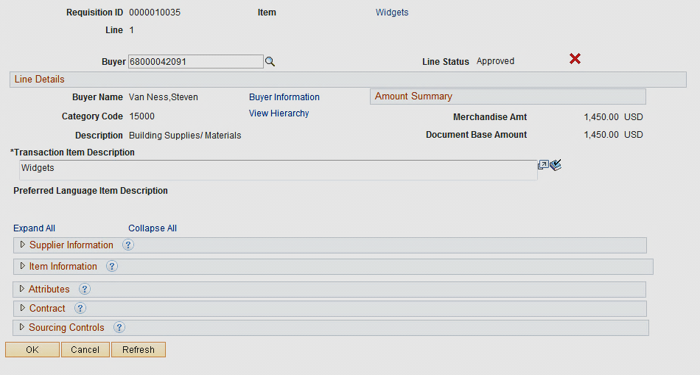

NOTE: The Line Description should include the following (if applicable):
- Part/Item/Product Number
- Part/Item/Product Name

For Example:
Part Number: XCO Monitor

Adding/Deleting Req Lines

To add or delete a Req Line, hit the at the end of the last line.  For Adds – After you hit the , in the upper left hand corner you will be prompted for the number of rows to add. Enter the number and hit OK. | 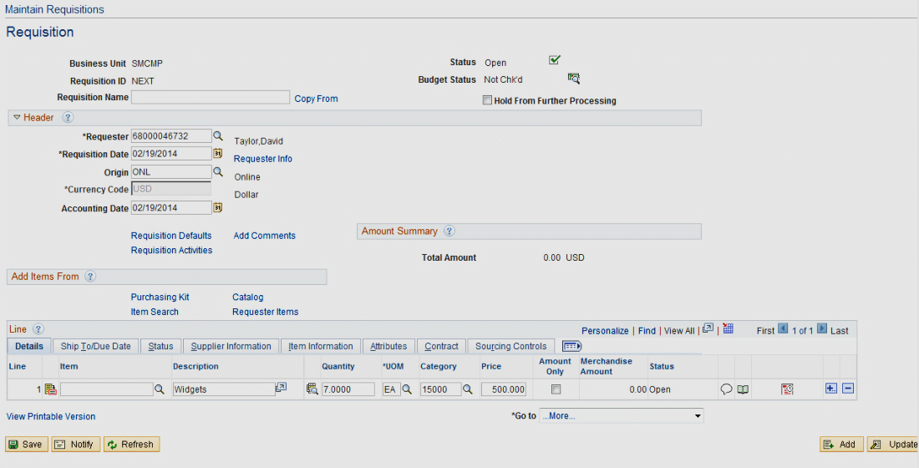

Requisition Schedule

The Requisition Schedule Page contains the Schedule and Distribution information of the Requisition.

Schedule

Select the Schedule link to access the Schedule page.  The Ship To, Quantity, Price, and Due Date have all defaulted from the Maintain Requisition page.  Click the Distribution link to specify where the goods or services should be charged to (Chartfield String). | 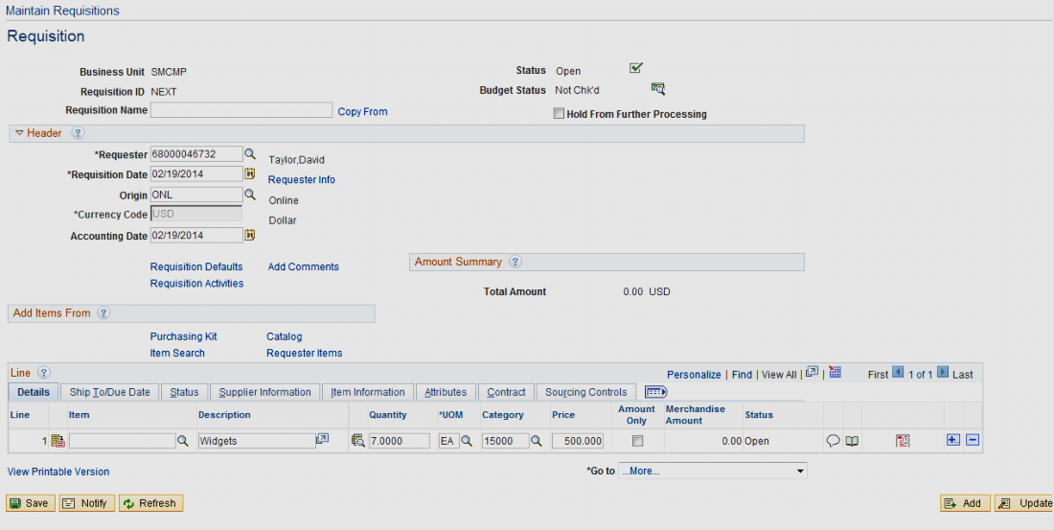

Distribution

Enter the following:
Account DO NOT CHANGE Defaults from Category entered on either the Defaults or Requisition page.

Fund Required

DeptID Defaults based on the Requestor

Program Optional

Class Optional

Proj/Grt Optional

Click OK to return to the Schedule page.

Note: If you specified the Chartfields on the Requisition Defaults page, you will not need to enter these fields. They will default in.
Splitting the Distribution

The distribution can be split by line/schedule among two or more departments and/or Chartfield strings. Distribution can be split by quantity or amount.

From the Schedule page (see above) click the link to go to the Line 1 Schedule 1 Distribution page. Reduce the quantity and click the to insert another distribution line.  The remaining quantity is automatically copied down.  Change the distribution accordingly.  To split a distribution by dollar amount use the drop down to change the Distribute by from Qty to Amt and enter the dollar amounts.  For Adds – After you hit the , in the upper left hand corner you will be prompted for the number of rows to add. Enter the number and hit OK.  Click OK to return to the Schedule page. | 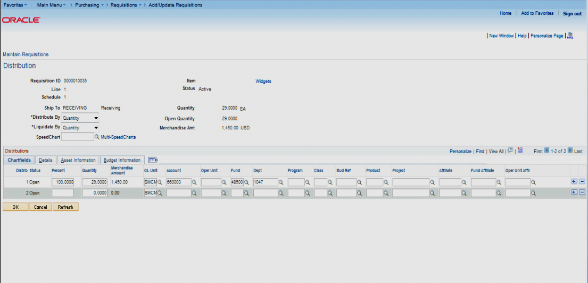

Approval and Budget Check

From the Requisitions page  If you put the requisition on Hold, Remove the Hold From Further Processing by unchecking it.  Next you want to Approve and Budget Check the Requisition.  Select the Approval Icon. After the Req is approved the Status will change from Open to Approved.  Select the Budget Check Icon. Once the Req is budget checked the Budget Status changes from Not Chk’d to Valid.  Icon. Once Req has been saved, the Cancel button is available. | 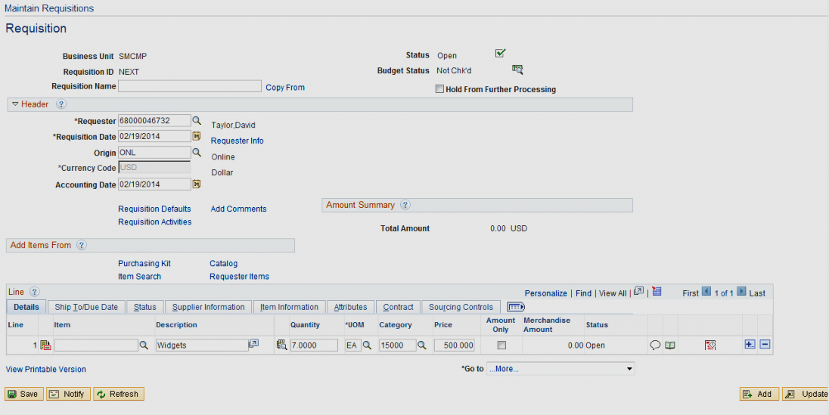  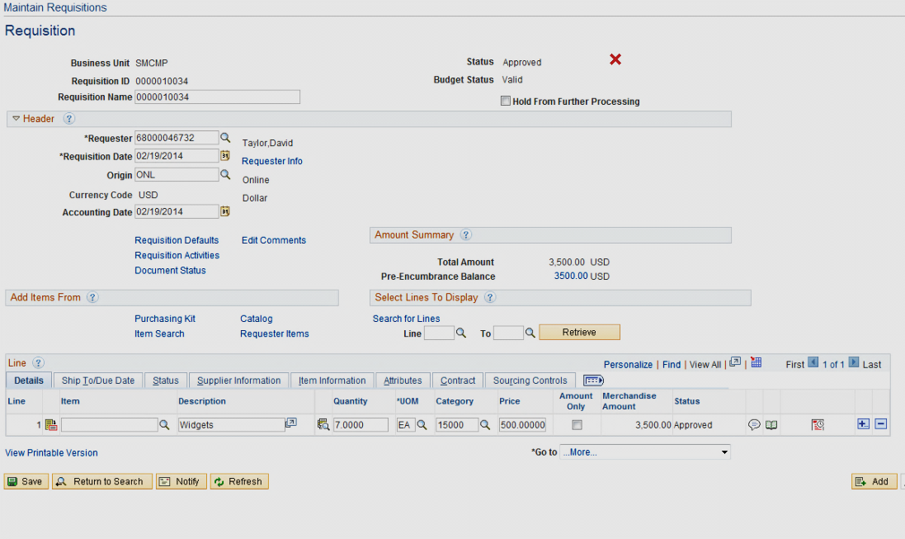

Note: Approved requisitions can be modified by the Purchasing Department only. To request a change to an approved requisition, send an email to procurementservices@csusm.edu referencing the requisition number in the Subject Line. Changes will be made to either the requisition or purchase order, depending on where the requisition is in the purchasing cycle. Online Requisition Change Orders is not implemented at this time.

Requisition Changes

Deleting a Requisition
You can delete a requisition line, schedule, or distribution by selecting the Delete Row button on the respective requisition page.

You can delete an entire requisition by clicking the Requisition Delete icon on the requisition Requisitions page. To delete an entire requisition, the requisition must meet the following criteria:

- The requisition is not on hold

- The requisition has never been successfully budget checked

- You are authorized to delete entire requisitions

- No requisition lines have been sourced to a purchase order

- No requisition schedules are staged

The following navigation is used to Delete requisition information:
Purchasing > Requisitions > Add/Update Requisitions

Deleting the Entire Requisition

The first step is to call up the Requisition you want to Delete.  Select the Find an Existing Value Tab. Enter in the Requisition Number or the Requestor. Click on Search.  If the Requisition is available to be deleted the will be available to select.  Note: If you just created the Requisition and have not navigated from the page, you must exit and then return to access the icon on the requisition.  You will receive a warning message. Select Yes if you are sure you want to Delete the Req. | 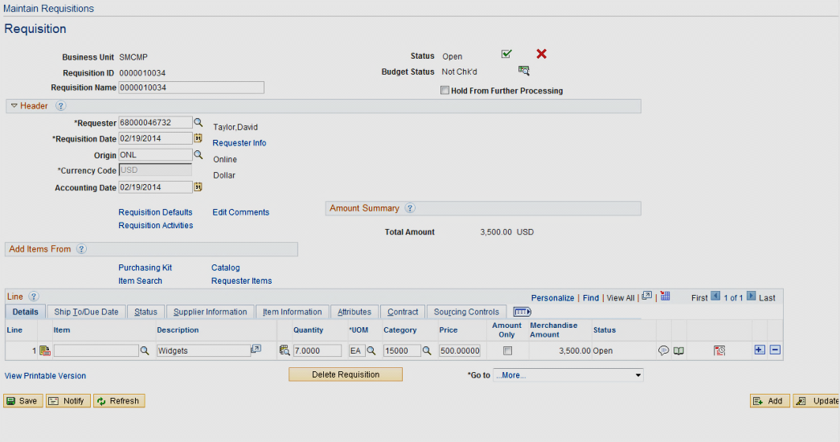

Once the Requisition is Deleted you can no longer view it.
Deleting the Requisition Line, Schedule, or Distribution

To delete a Requisition Line, Schedule, or Distribution, select the appropriate section and then the next to the row you want to delete. | 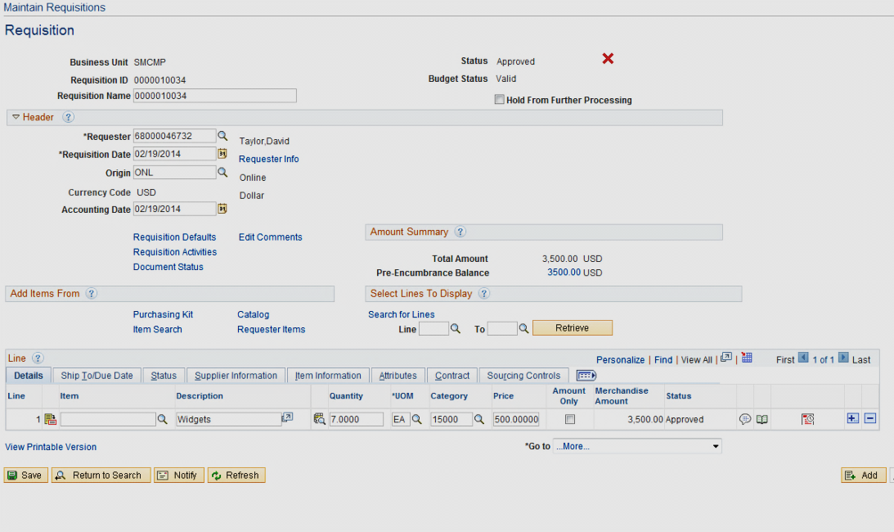

Canceling a Requisition

You can cancel a requisition line, schedule, or distribution by selecting the Cancel icon on the respective requisition page.

You can cancel an entire requisition by clicking the Requisition Cancel icon (Red X) on the requisition header page. To cancel an entire requisition, the requisition must meet the following criteria:

- The requisition is not on Hold

- You are authorized to cancel requisitions

- No requisition lines have been sourced to a purchase order

The following navigation is used to Cancel requisition information:
Purchasing > Requisitions > Add/Update Requisitions

Canceling the Entire Requisition

The first step is call up the Requisition you want to cancel.

Select the Find an Existing Value Tab. Enter in the Requisition Number or the Requestor.

If the Requisition is available to be canceled the will be available to select.  You will receive a warning message. Select Yes if you are sure you want to Cancel the Req.  Once the Requisition is successfully canceled you will receive this message. You will need to select the Budget Check button as this will eliminate the Requisition amount from your budget. | 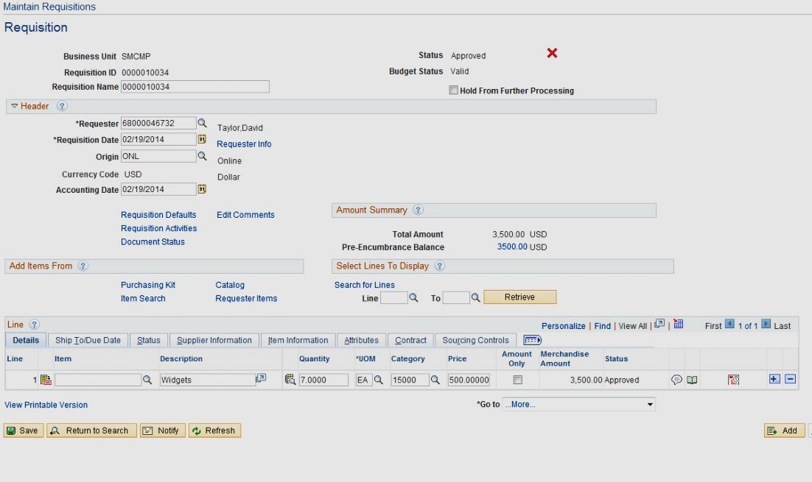  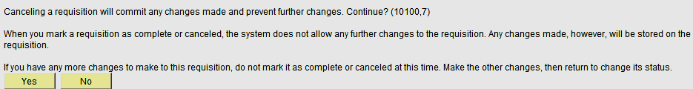  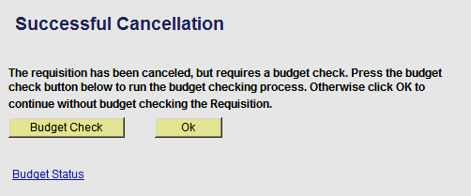
Once the Requisition is Canceled you can no longer review it through this path. You can see it using the Review Requisition Information menus.

Canceling the Requisition Line

To cancel a Requisition Line, select the Details for Line Link.  If the Requisition Line is available to be canceled the will be available to select.  You will receive a warning message. Select Yes if you are sure you want to Cancel the Req Line. | 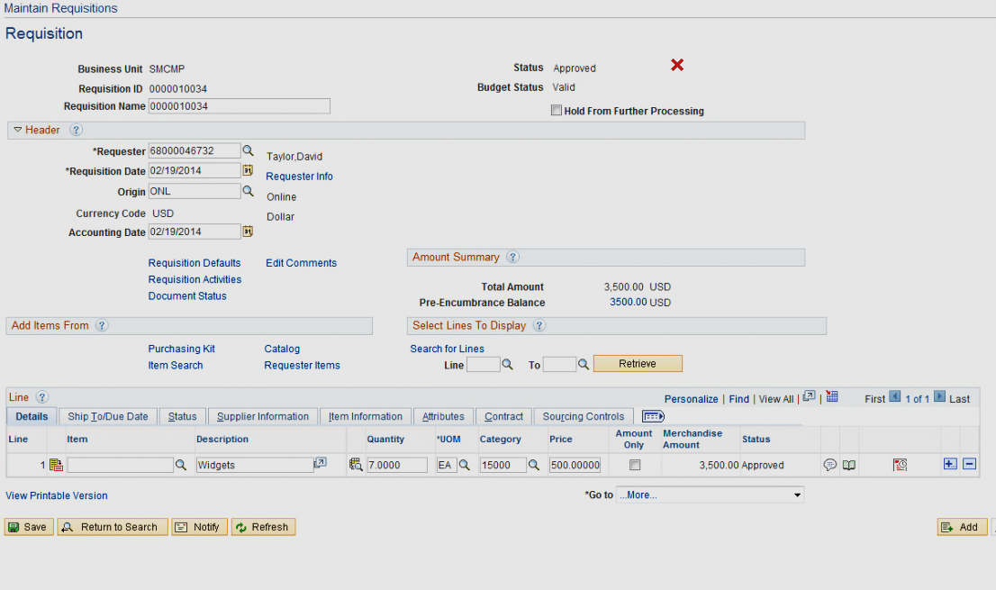  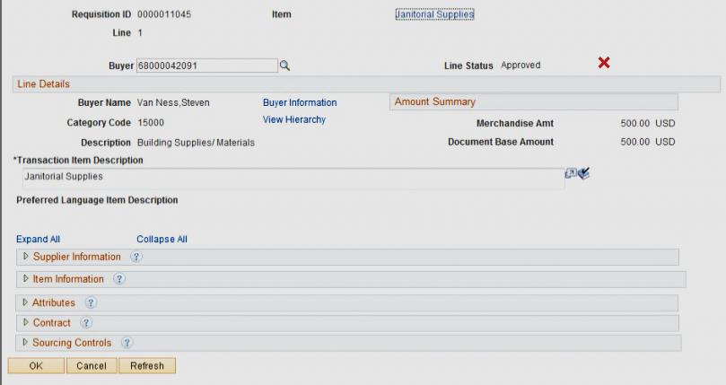  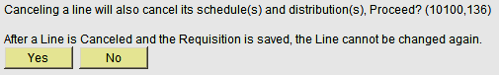

Once the Line has been canceled the Status will change to Canceled. | 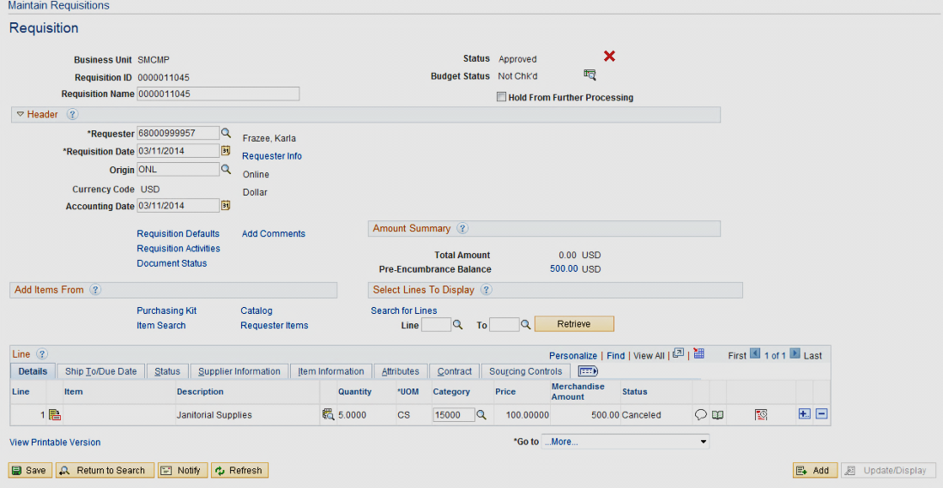
Canceling the Requisition Schedule
If the Requisition Schedule is available to be canceled the will be available to select.  You will receive a warning message. Select Yes if you are sure you want to Cancel the Req Schedule.  Once the Schedule has been canceled the Status will change to Canceled. | 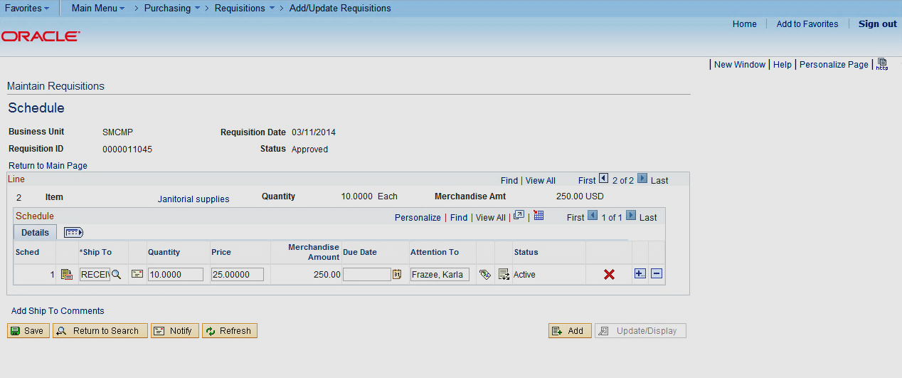  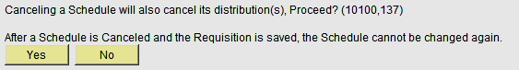

Canceling the Requisition Distribution
If the Requisition Distribution is available to be canceled the will be available to select.  You will receive a warning message. Select Yes if you are sure you want to Cancel the Req Distribution.  Once the Distribution Line has been canceled the Status will change to Canceled. | 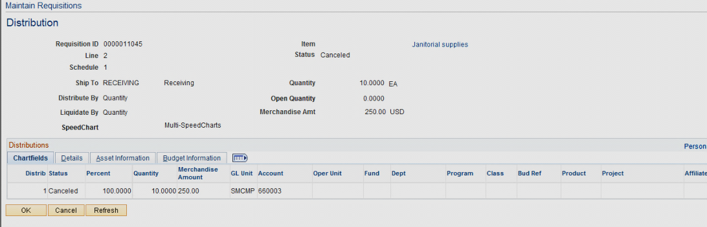

Requisition Inquiries

Requisitions
This inquiry is useful in helping you find your Requisition number. Some examples of how you might use this are: You can search by your name (requestor) or all Requisitions associated to a specific Department.

The following navigation is used to Review requisition information:
Purchasing > Requisitions > Review Requisition Information
This inquiry gives you line-by-line information for your requisitions, as well as access pages that contain more details about the selected requisition.

Enter criteria for selecting requisitions to view on the Requisitions Inquiry page.

Requisitions meeting the criteria will be displayed. Select the Requisition you wish to view. You will be able to drill down to the Line, Schedule and Distribution details.

Document Status
This is the most commonly used inquiry to find out whether a Requisition has been sourced into a Purchase Order, has been Vouchered, or has been Paid.

The following navigation is used for Document Status:
Purchasing > Requisitions > Review Requisitions >Document Status
This inquiry gives you an inquiry of all associated documents - the Purchase Order, Voucher, Payment, and Receipt of goods.

Enter criteria for selecting requisitions to view on the Document Status page.

Requisition Reports

Print Requisitions
If you want to print a hard copy of your requisition, you would use this.

The following navigation is used to print requisition information:
San Marcos Reports/Interfaces > Purchasing > Reports > Print Requisition
Business Unit is SMCMP

Select the Requisition ID you wish to print.

Click Run.

Server Name is PSUNX.

Select SMOPO006.

Click OK.

See the “Finance Inquiry & Reports Training Manual Ver. 9.0” for a detailed explanation on Run Controls and Process Scheduler Request instructions (How to run the report).

Requisition Form
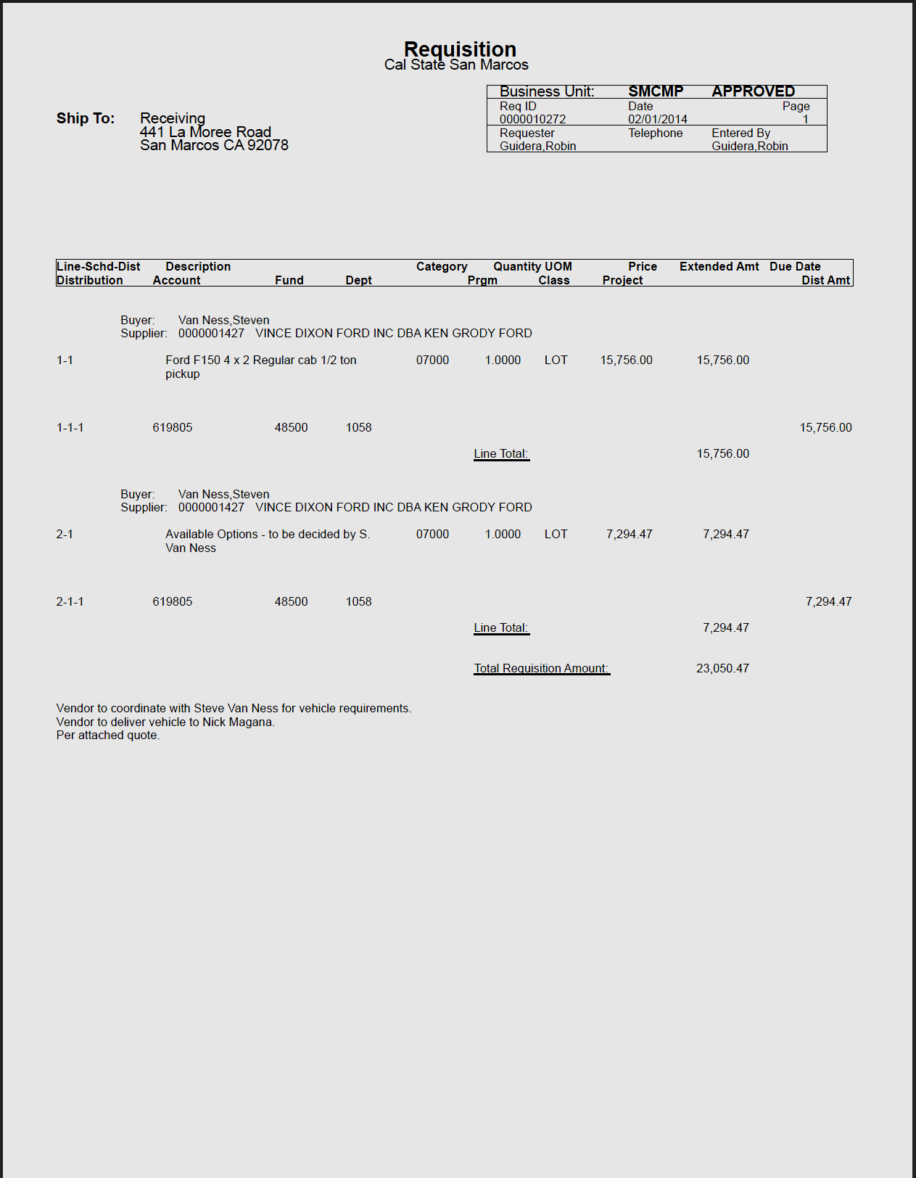

Open Requisitions by Department
This report lists all Open Requisitions by Department/Fund. It displays the Requisition Balance and associated Purchase Orders (if applicable).

The following navigation is used to print open requisitions by department information:
San Marcos Reports/Interfaces > Purchasing > Reports > Open Requisitions
Select by:  Business Unit  Fiscal Year (thru) Period (thru)  From/To Req  Department  From/To Fund  From/To Account  From/To Class  From/To Project  From/To Program | 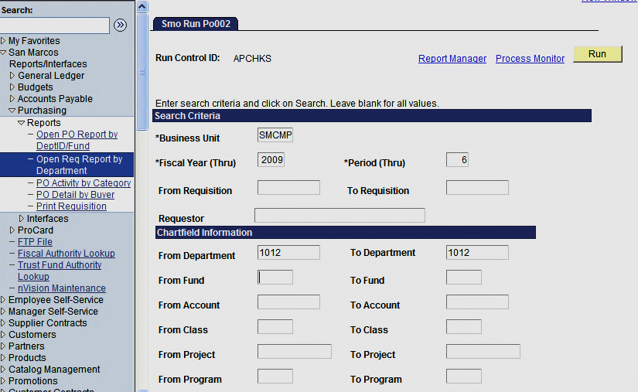

Delivery Date to be announced

Reconciling Requisitions

The Procurement department will automatically cancel all Requisitions that are 90 days old and have a balance remaining. This will result in the Requisitions Pre Encumbrance balance reducing to $0.00.

Appendix A - Inquiries Matrix

INQUIRY NAME | USE | NAVIGATION
Requisitions | View line-by-line information for your requisitions, as well as access pages that contain more details about the selected requisition. | Purchasing > Requisitions > Review Requisition Information > Requisitions
Req Accounting Entries | Shows the accounting distribution by line and schedule. This information shows after a req has been Budget Checked. | Purchasing > Requisitions > Review Requisition Information > Req Accounting Entries
Req Document Status Inquiry | Shows details of receivers, purchase orders, payments, and vouchers posted against a req. | Purchasing > Requisitions > Review Requisition Information > Req Document Status Inquiry
Purchase Order | Shows details of each page of a PO (lines, schedule, distribution, header and comments). | Purchasing > Purchase Orders > Review PO Information > Purchase Orders
Activity Summary | Lists all receipts and invoices on a PO as well as the quantity and amount that have been matched. | Purchasing > Purchase Orders > Review PO Information > Activity Summary
PO Accounting Entries | Shows the accounting distribution by line and schedule. This information shows after a PO has been Budget Checked. | Purchasing > Purchase Orders > Review PO Information > PO Accounting Entries
Document Status | Shows details of requisitions, receivers, vouchers and payments posted against a PO. | Purchasing > Purchase Orders > Review PO Information > Document Status
Supplier Review | Searches for a Supplier by name. Includes Supplier ID and order and remit to addresses. | Suppliers > Supplier Information > Add/Update > Review Suppliers

Appendix B - Reports Matrix

REPORT NAME | USE | NAVIGATION
Print Requisition  SMOPO006 | Print a hard copy of the Requisition. | San Marcos Reports/Interfaces > Purchasing > Reports > Print Requisitions
Open Requisitions by Department  SMOPO002 | Lists all open requisitions by department ID. Can be further defined by fund, account, class, program and/or project/grant. Includes the requisition amount, liquidated amount, PO amount and remaining amount. | San Marcos Reports/Interfaces > Purchasing > Reports > Open Requisitions by Department
CSU PO Detail Activity Report  CSUPO051  CSUPO052 | Lists purchase order activity for the PO business unit, department, and dates you select. Reviewing this report enables you to perform comparisons and resolve discrepancies proactively. | Purchasing > Purchase Orders > Reports > CSU PO Detail Activity Report
Open PO Report by Department  COOPO005 | Lists all open purchase orders by department ID. Can be further defined by fund, account, class, program and/or project/grant. Includes the requisition amount, liquidated amount, PO amount and remaining amount. | San Marcos Reports/Interfaces > Purchasing > Reports > Open Requisitions
Print POPO005 | Used to print a copy of the Purchase Order. | Purchasing > Purchase Orders > Dispatch PO’s

Appendix C - Category Codes

Code | Description | PS Account
03700 | Entertainment, Misc. | 660820
04000 | Animal and Supplies | 660003
04500 | Appliances Non-Industrial | 660003
05000 | Art Equipment and Supplies | 619002
06000 | Auto Parts and Services | 660021
06099 | Recycled Antifreeze | 660003
07000 | Auto Vehicles | 619805
08000 | Badges/Name Tags/Plates/Emblem | 660003
08500 | Bags/Bagging/Erosion Equipment | 660003
15000 | Building Supplies/ Materials | 660003
15500 | Buildings/Structures | 607031
17500 | Lab Equipment and Supplies | 660003
19099 | Recycled Solvents | 660003
20000 | Clothing/Athletic/Uniforms | 660003
20400 | Computer Hardware/Accessories | 616005
20800 | Computer Software/Licenses | 616003
23200 | Crafts General | 660003
26500 | Draperies/Curtains/Upholstery | 660003
26900 | Drugs/Pharmaceuticals | 660003
28500 | Electrical Equipment/Supplies | 660003
29500 | Elevators/Escalators/Bldg. | 607033
33569 | Recycled Compost | 660003
34000 | Fire Protection Equipment/Supp | 660003
34500 | First Aid/Safety Equipment/Sup | 660003
40500 | Fuel | 660003
40587 | Recycled Petroleum/Oil | 660003
42500 | Furniture | 660803
42558 | Recycled Plastic Furniture | 660803
42598 | Recycled Steel Furniture | 660803
44062 | Recycled Glass | 660003
44500 | Tools | 660003
45000 | Hardware Misc (Non-Info Tech) | 660003
Code | Description | PS Account
45064 | Recycled Rubber Products | 660003
48500 | Janitorial Supplies | 660003
51500 | Landscape Equipment/Supplies | 660003
54500 | Hardware Industrial | 660003
55000 | Traffic Control/Markers/Placar | 660003
57000 | Metals All Types | 660003
57099 | Recycled Steel | 660003
57800 | Miscellaneous Products | 660003
58000 | Musical Instruments/Access/Sup | 660003
60000 | Office Machines/Equip/Access | 660003
61500 | Supplies General | 660003
63079 | Recycled Paints | 660003
64066 | Recycled Paper Products | 660003
66572 | Recycled Plastic | 660003
68000 | Police Equipment/Supplies | 660003
71500 | Audio/Visual Equip/Supplies | 660003
72500 | Communication Equip/Supplies | 604090
78500 | School (Instructional) Eqp/Sup | 619002
80100 | Signs/Material/Equip/Supplies | 660003
80500 | Athletic Equip/Supplies | 660003
85500 | Theatrical Equip/Supplies | 619002
88500 | Water/Wastewater Chemicals | 660003
90600 | Major Arch/Eng Agreements | 607022
90700 | Major Arch/Eng Agree Extra Srv | 607023
90900 | New Major Capital Construction | 607031
91000 | Minor Cap Repair / Maintenance | 607011
91200 | Construction Serv / General | 607031
91400 | Construction Trade Services | 607031
91500 | Advertising/Media Services | 660017
91800 | Consulting Services | 613001
92500 | Pre-Construction Phase Agree | 607021
92600 | Environmental/Ecological Svc. | 613001
92645 | Hazardous Material Services | 613001
92800 | Equipment Maintenance/Repair | 660021
Code | Description | PS Account
95300 | Insurance | 660010
95800 | Cap. Outlay Constr. Management | 607032
96100 | Mjr/Mnr Cap - Othr Srv - Const | 607033
96200 | Miscellaneous Services | 613001
96600 | Printing Services | 660002
96800 | Public Work Service | 607031
97100 | Rental/Lease Real Property | 660041
98100 | Rental/Lease Equipment | 660835
99000 | Safety Services | 613001

