Risk & Safety Solutions (RSS) Chemical Inventory
User Reference Guide
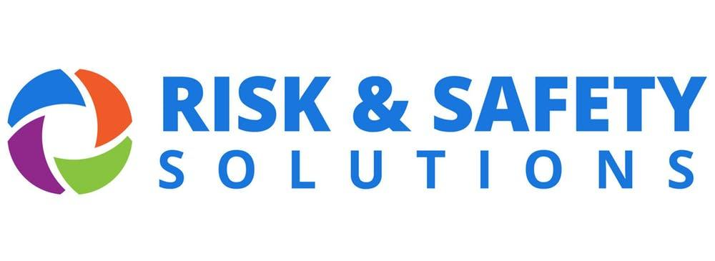
prepared for CSUSM by
Safety, Health & Sustainability
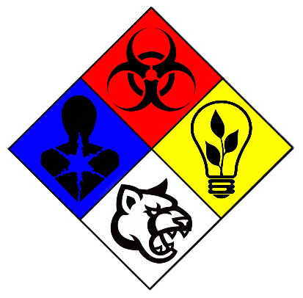
Table of Contents
- Accessing RSS Chemicals
- Viewing/Searching Your Inventory & SDS
- Adding Chemicals to Your Inventory
- Removing Chemicals from Your Inventory

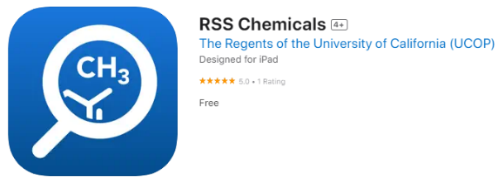
I. Accessing RSS Chemicals
- Go to riskandsafety.com and Sign In,
or use the mobile app “RSS Chemicals”.
- Log in using your campus credentials.
- If using a browser, open the More Apps dropdown menu and select Chemicals.
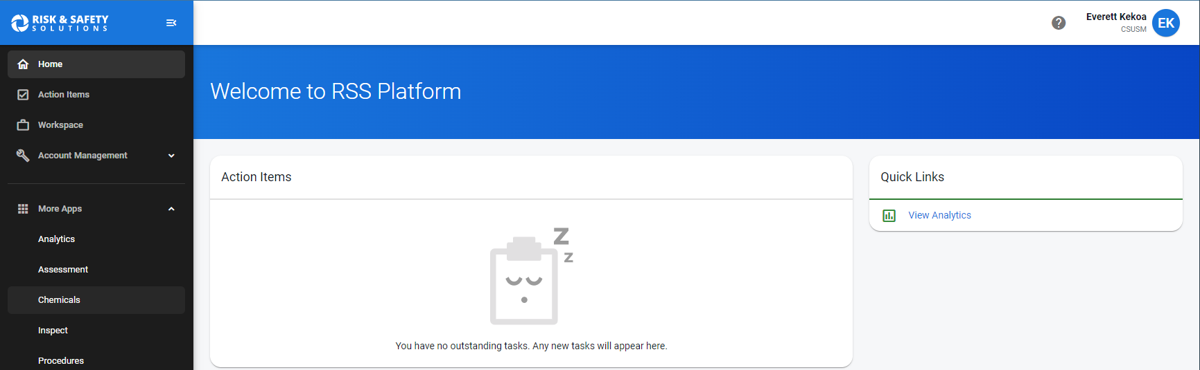
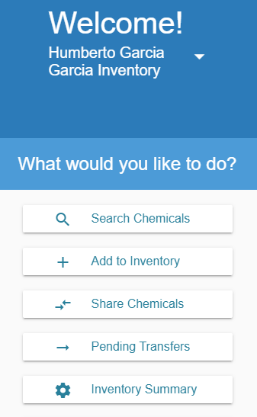
II. Viewing/Searching Your Inventory & SDS
If using a browser:
- Select Search Chemicals to view your inventory. Use the search function to find a specific chemical currently in your inventory.
- Select a chemical’s name to view its information, including how many containers you have of this chemical and the last recorded storage location of each container. You can also search for specific containers.
- To view the chemical’s Safety Data Sheet (SDS), scroll down to the Attachments section below the Related SDS section and select a PDF from one of the available manufacturers. The SDS will open in a new tab or window.
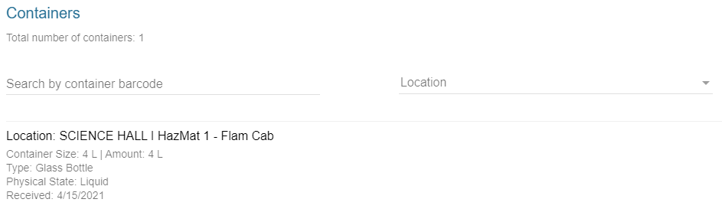
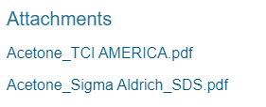
If using the mobile app:
- The app should open in the Inventory tab by default, indicated at the bottom of the screen.
- Select a chemical’s name to view its information, including container-specific data such as volume and last recorded storage location. You can also Scan the QR code on a container’s RFID tag with your device’s camera to bring up its information.
- To view the chemical’s Safety Data Sheet (SDS), it is recommended to do so in a browser. The links in the Related SDS section may fail to load within the app.
III. Adding Chemicals to Your Inventory (app recommended)
- Select Add to Inventory if using a browser, or Chemical Database if using the app.
- Search for the chemical and select its name to view its information.
  - Pro Tip: Use the product number for items from Fisher Scientific and Sigma-Aldrich.
- Once the correct chemical has been selected, take this moment to affix a new RFID tag to the manufacturer’s container.
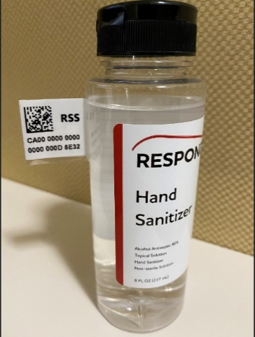
  - Fold along the perforated edges to form a “T” shape so that the tag can be affixed like a flag.
  - Placement should be high along the side, near or on the neck of the bottle. Do not place tags on the cap.
  - Avoid obscuring any information on the label.
  - For containers stored below ambient temperature, wipe surface down with a clean rag before affixing tag.
  - Particularly difficult containers may be placed inside plastic bags with tags affixed to the bags instead.
  - For very small containers, record the names and CAS # on a sheet of paper and affix the tag next to each name.
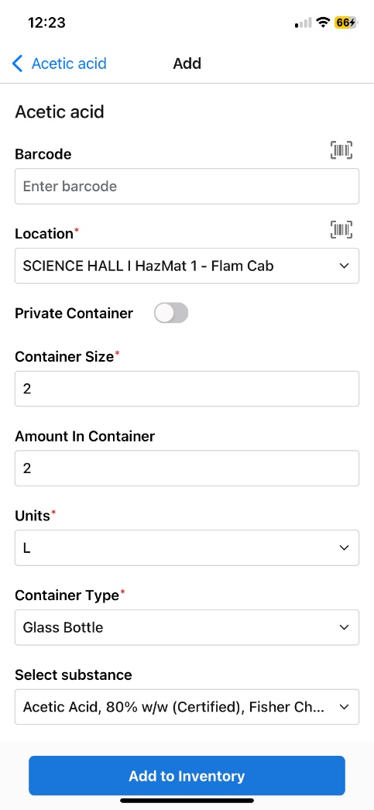
  - To request RFID tags, contact SH&S (ext. 4502).
- Click the add icon () in the Containers section or tap Add Container and fill out the required fields.
  - Barcode: If using the app, tap the barcode icon to use your device’s camera to scan the QR code on the RFID tag to automatically populate the field.
  - Amount in Container can be defaulted to the value in Container Size if unknown.
  - Substance: If the product name printed on the manufacturer’s container varies from the chemical name as it appears in RSS Chemicals, select the option in this dropdown menu that most closely matches the printed name.
  - Private Container should be left unselected or as “No”.
  - Concentration should match what is printed on the bottle, if applicable.
  - Expiration/Opened Date should be left blank if unknown.
- Select Save or Add to Inventory once finished.

IV. Removing Chemicals from Your Inventory
WARNING: Removing chemicals is a permanent action that cannot be undone!

- Select Search Chemicals if using a browser or Inventory if using the app.
- Search for the chemical you wish to remove and select its name.
  - Pro Tip: If using the app, tap Scan at the bottom of the screen and change “View Container” to “Remove Containers”. Use the camera to scan the QR code on the RFID tag to quickly queue multiple bottles for deletion.
- In the Containers section, click or tap the more icon (), then select Remove.
  - Ensure you select the correct container(s) by double checking that the 24-digit number matches the RFID tag.
  - If using Scan in the app, tap Remove Containers.
  - If using a browser, the container will be “Marked for Deletion” and appear in a column titled “Containers to Delete”. If you wish to remove more chemicals, simply select the remove icon () in the container’s row to add it to the column. Once finished, select Delete and Confirm to remove all the containers that were in the column.
- If the chemical or its container needs to be managed as hazardous waste, please deface the letters “RSS” on the RFID tag with sharpie to indicate to SH&S that it has been removed prior to pick-up.
