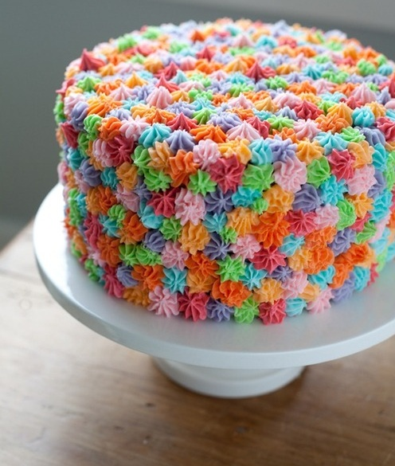
Teacher’s Edition EXAMPLE
Graphic Organizer for Persuasive/Argument

Clear introduction that includes your thesis statement:

Introduction and claim: There are many different types of cakes and they come in many different shapes and sizes. In addition, cakes have many different flavors, both the cake and the frosting can be different. For example, some flavors of cakes include chocolate, vanilla, and even raspberry or fruit flavors! Different frostings can add to the flavor and the appeal of cakes. (Claim)The cake you see in this picture is the best cake in the entire world. (Reason 1) The first reason is because it is very colorful and appealing to the eye. (Reason 2) Another reason I realized that this is the best cake in the world is because the recipe was created and the cake was baked by a very famous baker with lots of experience. (reason #3) But the most important reason this cake is the best in the world, is that it has the most delicious flavor I have ever tasted in my life.

Reasons and information for your argument, supported by details and facts #1
(Reason One with detail) One of the reasons this cake is so fabulous and the best in the world is because it is so colorful. When I see all of the colors in the frosting, it makes it almost impossible for me to resist taking at least one bite. The colors on the frosting are my favorite colors, which makes me want to forget about my dinner and just start by eating the colorful frosting!

#2
(Reason Two with detail) Another reason this cake is the best is because it was made by a very famous baker. Bakers who are famous have had experience and know to use only the finest ingredients. Specifically, he knows where to purchase the best flour and all of the ingredients necessary to give this cake such an excellent flavor. This baker studied baking for many years. This is important, because he learned from mistakes over the years, and is now very experienced and able to make the best cake in the world.

#3
(Reason Three with detail)The last reason why this is the best cake in the world is the most important reason. When I think about this cake and its delicious flavor, my mouth starts to water! I am very tempted to at least put my finger in the frosting to get a quick taste, even though it is not time to cut the cake. I am not proud to admit this, but I realize that I would rather eat the entire cake myself, rather than eat dinner, or share with other people. When I eat this cake it melts in my mouth and I cannot resist another bite!

Conclusion related to the claim or (3 reasons) for your argument:

Most people love cakes, and if they had some of this cake they would agree that this is the best cake in the entire world. Colorful cakes like this one are good looking and attract you right away. In addition, an experienced baker who studied for years had the skill to make this cake fabulously delicious. Writing about this cake makes me think about my last reason; this cake is so unbelievably delicious that it melts in your mouth and you cannot resist it! I’m going to cut a huge piece of the best cake in the world right now!

Linking words:
for instance, in order to, in addition, specifically, this is important because, this shows that, this proves that, this has shown me that, this made me realize, in contrast, especially, another, for example, also, more, but, and, because

