Extracting Data
Extracting data from the form as excel, txt or csv:
This feature allows you to extract the raw date from the form (not the same as running reports).
- Go to the home page
- Place cursor on the form
- Click on “entries”
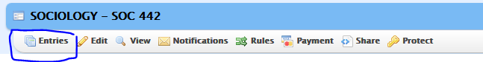
- In the middle of the page, you will see “BULK ACTIONS” next to “recent entries” in yellow
- Click on “Bulk Actions”
- Side panel will appear, click on “Export” 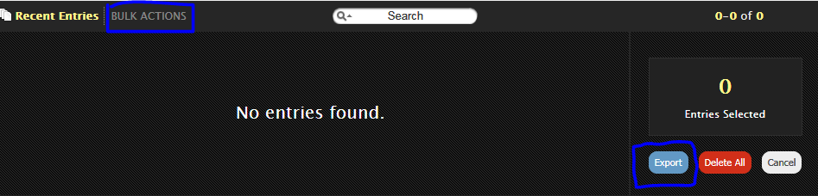
- Select the desired format and save or open the file.

