Running Reports
This feature is for creating reports to examine the data inputted by user
- In the home page, hit “Reports” in the top center of the page

- Create “New report” in the top right corner of the page
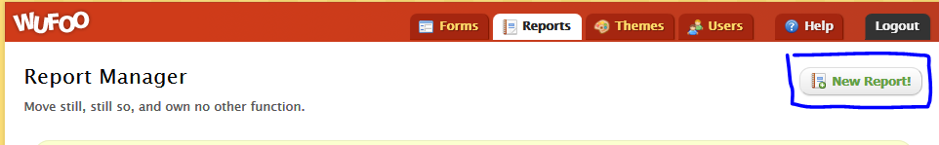
- Hit get started in the top panel
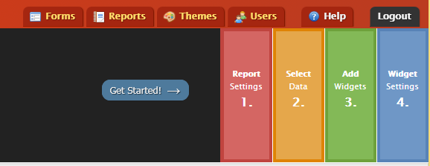
- Change the title and description of the form
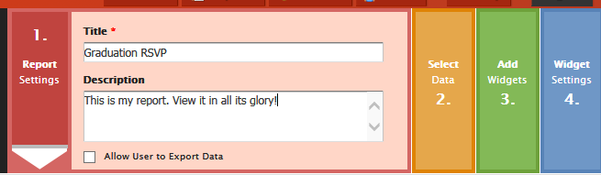
- Select the form you are trying to analyze (you can select certain entries)
- Add widgets (i.e a graph or chart) based on the degree of data analysis required by clicking on the widget in the top panel
- Select the layout of the three widget
- You can edit each widget by single clicking on the widget and choosing the appropriate field name
- Make sure you hit save once you are done
- The report will be saved in the “reports” portion of Wufoo until you delete it.

Delete/Edit/Print one entry or multiple entries:
This feature is embedded to edit, delete or print one or multiple entries and only the creator can do so. You can also add a comment to a certain entry
- Delete/Edit/Print on entry:
- Go to the home page
- Place cursor on the form
- Click on “Entries”
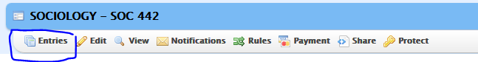
- Select the entry you will modify by clicking on the entry
- The entry will appear on the top section of the page
- You can edit the entry or send a copy of the entry to someone or print a copy of it.
- You can also delete certain entries
- If you need to add a comment, you can add the comment and change the name to show your name on the comment.
- Delete All entries to reset the form:
- Go to the home page
- Place cursor on the form
- Click on “entries”
- In the middle of the page, you will see “BULK ACTIONS” next to “recent entries” in yellow
- Click on “Bulk Actions”
- Side panel will appear, click on “Delete All”
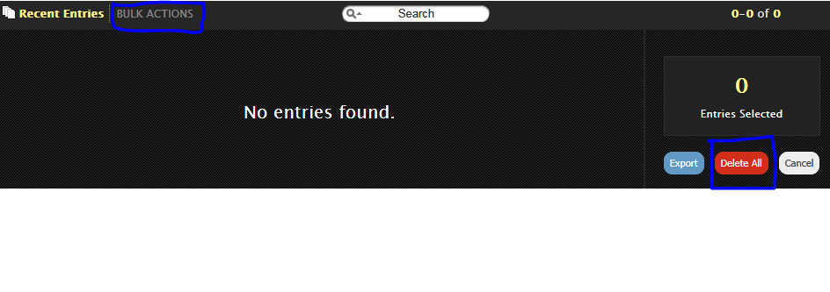
- All the entries will be deleted!!

