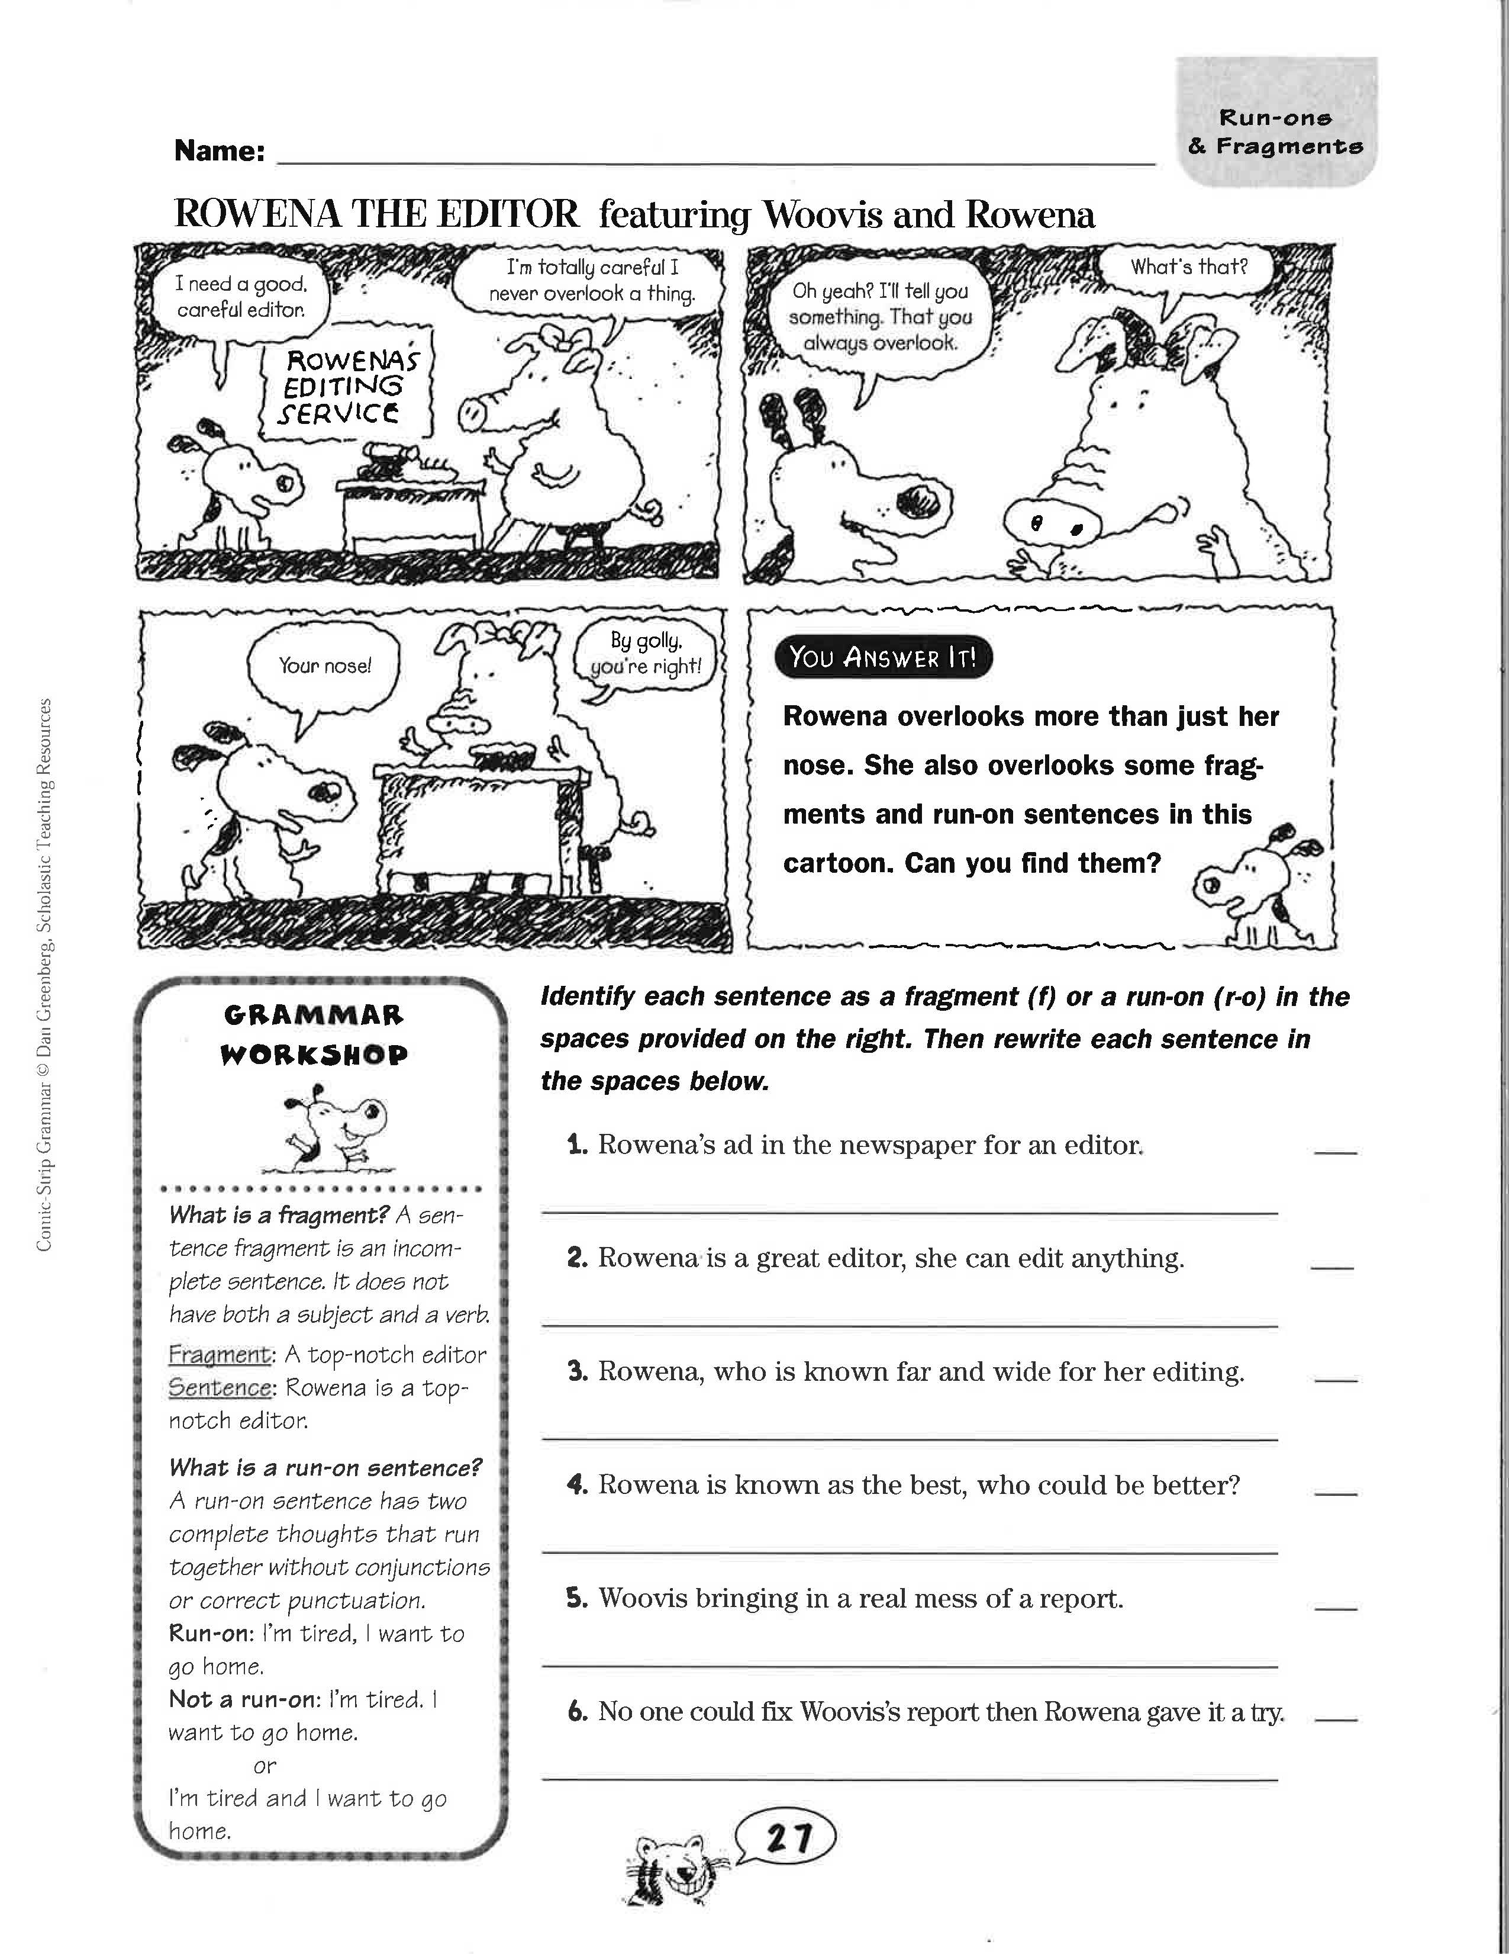Definitions:
Fragment- an incomplete sentence missing a subject or predicate, a stand-alone subordinate clause, or a phrase.
Run-on sentence- two or more complete thoughts joined together without conjunctions or correct punctuation.
Comma splice- two or more complete thoughts joined by a comma WITHOUT a coordinating conjunction.
Practice I
Directions: Draw one line under the subject and two lines under the predicate.
Example: The dusty old car won’t start anymore.
===============
- I want a new car.
- James is nice.
- The sun is moving.
- Max wrote the letter.
- The letter was written by Max.
- The farmers are plowing the field.
- Billy Reynolds is an amazing baseball player.
- The storm clouds are getting darker.
- Dogs, cats, and turtles make the best pets.
- The stern judge ruled that the defendant was not guilty.
- Only I am able to know what I am thinking.
- All of the townspeople ran from the burning building.
- His broken leg will heal in three months.
- The saber toothed tiger is a good example of an extinct predator.

How to Fix Fragments
1. Pull/ attach the fragment into a nearby sentence.
2. Turn the fragment into a sentence.
Practice II
Directions: Read the following short essay. Put brackets [] around any sentence fragments you find and mark them Frag. Then correct the fragments.

Women Drivers
Sexism extends even into the area of automobile driving, it seems. Believing that they are far better drivers than women. Men consider women drivers incompetent, inattentive, and even dangerous behind the wheel.
However, statistics prove that women are, in fact, safer drivers than men. For example, insurance rates. Insurance rates for women are 20 percent lower than they are for men. Another proof is that more accidents are caused by male drivers between the ages of 18 and 25 than by any other group. Also, the greater percentage of accidents involving deaths caused by men. Although women are criticized for being too cautious. They are really just being safe drivers.
The reasons for women drivers' safer driving habits can perhaps be found in the differing attitudes of the sexes toward automobiles. On the one hand, women drivers who regard the automobile as a convenience. Like a washing machine. On the other hand, men regard the automobile as an extension of their egos. Using it as a weapon when they feel particularly aggressive. Or using it as a status symbol.
All in all, women are safer drivers. Because of their attitude. Men can learn to become safe drivers. If they adopt the attitude that an automobile is merely a convenience.

How to Fix Run-Ons
1. Use a comma+ a coordinating conjunction (and, but, or, nor, for, so, yet).
2. Use a semicolon (+ transitional expression).
3. Make the clauses into separate sentences.
4. Restructure the sentence by adding a subordinating conjunction (after, although, unless, when, if, etc.)
Practice III
Directions: Correct the following run-on/comma splice sentences using the method indicated.

1. A newly arrived international student faces several challenges, for example,
he or she has to cope with a new culture.
a. Add a period:
___________________________________________________
b. Add a semicolon: ______________________________________________________
2. New York City is very cosmopolitan, people from many cultures and ethnic groups live there.
a. Add a period:
_______________________________________________________
b. Add a semicolon:
_______________________________________________________
c. Add a subordinator:
__________________________________________________________
d. Add a coordinator:
____________________________________________
3. Learning a new language is like learning to swim it takes a lot of practice.
Add a coordinator:
_______________________________________________________
4. Ask for assistance at the reference desk in the library, a librarian is always on duty.
Add a semicolon:
_______________________________________________________
5. Skiing is a dangerous sport you can easily break your leg or your neck.
Add a subordinator:

