“Green Eyes” by Coldplay
Honey, you are a rock
_____________________.
And I come here to talk;
I hope you understand.
That green eyes, yeah the spotlight, shines upon you.
And how could anybody deny you?
I came here with a load,
and it feels so much lighter now I’ve met you.
And, honey, you should know that I could never go on without you.
Green eyes
Honey you are the sea
_____________________.
And I came here to talk.
I think you should know.

That green eyes, you’re the one
__________________________________.
And anyone __________________________________ must be out of their mind.
Cause I came here with a load.
And it feels so much lighter since I met you.
Honey, you should know that I could never go on without you.
Green eyes
Green eyes
Ohohohohooooo
Ohohohohooooo
Honey you are a rock
_________________________________.

Identifying Adjective Clauses

Directions: Mark a sentence AC if it has an adjective clause in it. Underline the adjective clause.

___ 1. I have not read the contract that was signed yesterday.
___ 2. Everyone should know that mortgage interest rates will increase next year.
___ 3. We tried our luck at the same flea market where George found Amazing Spider-Man #96 in fair condition.
___ 4. The book, the front cover of which is badly scraped, belongs to my roommate.

The following sentences have adjective clauses: 1, 3, and 4.

Relative Pronouns

Directions: With a partner, mark the sentences C for correct or I for incorrect. Re-write the incorrect sentences, using the correct relative pronoun.

___1. Otzi was found about six hours from the valley where he had his last meal.
___2. Otzi was a man whom lived 5,000 years ago.
___3. The mountains which Otzi was found were a long way from his home.
___4. The hikers which found Otzi were Europeans.
___5. Otzi carried several weapons included an unfinished bow and some arrows that needed arrowheads.
___6. The scientists whose investigated the body tried to find the cause of death.
___7. The mystery scientists finally solved had lasted for more than 10 years.
___8. Otzi was killed by an arrow had been shot by someone behind him.
Correct: 1 and 7; Incorrect: 2, 3, 4, 5, 6, and 8

Restrictive vs Nonrestrictive
Directions: Underline the relative clauses in the following sentences and double underline the nouns they refer to. Determine if the clause contains essential information or additional information. If the information is additional, set the clause off with commas.

- Only people who speak Russian should apply for the job.
- Irina who speaks Russian applied for the job.
- Marco and Guillermo who did not come to class yesterday explained their absence to the instructor.
- The students who did not come to class yesterday explained their absence to the teacher.
- The geologist who lectured at Browning Hall last night predicted another earthquake.
- Dr. Fields who lectured at Browning Hall last night predicted another earthquake.
- The rice which we had for dinner last night was very good.
- Rice which is grown in many countries is a staple food throughout much of the world.
- I have good memories of my hometown which is situated in the mountains.
- I live in a town which is situated in the mountains.
- The Mississippi River which flows south from Minnesota to the Gulf of Mexico is the major commercial river in the United States.
- A river which is polluted is not safe for swimming.
- The man whom I spoke to was wearing a black hat.
- The man who must have been in his forties really scared me.
- We enjoyed Mexico City where we spent our vacation.
Final Practice

Directions: The following patented inventions were never sold on a wide-scale basis. Write sentences for each one, describing for whom the inventions were probably made. Use two relative clauses in each sentence.

- Example: The carry-all hat was probably invented for someone who does not want to carry a purse and who always needs her cosmetics nearby.

- 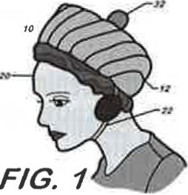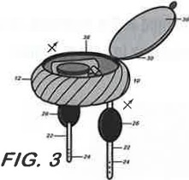

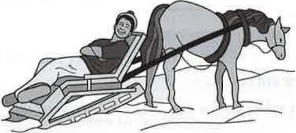
- combination deer carcass sled and chaise lounge

- eyeglass frame with adjustable rearview mirrors

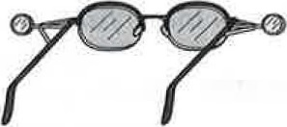

3. power-operated pool cue stick

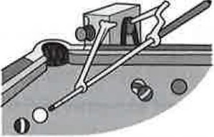

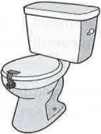
4. toilet-lid lock

5. baby-patting machine

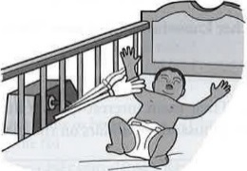
6. alarm fork