2018/19  Mid-Year guidelines | University Budget Office

Table of Contents
Title Pages

Guidelines . . . . . . . . . . . . . . . . . . . . . . . . . . . . . . . . . . . . . . . . . . . . 2 - 6

Department Level Report Instructions . . . . . . . . . . . . . . . . . . . . . 7 - 10

Fund Level Report Instructions . . . . . . . . . . . . . . . . . . . . . . . . . . 11 - 14

Projection Worksheet Instructions . . . . . . . . . . . . . . . . . . . . . . . 15

Timeline . . . . . . . . . . . . . . . . . . . . . . . . . . . . . . . . . . . . . . . . . . . . . 16

Each year the campus conducts a comprehensive mid-year review to identify any problematic financial situations that have occurred or may be expected to occur prior to the end of the fiscal year, June 30th. The objective of the Mid-Year Review is to perform an analysis of expenditures compared to budget and identify material concerns (minimum of $50,000), either favorable or unfavorable that may have a material impact on the current budget. The scope of the mid-year review will include a comprehensive budget review for all revenue and expenditure activities for the entire campus, for all funds, including Operating, Lottery, Capital Projects, Financial Aid, Self-Support, Trust funds, CSUSM Corporation, Foundation and ASI.
Mid-Year Review Process: Each Division is requested to provide a memorandum commenting on the outcome of their financial review process and include comments on the financial condition of each subdivision level. Favorable and unfavorable variances of $50,000 or greater at the subdivision level, and the cause, must be identified and explained in the written report. Additional suggestions to note within the report include service level changes, growth issues, unmet needs, trend issues, new programs, reserves or other factors that currently have or are expected to have an impact on the budget. The reports will serve as an attachment to the comprehensive Mid-Year Review report that is prepared by the Budget Office for the President’s review.

Analysis/Scope: The department analysis should consist of a reconciliation of transactions to the PeopleSoft Financial System through December 31, 2018, and estimates for the remaining six months of the fiscal year ending on June 30, 2018.
NOTE: Mid-Year projections will be used in determining available fund balances as part of 2019/20 planning – so please provide your most accurate representation of spend for the remainder of the year. Mid-year is essentially a reforecast of the original budget.
In addition, the Budget Office will perform a look-back analysis, comparing mid-year projections to actual year-end results, and will reach out to divisions / business units to provide explanations for any material variances.
- Operating Fund Analysis: The department analysis should consist of a reconciliation of transactions to the Data Warehouse Department Report. A copy of each department’s completed Mid-Year Department Level Report is required to be submitted as a part of the division summary. The required format is provided on page 7.

Although the benefit expenditure line items appear on the Data Warehouse reports, no projection is needed for these accounts unless your department is considered self-support, supported by student fees and is responsible for benefits (i.e., Health Services, Orientation, etc.).

- Lottery Fund Analysis: The department analysis should consist of a reconciliation of transactions to the Data Warehouse Department Report. A copy of each department’s completed Mid-Year Department Level Report (page 7) is required to be submitted as a part of the division summary.
- Capital, Financial Aid, Self-Support Funds and Trust Projects Analysis: The department analysis should consist of a reconciliation of transactions to the Data Warehouse Fund Report and should be based at a fund/department level. Each self-support operation and trust project needs to be reviewed to determine whether it will maintain a positive cash flow to comply with regulatory provisions. This analysis, along with a copy of the completed Mid-Year Fund Level Report, must be submitted for each fund. The required format can be found on page 11.
- CSUSM Corporation: A copy of the completed Mid-Year Fund Level Report, must be submitted for each fund. The required format can be found on page 11.
- Foundation: Only includes Central Operations (86502)
- ASI: A copy of the completed Mid-Year Fund Level Report, must be submitted for each fund. The required format can be found on page 11.

Supporting Schedules and Reports: The primary objective of the Mid-Year Department/Fund Level reports is to determine if the funds available for the remainder of the fiscal year are adequate to maintain planned service levels. The following reports are provided to assist you in completing the required mid-year financial analysis:
- The Mid-Year Department Level Report is designed to determine budget balances at June 30 by adding year-to-date actuals and estimated projections (by account code) for the operating fund.

- The Mid-Year Fund Level Report is designed to estimate the year-end balance in the fund as of June 30th. Projections are done for both revenue and expense at the account code level.

- The Projection Worksheet is not required, and is provided as an additional tool to assist with the estimation of expenses for the January to June time period. These projections can be pivoted and then linked to the projections column on the Mid-Year Reports.

- Positive Pay salaries should not include June earnings. Positive pay is overtime, student assistants, special consultants, etc. December – May earnings should be projected, as they will be paid in January – June. June earnings will be paid in July using the 2018/19 Budget.

- The Division Summary is meant to link to all Mid-Year Department Level and Fund Level reports and provide summary information at the division/department level.

Running the Data Warehouse reports through December 31, 2018 will provide six months of year-to-date actual expenses and encumbrances. When combined with the Mid-Year Report forms, additional columns are provided to enter expenditure and/or revenue projections by account code for the remaining portion of the fiscal year. All projections require manual entry.
- Mid-Year Department Level Report
- Mid-Year Fund Level Report
- Projection Worksheet
- Division Summary

- The worksheets listed in bold above (1, 2 and 4) are required to be completed for each department or fund and submitted to the Budget Office.
- Worksheet 3 is to assist you and (if used to link information) can be submitted also.
- All Data Warehouse reports include the percentage of budget utilized. Areas that significantly exceed or are below 50% may require additional research.
- The HR Actuals Report can be used for payroll analysis.

Please refer to the Budget Office web site http://www.csusm.edu/budgetoffice for all mid-year documents.

Technical and Financial Data Information: Account balances will reflect the following types of transactions that have been processed through December 31, 2018:
- Vendor payments and encumbrances
- Receipts
- Journal entries
- Budget transfers and augmentations

Budget Transfers/Journal Entries: Budget transfers and journal entries reflect expenditure activity and budget postings through December 31, 2018.
  - Transactions being processed between January 1 and January 12 (estimated closing date), must be dated December 31, 2018 in order to be captured in the December close.
  - Important: Please coordinate with other budget representatives to ensure that all planned budget transfers between departments/divisions are accounted for in both area budgets, and the net balance of the transactions equals zero.

Payroll/Compensation Increases: Payroll transactions reflect expenditure activity and budget postings through December 31, 2018.
  - Budget allocations are not posted for temporary (non-permanent) employee compensation increases or non-bargaining unit increases. Please keep this in mind when projecting payroll costs for the January – June pay periods.

  - Compensation GSI allocations from the Compensation Pool have been completed as of the Mid-year process, December 31, 2018, with the exception of bargaining units 8 and 11 (pending). All other GSI base compensation allocations have been posted for 2018/19. As a result, please reconcile all salaries at mid-year and inform the Budget Office of any discrepancies at this time. Going forward, it is our intention to avoid budget compensation adjustments late in the year and reflect the most accurate mid-year projection.

Chargeback Entries: The Chargeback Simplification Plan, started 2018/19, eliminated most chargeback activity within 48500 (departments charging each other within Fund 48500). Further guidelines and FAQs will be forthcoming this year, however, listed below are a few areas to keep in mind when working through your mid-year projections:
- As of the beginning of 2018/19 base budget was reallocated from the division consumers to the division providers for the following activities:
  - IITS
    - Telephone
    - Technology (digital signage, DSS, conf room, copier move)
  - FDM
    - Work Orders under $1,000
    - University Vehicle Use
    - Campus Moves
    - Campus Sign
    - Fed Ex
    - UPS
    - Work Orders Move

- Chargebacks will still occur for the following:

  - Services provided to Auxiliaries, Third Party and Self-Support Funds
  - Charges incurred outside of the current Computer Refresh Program – see IITS webpage for details – link as follows: https://www.csusm.edu/iits/trp/index.html

Expenditure Transfers: Expenditure transfers must be included when projecting expenses. If an expense is being transferred out, it is a reduction to the department’s expenses. The department receiving the expenditure will show it as an increase to expenses. Please coordinate with the appropriate department to ensure that all planned expenditure transfers are accounted for in both areas’ projected expenses.
Pre-Payments: Generally, pre-payments will not be allowed unless approved by the Vice President. Interest earnings potential needs to be maximized by managing cash flow and maintaining it at higher levels whenever possible. Paying for expenditures in advance reduces cash available for investment, and compromises the opportunity for higher interest earnings. Generally Accepted Accounting Principles (GAAP), require expenses and revenue to be recorded and recognized in the fiscal year in which the goods and/or services are received. If we do not adhere to this accounting practice, the campus will be vulnerable to audit findings.
Cost Projection: The mid-year review provides the opportunity to look at what funds are remaining to cover expenses over the next six months. This is the time when you list the expenses expected from January through June that must be covered with the budget available. Some things to keep in mind when projecting the remaining year expenses:
  - Will current monthly costs stay constant? If so, the YTD costs will be the projected costs also.
  - Refer back to last year’s mid-year report. Were you on target with your estimates?
  - Impending reclassifications or in-range progressions need to be included in projected expenses.
  - Non-bargaining unit or temporary employee salary increases that won’t receive a budget allocation should be included.
  - Are you expecting to purchase equipment in the next 6 months?
  - Will budget transfers take place to either increase or decrease your funds?
  - Is there an annual one-time expense that hasn’t occurred yet?
  - Historical information is always helpful. Look at your June 30 Department or Fund report from the prior year to see what account code actuals were and what your budget balance available (BBA) was.
  - Plan with the chance of unforeseen expenses popping up.
Mid-Year Department Level Report
It is suggested that you have the Mid-Year Department Level Report form open before you start this process.
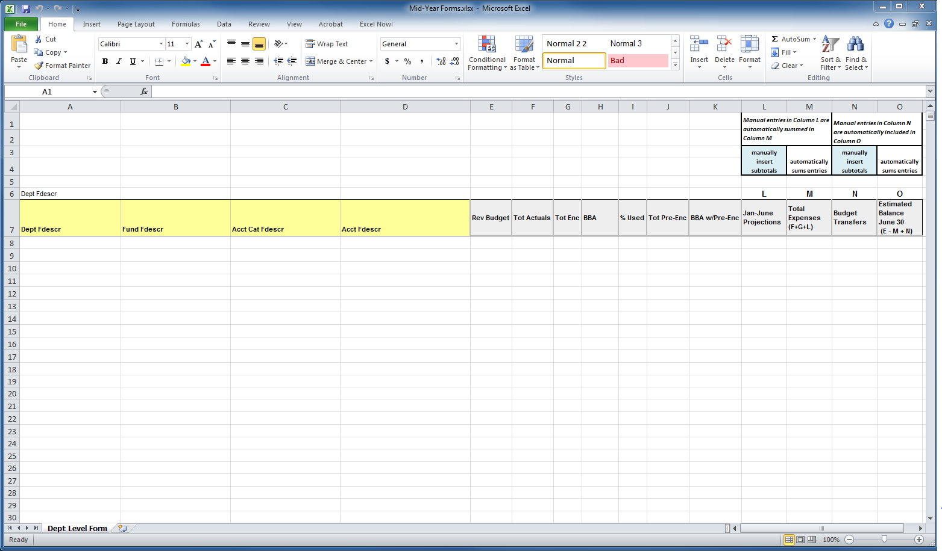
Running the Report in Data Warehouse – Financial Reporting Dashboard
- Click or hover over the Dashboards dropdown menu and click on “Financial Reporting.”
- Make sure your default Settings for this Dashboard are set up:
  - Primary Business Unit = SMCMP / Other
  - Primary budget ledger = Standard Budget
  - Original budget scenario only = Leave Blank
- Click on Apply, then save under Page Options (the bullet point icon in the upper right corner), “Save Current Customization,” check the box next to “make this my default for this page,” and select a name.
- Click either the Financial Summary As of Period tab or Financial Summary As of Period hyperlink in the Report Index.
- Report Filters
  - Fiscal Year: 2018
  - Period: 6 (default will be 7)
  - Fund: leave blank (be sure to remove the X). This will give you all the funds in your dept. If you manage a self-support fund or trust, you will need to run the Mid-Year Fund Level Report for submission (page 9).
  - Department: Select your department(s)
  - Click Apply Filters
- Show Columns sections
  - Show Column 1: select Dept Fdescr
  - Column 2: select Fund Fdescr
  - Column 3: Acct Cat Fdescr (multiple subtotals) OR Acct Type Fdescr (subtotals at Revenue & Expense)
  - Column 4: select Acct Fdescr
  - Select Report View: select Summarized with Pre-Enc
  - Click OK
- Save at this time by clicking on the bullet icon in the upper right corner under your name, Save Current Customization, For Me, and name it using Mid-Year in the title (suggested).
Report results:
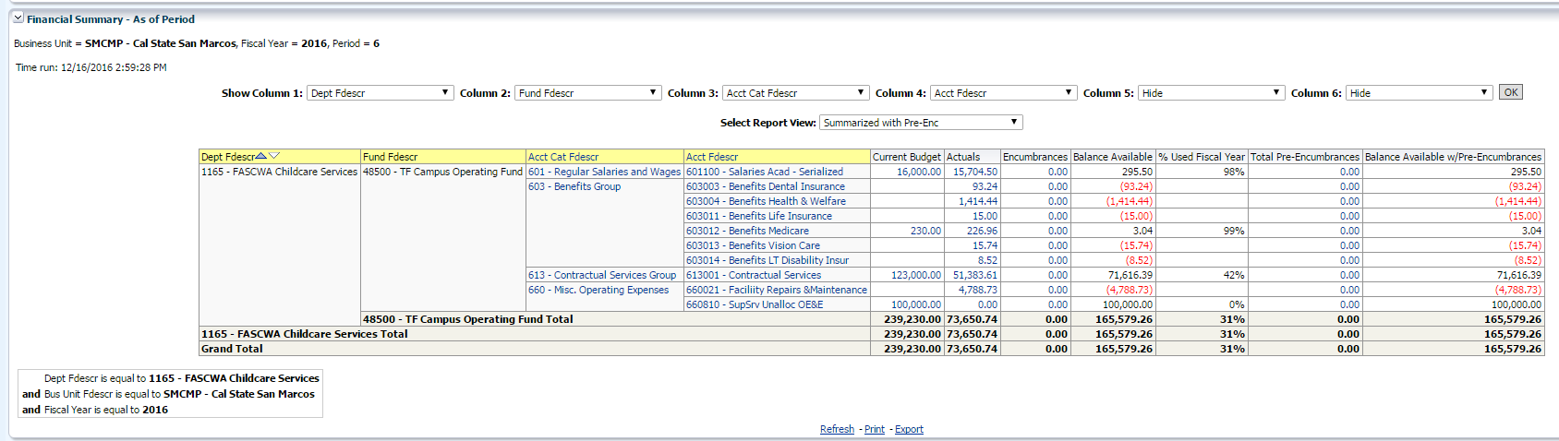
Mid-Year Report
- Go down to the bottom of the data warehouse report results
- Click on Export
- Hover over Excel and then click Excel 2007
- In Excel Select columns A-K in the Excel report & copy

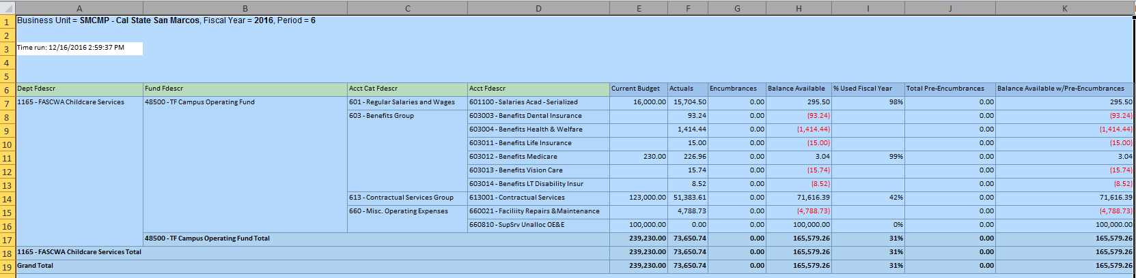

- Go to the Mid-Year Department Level Report form; place your cursor in cell A1, and paste.
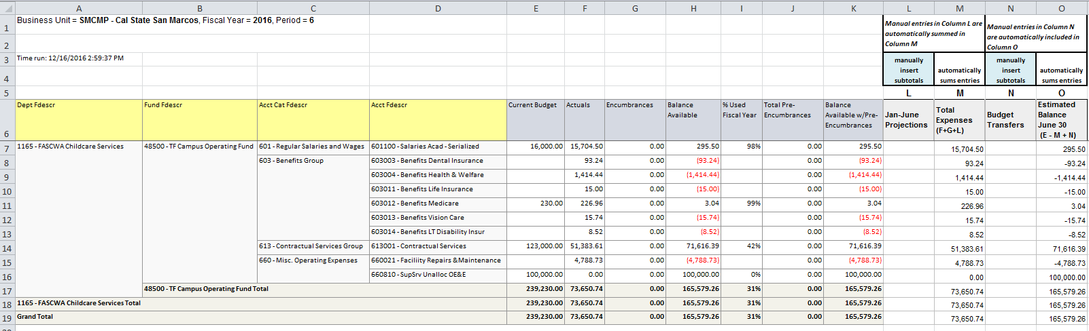

- Manually enter your projections in Column L, and your budget transfers in Column N. Remember, if it is an expenditure transfer out or a budget transfer out from your department it is a minus.
  - Columns M and O automatically recalculate when you enter your amounts.
- Enter zeros in empty cells.
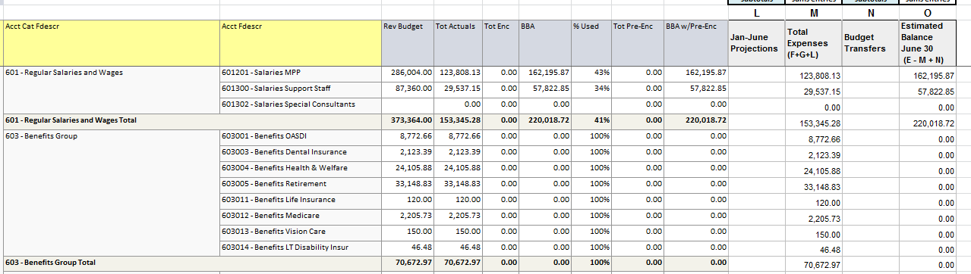
- Subtotals and Totals in Columns L and N will need to be entered manually.
  - Enter a formula (not a hard entry) when you are manually entering totals. This allows the worksheet to re-total each time you change a projection or budget transfer amount.
  - The report will automatically update Columns M and O as your subtotals are calculated.

- If you need to add a line for an additional account code, you will need to copy the formulas in Columns M and O into the added line.
NOTE: You may hide unneeded columns to enlarge your page, but do not delete the columns.

Column L – Jan-June Projections
- Any account codes that do not appear on the Data Warehouse report but are needed for projections through June 30th will need to be added by inserting rows.
    - Positive Pay salaries should not include June earnings. Positive pay is overtime, student assistants, special consultants, etc. These earnings are paid in the month following the time worked. As a result, December – May earnings should be projected, as they will be paid January – June. Any June earnings will be paid in July using the 2019/20 Budget.
  - While benefit expenditures appear on the Data Warehouse Department Level report, no projections are needed for these account codes, as budgets are allocated to match actuals, unless:
- Your department is supported by student fees and is responsible for benefits (i.e., Health Services, Orientation, etc.)
  - Enter projections for all OE&E account codes that are expected to have expenses between January and June.
  - Any expenditure transfers or credits, i.e., chargebacks, etc., should be included in operating expense estimates.

Subtotals

As previously stated, enter formulas for all subtotals of manual entries, as the totals will update with any changes. The subtotals/totals will be included in the automatic calculation of the Total Expenses (Column M) and Estimated Balance June 30 (Column O).

Mid-Year Fund Level Report
It is suggested that you have the Mid-year Fund Level Report form open before you begin this process.
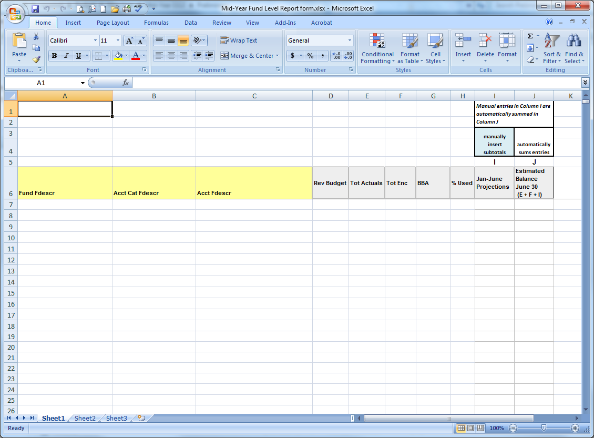
Running the Report in Data Warehouse
- Click or hover over the Dashboards dropdown menu and click on “Financial Reporting.”
- Make sure your default Settings for this Dashboard are set up:
  - Primary Business Unit = SMCMP / Other
  - Primary budget ledger = Standard Budget
  - Original budget scenario only = Leave blank
- Click on Apply, then save under Page Options (the bullet point icon in the upper right corner), “Save Current Customization,” check the box next to “make this my default for this page,” and select a name.
- Click on the Financial Summary As of Period tab or the Financial Summary As of Period hyperlink in the Report Index.
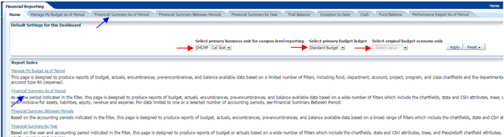
- Report Filters
  - Fiscal Year: 2018
  - Period: 6 (default will be 7)
  - Account Type: Select 50 – Revenues and 60 - Expenditures
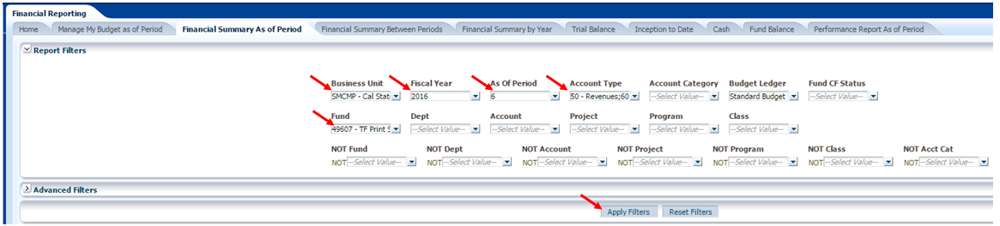
  - Fund: Enter your fund or funds. (Remember to remove the X)
  - Click Apply
- Show Columns sections
  - Column 1: select Fund Fdescr
  - Column 2: select Acct Type Fdescr
  - Column 3: select Acct Fdescr
  - Select Report View: select Summarized
  - Click OK
- Save at this time by clicking on the bullet icon in the upper right corner , Save Current Customization, For Me, and name it using Mid-Year in the title (suggested).

Mid-Year Report
- Scroll down to the bottom of the report
- Click on Export
- Select Excel
- Select columns A-H in Excel & copy.
- Go to the Mid-Year Fund Level Report form; place your cursor in cell A1, and paste.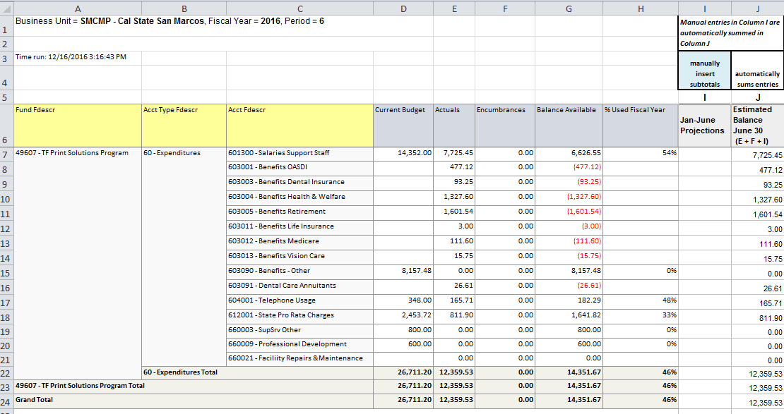
- Manually enter your projections in Column I.
a. Remember, an increase in revenue is entered as a minus. On the expenditure side, a decrease in expenditures is a minus.
- Enter zeros in empty cells.
- Column J automatically recalculates when you enter your amounts.
- Subtotals and Totals in Column I will need to be entered manually.
a. Enter a formula for any total, not a hard entry. This will allow the worksheet to re-total correctly
each time you change a projection.
- Insert additional lines as needed to add other account codes as necessary. You will need to copy the formula in Column J into the added line.
NOTE: You may hide unneeded columns to enlarge your page, but do not delete the columns.

Column I – Jan-June Projections
- Enter projections for all revenue and expenditures expected to occur between January and June.
- Jan-June Projections can be populated by a link to the Projection Worksheet pivot (page 14).
- Any account codes that do not appear on the data warehouse report but are needed for the projections through June 30th will need to be added by inserting rows and can be linked to the totals on the Projection Worksheet or pivot.
    - Positive Pay salaries should not include June earnings. Positive pay is overtime, student assistants, special consultants, etc. These earnings are paid in the month following the time worked. As a result, December – May earnings should be projected, as they will be paid January – June. Any June earnings will be paid in July.
  - Benefit projections are needed if covered by the fund.
  - Enter projections for all OE&E account codes that are expected to have expenses between January and June.
  - Any expenditure transfers or credits should be included in the projections.

Subtotals
As previously stated, enter formulas for all subtotals of manual entries, as the totals will then update with any changes. The subtotals/totals will be included in the automatic calculation of the Estimated Balance June 30 (Column J).

NOTE:
Fund Balance Use. Self-support Funds and Trust Projects cannot end the year in a negative balance. If it is estimated that current fiscal year expenditures will exceed revenues, a portion of the Fund Balance-Continuing Appropriation will be needed to cover the shortfall. The beginning fund balance (as of July 1 of the current fiscal year) can be found by running the Fund Balance report in data warehouse, found under the Financial Reporting dashboard. Please contact the Budget Office for assistance if needed.
The Budget Office recommends that if year end balances show a sizeable variance from your original budget, that budget adjustments be made. Please contact the Budget Office for additional information.
Balance Available is not calculated for use with these funds. The budget is only used as the plan for the fund’s current year operations.
Net Income. Net income is arrived at by adding current year total revenue and current year total expenses.

Projection Worksheet
The Projection Worksheet calculates projected payroll and OE&E expenditures and can then be pivoted to provide a summary by account code or sorted by account code and subtotaled to link to the Mid-Year Department Level or the Mid-Year Fund Level reports.
Column A: Account Code – Enter the account code used for the cost you are projecting.
- Account codes do not have to be entered in any certain order, when using the pivot. If using the subtotal method, remember to sort by account prior to subtotaling.
- Projections are not needed for Benefits unless you are creating a new position, or if the department is supported by student fees (Health Services, Counseling, Orientation, etc.).
- Projections are not needed for Federal Work Study.
Columns B, C, D: Program, Class, Project codes – use these as needed.
Column E: Account Description – Enter the description of the account code you are using.
Column F: Cost Detail – Enter who/what/where that describes the use in more detail.
Column G: Rate – Enter the monthly/hourly rate, or the cost per item or occurrence.
- December positive pay earnings are paid in January. May earnings are paid in June. Therefore, you need to estimate six months.
Column H: Months/Hours/Frequency – Enter the number of months, hours or occurrences you are projecting in the January thru June period.
    - Positive Pay salaries should not include June earnings. Positive pay is overtime, student assistants, special consultants, etc. These earnings are paid in the month following the time worked. As a result, December – May earnings should be projected, as they will be paid in January – June. Any June earnings will be paid in July using the 2019/20 Budget.
Column I: Projected Cost – This column is automatically calculated for you. It takes the rate and times it by the Months/Hours/Frequency to arrive at the Projected Cost. (Column D times Column E).
Once all data is entered on the Projection Worksheet you can pivot the information or sort it by account code and subtotal at each change in account.
Mid-Year Review Timeline
Task Description | Date | Responsibility
Mid-year guidelines distributed to campus reps - posted to the web | by December 15 | Budget Office
December financial close | January 11 (approx.) | Fiscal Services
One-on-one assistance  (by request) | January 11 – February 8  (approx. 4 weeks) | Budget Office
Mid-year analysis performed | January 11 – February 8 (4 weeks) | Budget Office & Divisions
Training | January 16  (if unable to attend – 1:1 training by request is available) | Budget Office
Mid-year reports submitted to Budget Office | February 11 | Vice Presidents
Mid-year reports reviewed | February 11 – February 22 | Budget Office
Comprehensive mid-year report reviewed | February 27 (approx.) | AVP, BFS and VP, FAS
Comprehensive 2018/19 Mid-Year report submitted to the President | March 2 (TBD) | Budget Office

