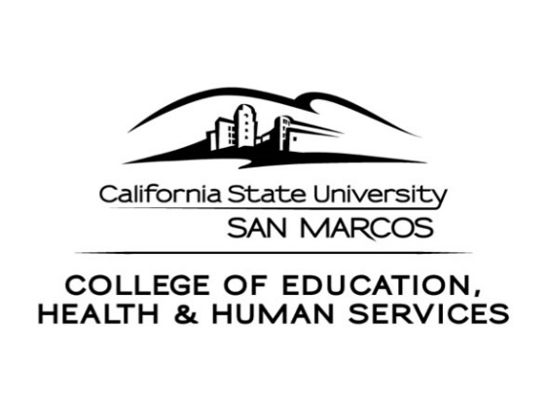
CEHHS Student Services
333 S.Twin Oaks Valley Road
San Marcos, CA 92096-0001

760-750-4277/760-750-3539 (fax)
www.csusm.edu/cehhs/studentservices/

SCHOOL OF EDUCATION

OVERVIEW OF THE ONLINE RECOMMENDATION PROCESS

First Step
When we receive your application packet (Credential Evaluation Request Form), we will review your file to make sure all requirements have been met. After our verification that requirements have been met, CEHHS Student Services recommends you for the credential vial the California Commission on Teacher Credentialing’s (CTC) online recommendation system.

Second Step
CTC will notify you via email that you have been recommended for your credential. CTC will also send you a link to use where you will then provide or confirm your contact and credential information. You will be asked to pay for the credential document on-line; payment by MasterCard or VISA debit/credit card is the only option for on-line recommendation.

Next, CTC notifies CSU San Marcos, School of Education that all fees have been paid and notifies you a credential will be issued to you. The payment confirmation issued by the Commission may be used to verify your recommendation status with an employer.

Third Step
The Commission does not issue paper documents. Your credential is issued by CTC and posted to their official document web site. You may view and download document information at http://www.ctc.ca.gov/.

If you have any questions about the on-line process, please do not to hesitate to call us.

CREDENTIAL EVALUATION APPLICATION & ON-LINE RECOMMENDATION REQUEST

(Please Clearly Print)

Personal Information

Name
Last First Middle Maiden/Former

CSUSM Student ID# Date of Birth

Street / P. O. Box Address

City State ZIP

Home Phone ( ) Cell Phone ( )

Work Phone ( )

Current Email Address: _____

Alternate Email Address: ____ Due to problems associated with district firewalls, please use emails other than your district email.

Permanent/Credential Mailing Information:

Street / P. O. Box Address

City State ZIP

Please return completed application to:

Education Services Center

School of Education, UH 221

Cal State San Marcos

San Marcos, CA 92096-0001

I authorize the School of Education to release information concerning my credential application to appropriate inquiring school districts and offices and to submit on-line my credential application and supporting materials to the California Commission on Teacher Credentialing for issuance of the credential I have requested.

Signature Date

Name: CSUSM Student ID#

Please Check the Appropriate Certification Request:

□ Administrative Services Certificate of Eligibility
- Completion of required program
- Valid Professional Clear Teaching Credential

(Completion of Computer and Mainstreaming Courses)
- Verification of five (5) years employment, on school letterhead
- Copy of Basic Skills or CBEST scores

□ Administrative Services Preliminary, Tier I
- Completion of required program
- Valid Professional Clear Teaching Credential

(Completion of Computer and Mainstreaming Courses)
- Verification of Employment, CL 777 Form from District Office
- Copy of Basic Skills or CBEST scores

□ Reading and Literacy Added Authorization (RLAA)
- Completion of required program
- Valid basic teaching credential

□ Reading and Literacy Leadership Specialist Credential (RLLSC)
- Completion of required program
- Valid basic teaching credential

