SEMESTER/SESSION YEAR
DEPT #: COURSE NAME (SECTION #)

Instructor: YOUR NAME
Email: ADDRESS
Office: Markstein Hall #

Date/Place/Time: DATE – DATE
CLASS DAY(S) – CLASS TIME(S)
Markstein Hall #

Office Hours: DAY(S) – TIME(S)

CoBA Mission Statement

CoBA provides a transformative business education that prepares our diverse student body for success in an evolving economy and society. Our faculty delivers a relevant and innovative curriculum, upholding high academic standards. We integrate theory and practice, guided by scholarship and collaborations with industry experts and community leaders.

Course Description

This course… (Expand on catalog description).

Course Learning Outcomes

Upon successful completion of this course, each student will be able to:

Include any college-wide PSLOs your department has determined are addressed in the course; CoBA Undergraduate and Graduate PSLOs can be found here: https://www.csusm.edu/coba/about/mission-vision-values.html

Required Textbook

The required textbook for this class is TITLE, EDITION (YEAR), AUTHOR, available at [provide university bookstore link here and/or above, if available]. If applicable: Please note the textbook is also available for a 2-hour checkout at the 3rd floor library check-out desk as part of the CALM initiative. Handouts may also be provided by the instructor from time-to-time. If students miss class for any reason, it is their responsibility to obtain any distributed handout(s) from a classmate and/or the instructor during the office hours set forth above.

Student Preparation

For the learning process to be effective, it is necessary that you complete the assigned readings and/or cases before class and actively participate in the case discussions during the class, and in your teams. Preparation is an important part of class participation.

Attendance Policy

[NOTE: CSUSM POLICY REQUIRES INSERTING A COURSE ATTENDANCE POLICY IF IT EXISTS, BUT THE POLICY CAN ALSO BE INTEGRATED WITH GRADED COMPONENTS. TWO SUGGESTED POLICIES ARE LISTED BELOW.]

SUGGESTED OPTION 1:
Attendance at every class is extremely important. If you are seriously ill, it may be wise for you to get medical attention early-on and to follow your doctor’s advice, including staying home to recuperate. There will be a maximum one-week make-up period for late work, and it is completely up to you to initiate the make-up.

SUGGESTED OPTION 2
After the third unexcused absence, each unexcused absence will result in a one-third letter grade deduction to the student’s final course grade. Please let the instructor know as early as possible if you will miss class for any reason.

Participation

Class participation will be assessed by your diligent and timely interactions during class. Attendance is a factor of your class participation grade, although simply being present at a class meeting does not mean that you actively participated.

Computers and Mobile Devices

You may use a computer and/or mobile device (smart phone, tablet, etc.) only to take written notes in class and not for email, internet research, etc. unless otherwise explicitly authorized by the instructor in advance or pursuant to a learning accommodation approved by DSS. Please do not make any audio or video recordings during class without the explicit prior consent of the instructor. During all exam times, computers and mobile devices are to be turned off and stowed. Once an exam begins, students who leave the exam room will not be allowed to return to the exam.

Graded Components

% Description of responsibility/category
% Description of responsibility/category
% Description of responsibility/category

Grading Scale

Insert Your Grading Scale – see sample syllabi.

University Writing Requirement

CSUSM has established a writing requirement of 850 words for a 1-unit course, 1700 words for a 2-unit course, and 2500 words for courses of 3 or more units. To meet this requirement, each student in this course will complete the writing assignments described in this course outline.

[Optional Sections: Course Website, Student Information Sheet, Course Communications and Technology, Conduct Expectations, etc.]

Online Instruction Policy (If Applicable)

[For an online and/or hybrid course: detail course format, necessary technical competency required for students, contact information for technical support assistance, and course requirements for participation.]

Credit Hour Policy

Please note that per the University Credit Hour Policy students are expected to spend a minimum of two hours outside of the classroom each week for each unit of credit engaged in learning. For this course, it means that you are expected to spend the required minimum number of hours each week working on readings, assignments, and preparation for class, project work, etc.

Inclusivity Statement

Our community represents a rich variety of backgrounds, experiences, demographics and perspectives and we are committed to fostering a learning environment where every individual is respected and engaged. To facilitate a dynamic and inclusive educational experience, we ask all members of the community to:

- be open to the perspectives of others
- appreciate the uniqueness their colleagues
- take advantage of the opportunity to learn from each other
- exchange experiences, values and beliefs
- communicate in a respectful manner
- be aware of individuals who are marginalized and involve them
- keep confidential discussions private

Academic Honesty

Students are expected to adhere to standards of academic honesty and integrity, as outlined in the Student Academic Honesty Policy. All assignments must be original work, clearly expressed and as free from errors as possible. All ideas/materials that are borrowed from other sources must have appropriate references to the original sources. Any quoted material should give credit to the source and be punctuated with quotation marks. The University’s Academic Honesty Policy states, “The maintenance of academic integrity and quality education is the responsibility of each student within CSUSM and the CSU system. Cheating and plagiarism in connection with an academic program at a campus is listed as an offense for which a student may be expelled, suspended, put on probation, or given a less severe disciplinary sanction.” The instructor is required to report all instances or possible academic dishonesty to the Dean of Students. Please see the online version for more details at:

https://www.csusm.edu/dos/about/polpro.html

Learning Accommodations

Students requiring reasonable accommodations because of a disability must be approved for services by providing appropriate and recent documentations to the Office of Disability Support Services (DSS). Students authorized by DSS to receive reasonable accommodations should meet with me during my office hours in order to ensure confidentiality.

Student Resources Statement

CSUSM offers a variety of services and resources for students, including but not limited to academic support, financial support, food assistance, mental health support, and career support. Should you need help or have questions about any of these resources, please visit https://www.csusm.edu/students/index.html.

AI Use Policy

Below are statements about the ways AI tools (such as Grammarly, Dall-E, and ChatGPT) are and are not permitted to be used in this course. If there is evidence that you violated these rules in this course, you will be reported to the Dean of Students and receive a 0 on the relevant assignments. Each professor and course may have their own policy on the use of AI tools. If you have questions about what is and is not permitted with the use of AI tools in this course, please speak with the instructor.

Permitted | Not Permitted
You may use AI tools to edit work or generate ideas. | You may not use AI tools to originate assignments you submit.
You are permitted to use AI tools to generate ideas. | You may not submit any work generated by an AI program as if it is your own. You must acknowledge the use of AI tools with a paragraph summary at the end of the assignment describing what it was used for, the prompts used to get the results and how it was edited.
You are permitted to seek suggestion or feedback on work you originated from AI tools. | You are not permitted to use AI tools to obtain answers to course related questions or assessments (e.g., quizzes or tests) using AI tools.

[The following were discussed and proposed by UGCC as a guide. However, faculty are encouraged to select the statements they deem appropriate for their course, and develope their own statements should those offered above be something individually preferred.]

TENTATIVE CLASS SCHEDULE

Class Date Topic Pre-Class Reading Assignment Due
1 | DAY DATE YEAR
2
3
4
5
6
7
8
9
10

FINAL EXAM: DATE, PLACE, TIME (If no final exam, must state THERE IS NO FINAL EXAM).

The instructor will endeavor to adhere to the above schedule, but modifications to the syllabus may be made to enhance learning outcomes. If changes are made, students will be informed during class. It is the students’ responsibility to stay aware of any changes.

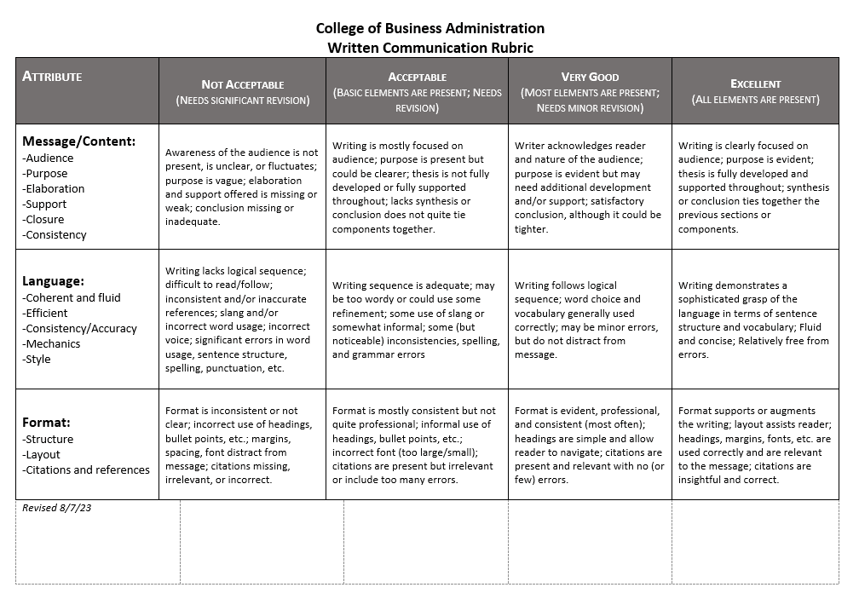

Attributes and Definitions
Message/Content
- Audience: It is clear that the writer understands and addresses the audience. This is shown by how the reader is engaged, the words chosen, etc. For example, a message written for a general audience will avoid discipline-specific jargon.
- Purpose: All writing has a purpose/goal; the reader should be able to identify what the writer’s purpose/goal is.
- Elaboration: The message is fully developed and remains focused on the topic throughout. The writer uses compelling content to convey the writer’s perspective.
- Support: Examples, illustrations, and sources are used to clarify and persuade. The supporting information should be relevant, credible, and clearly related to the message and its subcomponents.
- Closure: The writing provides some form of synthesis or a conclusion that ties together the previous sections or components of the message.
- Consistency: Writer maintains same tone, purpose, focus, etc.

Language
- Coherent and Fluid: Main ideas and meaning are easy to read, follow, and understand. Writing connects ideas in a fluid and comprehensible way. Writing uses language/vocabulary accurately and is understandable by the intended audience.
- Efficient: Writing is concise and to-the-point.
- Consistency/Accuracy: Writer pays attention to references, consistently using the same and accurate reference throughout (U.S. or United States, Nov.
or November, etc.). Writer has taken time to avoid simple typos and errors in punctuation and spelling (their/there or to/too).
- Style: Writer uses appropriate voice (active or passive) and point of view (first, second, third person).
- Mechanics: Grammar, spelling, punctuation, and capitalization abide by conventions of standard written English. Numbers (using words and numerals to represent numbers) abide by conventions of business and professional academic writing.

Format
- Formatting is professional, consistent, and easy to navigate.
- Margins, line spacing, and font selection and format are appropriate for the type of writing.
- The following apply as needed:
  - Headings are effectively used to help the reader navigate the document; they introduce and describe ideas contained in sections.
  - Bullet points and numbered lists are appropriately used to organize and present key ideas.
  - Cover page, table of contents, and page numbers abide by conventions of business writing.
  - Illustrations are appropriately formatted, numbered, and titled.
  - Citations and references abide by conventions of an accepted formatting guide (e.g., APA, MLA, Chicago).
    - Citation help: http://www.citationmachine.net

College of Business Administration

Oral Presentation Rubric

Attribute | Not Acceptable  (Needs significant revision) | Acceptable  (Basic elements are present; Needs revision) | Very Good  (Most elements are present; Needs minor revision) | Excellent  (All elements are present)
Delivery:  -Voice  -Pace  -Personal appearance  -Tools | One or more attribute (voice, pace, personal appearance, tools) detracts from the presentation. Speaker is reciting or reading, appears uncomfortable and unprepared. Presentation is under or over the allotted time. | Most attributes (voice, pace, personal appearance, tools) are present and most support the basic understandability of the presentation. Speaker appears tentative and uncomfortable, and needs more practice. Presentation may be under or over the allotted time. | All attributes are present and most augment the presentation. Speaker appears confident and comfortable, is familiar with the presentation technology and appears to have practiced. Presentation maintained within allotted time. | All attributes are present and make the presentation compelling. Speaker appears polished and confident, demonstrates mastery of technology. Presentation maintained within allotted time.
Content:  -Audience  -Elaboration  -Organization  -Expertise | Language in presentation is unclear and not appropriate to audience. Message can be deduced, but is not explicitly stated in presentation. Organizational pattern (beginning, middle, end, and transitions) is not observable within the presentation. Knowledge of the topic appears weak or vague. *Team introductions are not present, transitions awkward. | Language is appropriate to audience but is lacks interest and partially supports the effectiveness of the presentation. Message is basically  understandable but not memorable. Organizational pattern (beginning, middle, end, and transitions) is intermittently observable within the presentation. Knowledge of the topic is present but could be stronger. *Team introductions are present, but transitions are awkward (vice-versa). | Language is appropriate to audience, is thoughtful and generally supports the effectiveness of the presentation.  Central message is clear and consistent with the supporting material. Organizational pattern (beginning, middle, end, and transitions) is clearly and consistently observable within the presentation. Presenter established as credible on topic. *Team introductions are present; transitions are mostly smooth. | Language is appropriate to audience, is imaginative, memorable, and compelling, and enhances the effectiveness of the presentation. Central message is compelling. Organizational pattern (beginning, middle, end, and transitions) is clearly and consistently observable and skillful, and supports a cohesive content. Presenter established as credible authority on topic. *Team introductions are present and add to overall presentation. Transitions are smooth.
Visual Aids:  -Design  -Supporting elements | Design detracts from message and is inconsistent. Font attributes are not appropriate, and illustration may be irrelevant or distracting. | Design supports message and is somewhat consistent throughout the presentation. Font and illustrations are adequate, but not memorable. | Design augments message and is mostly consistent throughout. Font and illustrations are relevant and make appropriate reference to information or analysis that generally supports the presentation. | Design includes a variety of the types of materials that augments message and is consistent throughout. Font and illustrations are relevant and augment the message and theme.
 |  |  |  | SCORE

Attributes and Definitions
Delivery
- Voice: Presenter is confident, prepared, and demonstrates a conversational manner that does not sound as if the presenter is reading from notes directly, nor reciting from memory, nor reading contents of each slide, verbatim. A positive tonal quality is present with the correct amount of enthusiasm included. The presenter rarely, if at all, uses “um” or “ah” as fillers.
- Pace: The presentation moves at a pace that is generally comfortable and concludes within the correct allotted time. When delivering online, presentation has minimal to no background noise.
- Personal appearance: The presenter(s) demonstrates professionalism by dressing in appropriate business attire. (For example, the presenter does not look rumpled, uncomfortable, or disheveled.)
- Tools: The presenter has clearly practiced and is comfortable with presentation technology, uses appropriate functions of the program, lighting, background, placement of camera (when applicable), and engaging directly with the camera/audience with an ease of effort.

Content
- Audience: The presenter clearly understands and addresses the audience. This is shown by the way presenter engages the audience and keeps the audience’s attention. The presenter may engage directly with the camera/audience with an ease of effort.
- Elaboration: The message is fully developed and remains focused on the topic throughout. The presenter uses compelling content to convey the message/perspective.
- Organization: There is a clear beginning, middle, and end. Introduction is present and main topic is easily identified, clearly explained, and logically ordered to support the message/perspective. Presentation concludes appropriately with a smooth transition to Q&A.
*In team presentations, all presenters are introduced, and the section covered by each is identified. Transition between each speaker is fluid, and all components are cohesive (not choppy), clearly demonstrating the team has practiced.
- Expertise: The presenter demonstrates knowledge of the topic and can discuss, or answer questions, with professionalism and ease.

Visual Aids
- Design: Formatting is professional, consistent, and appear easy to navigate. Slides are visually pleasing and do not include large quantities of slide transition animation (e.g., every item POPs in or out). Design theme is consistent throughout the presentation. Use of blank space augments the presentation (for example, a slide or handout does not have every bit of space covered by an illustration or writing).
- Supporting elements: Font selection and format (size and color) are appropriate and do not distract. Illustrations are relevant and support the message/perspective.

