Accessing a Resource Mailbox via Web Browser
1. In a web browser (Internet Explorer or Firefox) go to https://exchange.csusm.edu. It will prompt you for a username/password.
2. Type in your full e-mail address as your username and current CSUSM password. (If you leave off the @csusm.edu in the username field it won’t accept your password.)
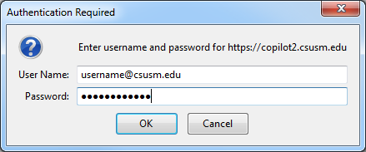
3. For the very first time logging in, time zone region will need to be registered. Select Pacific Time (US & Canada).
4. This will log you into a placeholder mailbox for your student account. Once logged in, click on your name in the upper right hand corner, choose Open Another Mailbox.
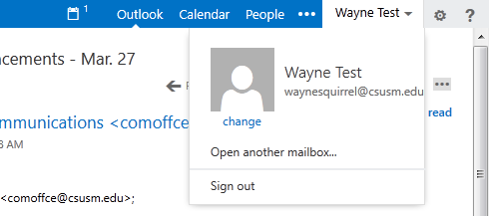
5. Enter the name of the resource mailbox you want to access and choose “Search Contacts & Directory”. Then select the correct mailbox and click Open.
