1.) LOG INTO CFS > CO Portal/CFS Access > Finance Data Warehouse Login > Dashboards> Financial Reporting
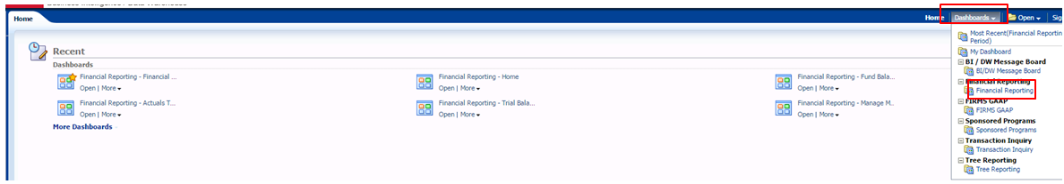
2.) SELECT Fund Balance tab
Fiscal Year = 2015
Period = 10
Fund = XXXXX
Apply Filters
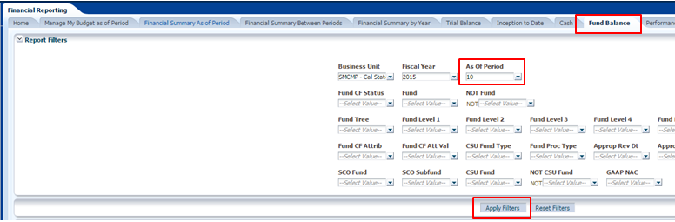
To Download Report into Excel
Click Export then Select Excel
