DW monthly department level report:
- Basis - 4 column department report (Manage My Budget dashboard)
- Show column 1: Dept Fdescr
- Show column 2: Fund Fdescr
- Show column 3: Acct Cat Fdescr
- Show column 4: Acct Fdescr
- Report view: Standard with Pre-Enc
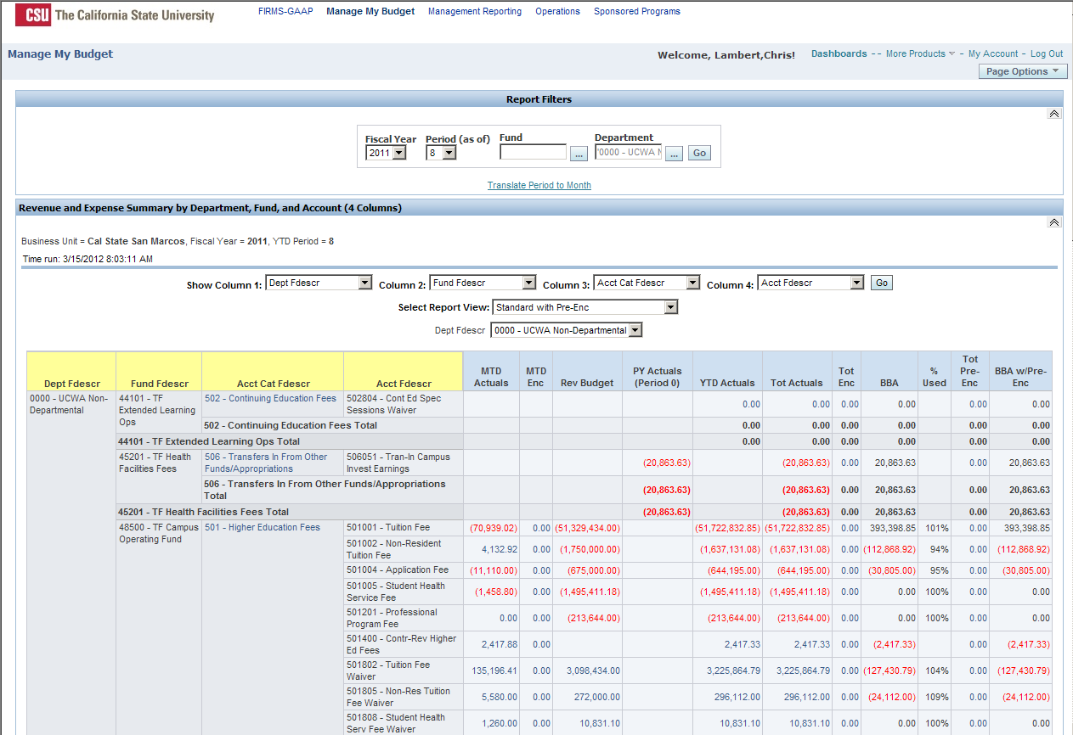
DW monthly fund level report:
- Basis - 3 column organization report (Operations dashboard)
- Show column 1: Fund Fdescr
- Show column 2: Acct Cat Fdescr
- Show column 3: Acct Fdescr
- Report view: Standard
