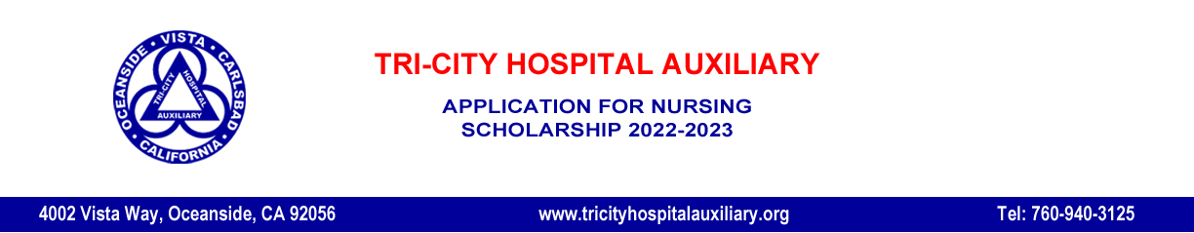
Student Name: ______________________________________________ ____________________________________
Last First
Address: _________________________________________________________________________________________
Street
__________________________________________________ ________________________ ___________________
City State Zip
Phone Number: (______) ______________________ Email: ____________________________________________

Student ID # ____________ Cumulative Grade Point Average __________ Nursing Course GPA _______________

Nursing School currently attending: ____________________________________________________________________

Nursing Program in which you are enrolled (LVN, RN, BSN): ________________________________________________

When did you begin this program? _____________________________________________________________________

Year/semester of Nursing School in which you are currently enrolled? _________________________________________
(Ex: 1st year, 2nd semester)
When do you expect to graduate? _____________________________________________________________________
` (Ex: Spring 2023)

Are you currently receiving a Pell Grant ____ CCPG (formerly BOGW) ____ Scholarship ____ Student Loan _____?

Please return completed application package to scholarships@csusm.edu by the deadline January 19, 2022

AUTHORIZATIONS

I hereby authorize the release of this information to the Tri-City Hospital Auxiliary, donors, and the college or university I am currently attending. If awarded a scholarship, you have my permission to release this information to the media and donors.
Signature: _______________________________________________________________ Date: __________________
I authorize the college or university I am attending to release my financial aid information to Tri-City Hospital Auxiliary.
Signature: _______________________________________________________________ Date: __________________
I authorize Tri-City Hospital Auxiliary Scholarship Committee to receive a statement that I am still enrolled in the Nursing program at my college or university.
Signature: _______________________________________________________________ Date: __________________
I affirm that the information contained herein is true and accurate to the best of my knowledge and belief.
Signature: _______________________________________________________________ Date: __________________

