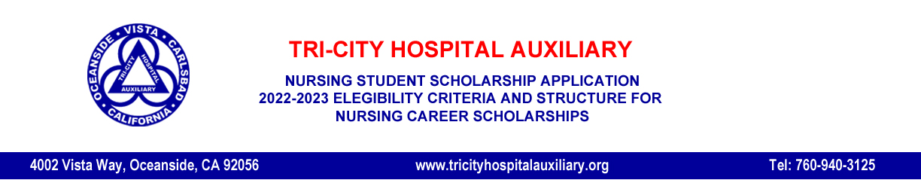
Thank you for your interest in applying for a Tri-City Hospital Auxiliary Scholarship. Please read all of the following information carefully. All criteria must be met for your application to be accepted for review.

The Tri-City Hospital Auxiliary Scholarship Committee has established the following Eligibility Criteria and Structure as the basis for Nursing School scholarship candidates.

ELIGIBILITY CRITERIA
- Must be a current student in the Nursing program at CSUSM, MiraCosta College, or Palomar College.
- Minimum 3.0 Cumulative Grade Point Average and a minimum 3.0 GPA in Nursing Classes.
- Complete and include a Tri-City Hospital Auxiliary Scholarship Application.
- Include an unofficial transcript from your current college or university.
- Include a list of three personal references and their contact information.
- Include a Personal Statement using the following format:
- One page typed and double spaced (more than one page disqualifies the applicant).
- Place your name, college or university, and ID number in the top, left hand corner.
- Must include in your statement:
• personal background information
• motivation
• career goals
• financial need

STRUCTURE OF THE SCHOLARSHIP
- Scholarships are for the academic year and may be renewed if funds are available. Recipients must apply each year.
- The scholarship is to be used for school related expenses such as tuition, fees, books, supplies, lab fees, uniforms, or computer accessories.
- Scholarships are not awarded to individuals working towards a Master’s degree.
- Recipient will be notified by letter of their scholarship award and will receive a certificate acknowledging the award. Scholarship funds will be sent to the college or university of the recipient for disbursement.
- The gender, race, color, creed, or disability of an applicant will not be a consideration in determining eligibility.
- The Tri-City Hospital Auxiliary will be notified by the recipient’s college or university if the student awarded a scholarship discontinues the academic program or becomes academically ineligible for the nursing program.
- Scholarship recipients will be invited to the Auxiliary Scholarship Awards Night held in April of 2022. Exact date and time will be announced at a later date.

Please return completed application package to scholarships@csusm.edu by the deadline January 19, 2022

