5 health benefits of having succulents in your home
Time to invest in succulents, cacti and other houseplants to improve your health
BY KARLINA VALEIKO
20/05/2019
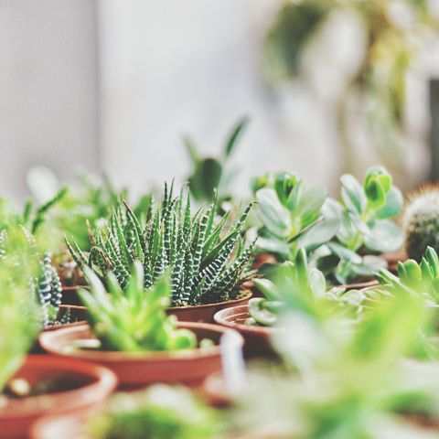
GETTY IMAGES
Great news alert: having succulents in your home can be great for your health.
Houseplants have always been an easy way of bringing in a little bit of personality and greenery into your home.
But the current trend of succulent potters and groupings might just be our favourite yet, as they require minimal attention. They're able to live through the harshest of environments and are incredibly easy to look after. Hallelujah.
Luckily, they not only look beautiful and are seriously low maintenance, but they also come with some useful health benefits.

FIVE WAYS SUCCULENTS CAN HELP YOU LIVE HEALTHIER
- They help you breathe - During the process of photosynthesis, plants release oxygen, however, at night most plants respire like humans, releasing carbon dioxide. Succulents, and a few other plants like orchids and areca palms, keep producing oxygen all through the night. Keep these plants in the bedroom for an extra boost of refreshed air during your sleep that ultimately leads to a better night’s sleep.
- They purify the air - Succulents, like snake plant and aloe vera, are excellent at cleansing the air and removing toxins. NASA’s research found that they are able of removing 87 percent of volatile organic compounds (VOC). These plants are extra helpful in library and study environments because VOC substances like benzene and formaldehyde are found in rugs, cigarette smoke, grocery bags, books and ink.
- They help prevent diseases - About 10 percent of the moisture in the atmosphere is water released by plants. The same applies to your home, the more plants you have, especially in groupings, the better you can improve the humidity in your home that can prevent dry skin, colds, sore throat and dry cough. The study by Agricultural University of Norway found a 60 percent decrease in sickness rates in offices with plants. Tina Bringslimark, an expert in environmental psychology, told The Telegraph: "We investigated the amount of self-reported sick leave there was and compared it with the amount of plants they could see from their desk. The more plants they could see, then the less self-reported sick leave there was".
- They help you focus - A number of studies of both students and workers have found that concentration, attentiveness and brain capabilities improve when studying or working with plants in the room. A University of Michigan study found that memory retention improved by as much as 20 percent when plants were present. Small plants like succulents are especially beneficial at work, as they don’t take up a lot of space on your desk.
- They aid in quicker recovery - Succulents can contribute to reducing flu-like symptoms, headaches, fever and coughs. According to researchers at Kansas State University, hospital patients with plants in their rooms required less pain medication, had lower blood pressure and heart rate and experienced less fatigue and anxiety.
Just the excuse we needed to purchase another one (or five)...

