CSUSM Procurement and CSUSM Corporation
Instructions for Submittal of Unauthorized Purchase Request for Approval

- CSUSM Procurement or CSUSM Corporation will request the submittal of the Unauthorized Purchase Request for Approval (UPRFA) in the following situations:
  - A contract is signed by an individual without delegation of signature authority.
  - Goods or Services are provided before issuance of a purchase order or contract.
  - A purchase is made that is not in compliance with CSUSM Policies and Procedures.
- Department will complete the form.
  - All UPRFA Forms require approval by the individual with the appropriate Delegation of Authority role pursuant to the Approval Limits and Roles provided herein.
    - The UPRFA Requestor cannot also be the Approver on the form.
    - The UPRFA must be signed by a Role 4, 3, 2, or 1, depending on the dollar amount.
    - UPRFA’s for purchases between $0 - $5,000 must be signed by a Role 4 Approver.
  - To process payment, the UPRFA Form must have the box checked approving the purchase: “Approved- I endorse the above request and agree the proposed action meets the educational mission and operational needs of the university.” This box should be checked by the highest role signing the form.
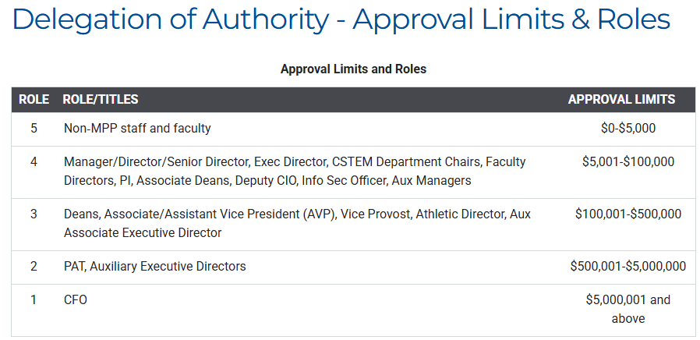
- Department will submit the Adobe Sign form for signature to CSUSM Procurement at lswensen@csusm.edu, CSUSM Corporation at corp@csusm.edu. Department shall include the following documents with the Form:
  - Backup Documentation, including any contracts, quotes, proposals, approvals, or invoices supporting the purchase.
  - Invoice, if services are complete.
  - Further documentation as requested by Procurement/CSUSM Corp.
- CSUSM Procurement or CSUSM Corporation will process the UPRFA in the appropriate manner, which may include requesting additional documentation from the vendor, including insurance.
  - Please submit the appropriate CSU Form Request under Showcases in CSUBUY P2P, depending on the purchase type. Please choose from the selection below. Please attach the completed UPRFA to the Form Request/Requisition. Procurement will issue a Purchase Order based on the requisition.
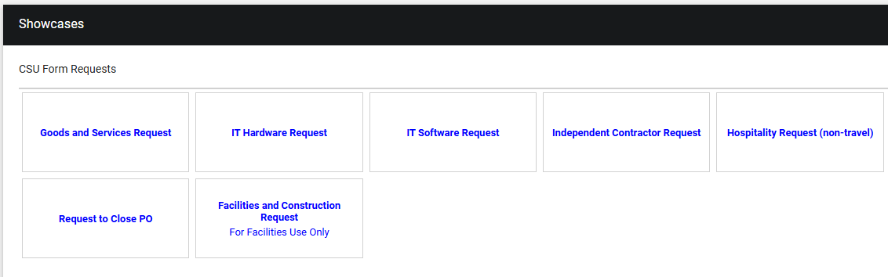
  - Once your Purchase Order is approved, please work with Accounts Payable on the method for submitting your invoice for payment.
  - NOTE: Purchases for goods or services made without an authorized purchase order or contract signed by CSUSM Procurement or CSUSM Corporation is a violation of California law, CSU policy, and CSUSM policies and procedures. Unauthorized purchases can be considered a personal obligation of the individual signing the contract or making the purchase. Submission of this request does not guarantee approval of payment or ratification of the purchases by CSUSM or CSUSM Corporation. Further information may be required, and this form may be rejected.

