What do These Posters Advertise?

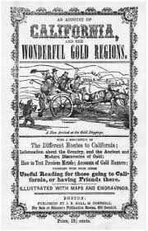
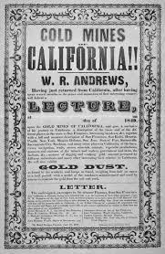

Convince the ‘49ers that they will learn ways problems can be addressed through the Rule of Law! Make a poster advertising the topic for the Town Hall Meeting.
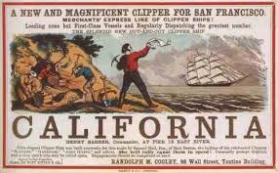

- Describe the structure of the U.S. and California Governments,

- List the branches and their roles.

- Use a graphic(s) to help explain the role of each branch.

- State at least one social, economic or political problem that could be addressed by working with the government structure. Explain, encouraging them to learn more at the Town Hall Meeting.

Create a Leaflet Describing the U.S.
And the California Constitution

What is a leaflet? A leaflet is a paper handout giving information or advertising something. In this case, the leaflet explains the government structures of the United States and California.

- Describe the structure of the U.S. and California Governments.

- List the branches and their roles for each government structure.

- Use a graphic(s) to help explain the role of each branch.

- State at least one social, economic or political problem during the Gold Rush that could be addressed by working with the California government structure.

Foldable idea:
https://www.teacherspayteachers.com/Product/Three-Branches-of-Government-Foldable-FREEBIE-2146659

