Challenge: Women of the West

Goal: Educate others about the lives of women and their contributions during the gold rush.

Role: Charlotte Parker, Biddy Mason and Louisa Clapp, and the children: Jack, Thomas, Constance, and Sarah.

Audience: Townspeople

Situation: The children are invited to have lemonade (with mint), and cookies with their neighbor and new friend, Mrs. Clapp. She introduces them to Charlotte Parker and Biddy Mason. After they speak to each other for a short amount of time, their conversation goes “back to the future”. The children learn about Charlotte, Biddy and Louisa ~ even things that had not happened yet! They later discover that the mint in the lemonade had special powers that allowed this to happen.

Problem: These women of the gold rush have each had unique challenges to overcome. The children ask many questions, discovering more about the life of and challenges each woman overcame during the gold rush. They also discover the special qualities of Charlotte, Biddy and Louisa.

Standards for Success: The contributions of women, and especially Louisa Clapp, Charlotte Parker and Biddy Mason become clear during this five- seven minute conversation.

Thoughts to consider before you begin your challenge:
The Who, What, When, Where, and Why!

*Note: The questions below are meant to guide you in gathering information from your reading, not for you to use as the exact dialogue in your drama.
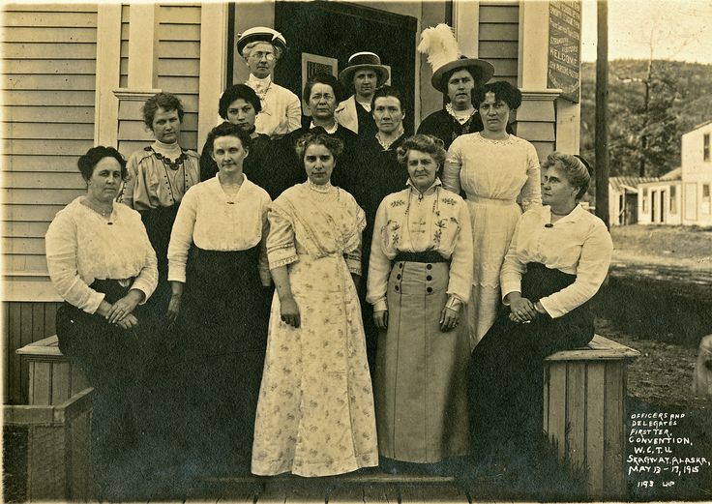
What is the overall theme of this article?

Who are you?

Where did you come from?

When did you arrive?

How did you get here?

Why did you come to the Gold Rush country?

In what way are you making a living?

What do you see as challenges women face in this time, and have you faced?
Have women solved some of the challenges of the time that men may not have been as successful solving? Explain

How have you handled some of the specific problems or challenges?

What else might be done to help with the issue?

What accomplishments have you contributed to society?

Compare the different ways women helped to solve challenges during the time of the Gold Rush.

In your opinion, is their one woman in the article who made the most difference? Which woman do you think is the most interesting? Why?

Imagine if there were more women living at gold rush sites, and in San Francisco at the time. Do you think this would be good for the community, or a problem? Explain your thoughts.

If you were a woman at the time of the Gold Rush, how do you believe you would have lived a typical day?

--------------------------------------------------------------------------------------------------------------

“Idea” or Example Outline for the Dramatization:

Beginning:

Mrs. Clapp: Hello children, how are you doing on your latest project ~ the assignments Praiseworthy gave you?

Constance: We have been very busy, Mrs. Clapp.

Mrs. Clapp: Too busy to have lemonade with mint, cookies, and meet some friends of mine?

All children: No mam!

Middle: (Students will create their own dialogue, approximately 2 minutes with each character)

Children eagerly go over to Mrs. Clapp’s house and she introduces them to Charlotte Parkhurst and Biddy Mason.

1) Mrs. Clapp explains to her friends Charlotte and Biddy that the children have been looking into some of the problems in the community, and some of the challenges of life during the gold rush. She suggests to the children that they might find it interesting to hear about the roles of women at that time, as life in the west is quite different than where all of them came from! She says, “Let’s begin with Charlotte.”

2) Charlotte tells a little about the beginning of her life, and the children ask her other questions, as they find her quite interesting. (The mint “kicks in” and they all agree that they feel very strange) Charlotte goes on to tell about events that happened in her life, even those that had not necessarily happened yet! Charlotte uses a primary source when asked about her story.

3) Biddy tells about how she arrived in California when Charlotte is finished, and then the children ask her questions. She comments on things that happened in her life, including things that had not necessarily happened yet! Biddy shares a primary source to help make her point.

4) Finally, the children ask Louisa to tell them more about her story. Even though they are friends, they don’t know very much about her life. She uses a primary source, one of her quotes, or part of her writing when asked questions.

End

5) Be sure to bring closure to the drama ~ including a comment about the “mint” in the lemonade, and how that must have been what allowed all of them to be able to look at the future!

