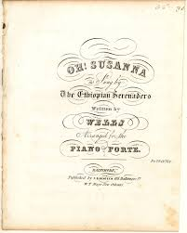
Oh Susanna!

Well I come from Alabama with my banjo on my knee
Oh, I’m bound for California, my true love for to see!

Oh Susanna! Oh don't you cry for me!
For I come from Alabama with a banjo on my knee
It rained all night the day I left, the weather was bone dry
The sun so hot I froze myself, Susanna don't you cry
Oh Susanna! Oh don't you cry for me!
For I come from Alabama with a banjo on my knee
Gonna get me lots of gold, and when I find that stuff,
I’ll dig and dig and dig and dig, I’ll never get enough

Oh Susanna! Oh don't you cry for me!
For I come from Alabama with a banjo on my knee

I tramp the prairies and the plains, I trudge each weary mile.
I’ll tramp and trudge and trudge and tramp, until I make my pile.
Oh Susanna! Oh don't you cry for me!
For I come from Alabama with a banjo on my knee.

I’m a ragged, rugged lover of the wild and wooly West.
Of all the things I haven’t got, I like my gold the best.

