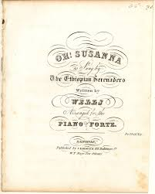
Teacher Edition: Questions to ponder with the lyrics:

Oh Susanna!

Well I come from Alabama with my banjo on my knee
Oh, I’m bound for California, my true love for to see!
(Who is the “true love”? Gold?)

Oh Susanna! Oh don't you cry for me!
(Who do you think Susanna is? Why would she cry for him?)
For I come from Alabama with a banjo on my knee
(How will his banjo help?)
It rained all night the day I left, the weather was bone dry
The sun so hot I froze myself, Susanna don't you cry
(How are these lyrics “nonsensical”?)
Oh Susanna! Oh don't you cry for me!
For I come from Alabama with a banjo on my knee
Gonna get me lots of gold, and when I find that stuff,
I’ll dig and dig and dig and dig, I’ll never get enough
(Why would it be important to dig and dig, and never get enough?)

Oh Susanna! Oh don't you cry for me!
For I come from Alabama with a banjo on my knee

I tramp the prairies and the plains, I trudge each weary mile.
I’ll tramp and trudge and trudge and tramp, until I make my pile.
(What pile?)
Oh Susanna! Oh don't you cry for me!
For I come from Alabama with a banjo on my knee.

I’m a ragged, rugged lover of the wild and wooly West.
Of all the things I haven’t got, I like my gold the best.

