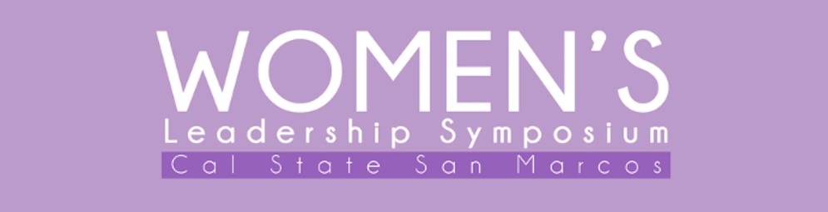

Workshop Presenters:
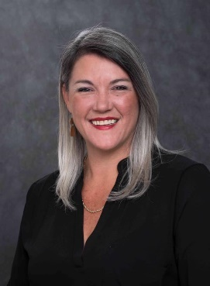
Cynthia Luvlee: Grassroots Organizing for Social Change
ABSTRACT: The workshop will highlight how Shyne San Diego is impacting social change on women's issues of sexual exploitation and violence. Shyne is a grassroots community driven initiative where survivors of human trafficking lead, develop, launch and own businesses and nonprofit organizations providing support for other women seeking freedom from exploitation. We will learn about the struggles, strategies and victories along Shyne’s journey of community organizing and how to leverage community assets for greater social impact, economic equity and diversity.
BIO: Born and raised in San Diego, Cynthia Luvlee has 20 years of experience in the non-profit and youth development fields, making it her mission to help create and launch innovative social change organizations in her hometown. After successfully launching several new non-profit organizations and programs in San Diego as a consultant to founding members, Cynthia learned of the harsh realities of sex trafficking in San Diego. With a passion for human rights, coupled with her vast experience, she launched her own venture Shyne San Diego. Shyne San Diego is a survivor business network and leadership training agency where women support women in starting their own nonprofits and businesses. She has been a board member with the Neighborhood House Association for over 5 years strengthening local underserved communities. Cynthia earned a Bachelor of Arts in Social Work from San Diego State University and studied Holistic Health at Body Mind College.

Dr. Fredi Avalos: Rocking the Boat Without Falling Off: How to become a “Tempered Radical”
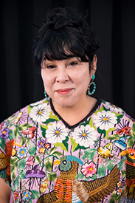
ABSTRACT: In this workshop, we will examine strategies for making meaningful institutional change without making too much trouble. How do we remain true to our values and sense of integrity when we find ourselves in work environments that may be at odds with our own? How do we express identities and values that may be different from the dominate culture we work in? We will discuss “tactics of influence” for those who are not in positions of power but, nevertheless, want to challenge aspects of the organizational status quo. We will look at how small acts of self-expression may open the door to dialogue and eventually to new practices and policies. Incremental change strategies will be introduced. Finding ways to balance the need to use our voices while still maintaining both our jobs and credibility will also be explored.
BIO: Dr. Fredi Avalos has served the community as a scholar and human rights activist for over 40 years. Chicanisma lies at the heart of her work in social justice, both in and outside the classroom. As an invited scholar, she spent time learning about digital uprisings and revolutions with the Zapatista National Revolutionary Army in Chiapas, Mexico. For the last 7 years she has served as the CSUSM Faculty Fellow in Diversity and Cultural Intelligence and the Director of the Difficult Dialogue Project of North County. Her pedagogy, research, key-note presentation, community workshops, and public seminars center on issues of media and democracy, race, class, gender, intersectionality and social justice. In 2013, she was named a "Woman Who Moves the City" by San Diego Magazine. She is the recipient of the2018 CSUSM President’s Award for Inclusive Excellence and Diversity.

Dr. Ranjeeta Basu: Mindful and Compassionate Leadership
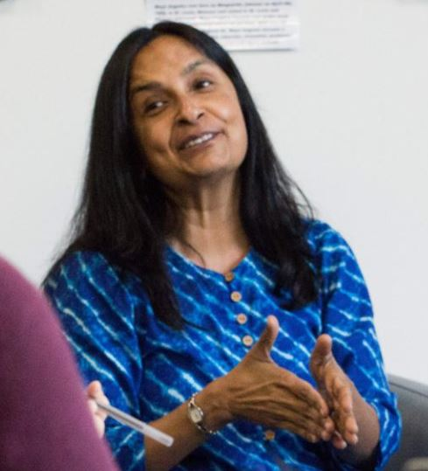
ABSTRACT: In this session we will learn some self-reflective mindfulness practices that will expand our capacity to be compassionate and effective leaders. Being present is the starting point of being a mindful leader. In this session we will learn how to be present by pairing intention with attention and leading from our core and using our internal compass for guidance and inspiration. We will also learn that a compassionate leader cares about people and truly listens to others and invokes in them a clear sense of contribution and significance. At the same time we will learn that compassionate leadership is about speaking your own truth while holding yourself and others in compassion.

BIO: Ranjeeta Basu has been teaching Economics here at CSUSM for the last 25 years and recently became CSUSM’s interim Provost. Over the last six years she has focused her attention on mindfulness practices and contemplative pedagogy. She, along with a group of faculty, staff and administrators, have started an initiative called Mindful CSUSM. The purpose of this initiative is to provide support to students, faculty, staff and administrators through contemplative practices that foster deep learning, reduced stress, increased capacity for compassionate listening and increased well-being.

Karin Iwasaka & American Association of University Women (AAUW): Ready for a Raise?
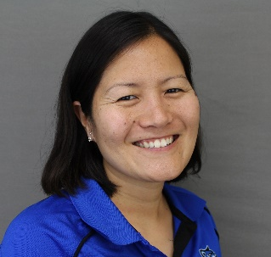
ABSTRACT: This workshop is presented by the American Association of University Women (AAUW) and CSUSM Career Center. In this session you will learn important aspects of salary negotiation. Come in to learn, and leave with confidence in your knowledge of negotiation strategies to help you achieve your financial goals.
BIO: Karin Iwasaka is the Associate Director at the Cal State San Marcos Career Center, where she provides career counseling to students and alumni and serves as a liaison to the College of Humanities, Arts, Behavioral & Social Sciences. She majored in History and minored in Sociology at UC San Diego, prior to earning her master’s degree in Counseling, with a Career Counseling emphasis, from Cal State Long Beach.

Dr. Kendra Dyanne Rivera: Why Everyone Needs a Mentor and Needs to be a Mentor
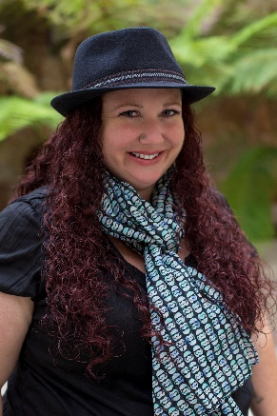
ABSTRACT: I have always attributed my success in life with the fact that I have had phenomenal mentors along the way. My own experiences as well as research by the experts show that EVERYONE needs a mentor, particularly women and those who are marginalized by the "norms" in our society. And once you have a mentor, it's time for you to mentor someone else! This workshop will provide an introduction to mentoring. Participants will leave with tips and scripts for finding a mentor, as well as tools and best practices for becoming a mentor themselves.
BIO: Dr. Kendra Dyanne Rivera is an Associate Professor of Applied Organizational Communication in the Department of Communication at CSUSM. She currently serves as the Faculty Fellow for the Faculty Mentoring Program. Since joining the CSUSM community, Kendra has developed a variety of High Impact Practices for teaching and has contributed to the university’s movement toward inclusion and equity through service leadership such as being the Faculty Director for Service Learning or the Chair of the General Education Committee. Her research focuses on our emotions, and the ways in which our identities—such as race, gender, socio-economic status, or ability—are impacted by the power structures at work in our everyday organizational lives. As a teacher-scholar-activist, Kendra is committed to helping students move through the layers of systematic oppression and marginalization and into a space of greater empowerment through education. As a mother-musician-environmentalist, she enjoys singing with her kids while gardening or walking along the beach.

Darcy Wright: Learning Your Leadership Styles
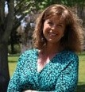
ABSTRACT: Build your leadership skills by understanding your work style strengths and challenges. We’ll dive into your comfort zones and triggers​. We’ll discuss the implications for women leaders. How can you meet people where they’re at? How can you connect with different styles? We’ll share ways to reflect and grow in your leadership journey…​and we’ll have fun using bird metaphors to map our leadership styles.

BIO: Darcy is an accomplished Organizational Learning & Development professional with over 14 years of experience in the Healthcare industry. Her expertise is in leadership development, teambuilding, and coaching. Her passion is presenting empowering workshops such as Leadership Communication, Clear Leadership, and Crucial Conversations. During her years at Palomar Health and Tri-City Medical Center, she managed New Employee and New Leader Orientation programs for over 7,000 employees. Darcy led Rapid Improvement Events utilizing Lean Six Sigma methodology to improve organizational processes. She won the Association for Talent Development’s PEAK Performance award for the Professional Mentor Program she designed for Tri-City Medical Center. Darcy earned her MBA from San Diego State University’s Executive Management Program and a BA in Communications from U.C. San Diego. She’s certified as an interpreter/coach for the MSCEIT Emotional Intelligence Test and as a facilitator for Clear Leadership. She currently works at CSUSM’s School of Nursing.

Panelists:
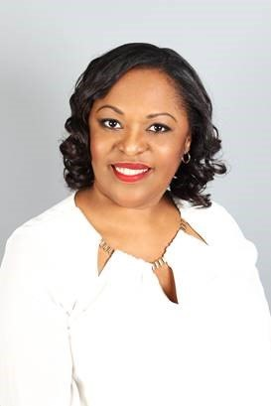
Lakitsia Gaines (Also our keynote speaker!)
Lakitsia Gaines is a Miami, FL native and a graduate of Florida A&M University in Tallahassee. After 10 years of promotions and relocations with State Farm, Lakitsia wanted more than success as an employee of a fortune 500 company. She wanted to be her own boss, achieve independent financial freedom and give more back to her community. So, in 2006, she became an agency owner of the #1 auto, life, homeowners and boat insurer in the country – State Farm.
She has been featured on the Steve Harvey Morning Show and twice on the Power Stage at the Essence Festival in Louisiana. She is a member of Miami Biscayne Bay (FL) Chapter of The Links, Inc., The Miami Alumnae Chapter of Delta Sigma Theta Sorority, Inc. Rotary International, a member of Antioch Missionary Baptist Church. She currently leads the Finance Workshop Committee. She serves as a board member for many nonprofits. Her personal motto is, “People don’t care how much you know, until they know how much you care.” As a college scholarship recipient, she personally donates more than $50,000 a year in sponsorships and scholarships for deserving high school students. She is an active volunteer sharing more than 200 hours of complimentary seminars for financial literacy to the public. She is a wife to Shawn and a mom of a teenagers Kendall and Kaitlyn.

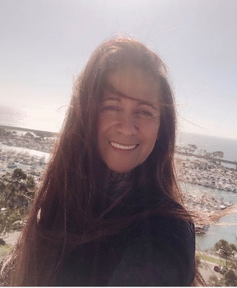
Eloise Madriaga
Eloise was born and raised in San Diego, California. She was raised in the foster care system and spent a majority of her adult life in the California state prison system. Born to a teenage mother who died on her 21st birthday from an alcohol and barbiturate overdose, Eloise suffered from childhood trauma at an early onset of life. To cope with the death of her mother and removal from family by child protective services she dove into street life to find acceptance. At the age of 16 Eloise was emancipated and attempted a family life with a marriage and children. In 2014, Eloise was facing a life sentence by means of the three-strike law. By what she calls GOD’S grace she found mercy in the courts and was only sentenced to 5 years with half and saw that as a wakeup call and a 2nd chance. While in prison Eloise attended college to begin a degree in sociology. Since her release in 2017, Eloise has become a part of a large recovery community. Through organizations such as Transitions Collective, Celebrate Recovery, Narcotics Anonymous and Juvenile Justice programs. Eloise now works for a multimillion-dollar recovery-based treatment facility in Laguna Hills as the lead client care manager. Fulfilling her passion in life to help other suffering addicts in hopes that they will also be set free to live a productive life.

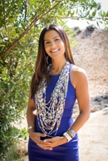
Dr. Joely Proudfit
Joely Proudfit (Luiseño), Ph.D., is a descendant of the Pechanga Band of Luiseño Mission Indians. Dr. Proudfit holds an M.A. and Ph.D. in political science with emphasis in public policy and American Indian studies from Northern Arizona University and a B.A. in political science with emphasis in public law from CSU Long Beach. A full professor, Dr. Proudfit has been tenured three times in the CSU system. In 2016 she was appointed by President Barack Obama to the National Advisory Council on Indian Education. A recent publication by Dr. Proudfit from 2017 focuses on California. On Indian Ground-: A Return to Indigenous Knowledge—Generating Hope, Leadership and Sovereignty through Education. Dr. Proudfit is also author of the forthcoming book titled Beyond the American Indian Stereotype: There’s More to Me Than What You See. Dr. Proudfit serves as the Department Chair of the American Indian Studies Department. Dr. Proudfit is also the Director of the California Indian Culture and Sovereignty Center (CICSC) at CSUSM. The mission of the CICSC is to foster collaborative study and community service relationships among the faculty, staff and students of CSUSM, and members of tribal communities, for the purpose of developing and conducting research projects that support the maintenance of sovereignty and culture within those communities.

