Adding Meals & Incidentals Expenses (M&IE) in Concur
(for travel beginning 1/1/2024)

Travel Request:
- Add the expense type:
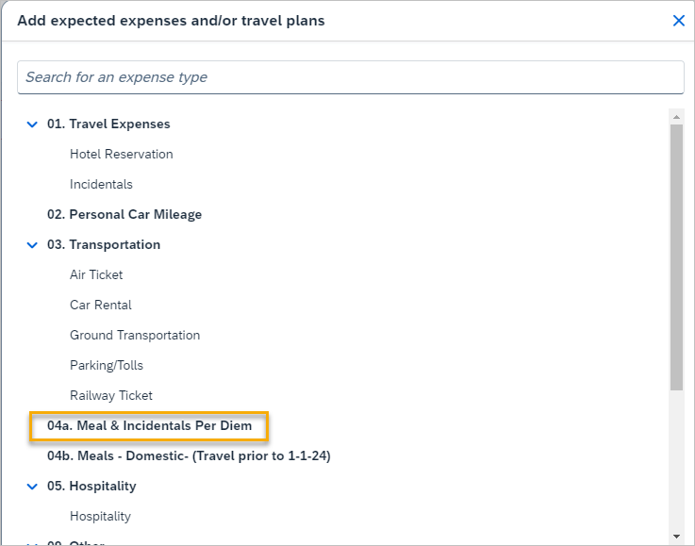
- Enter a reduction only if your department does not have enough funds to cover the full per diem reimbursement. Allowance will calculate upon clicking Save.
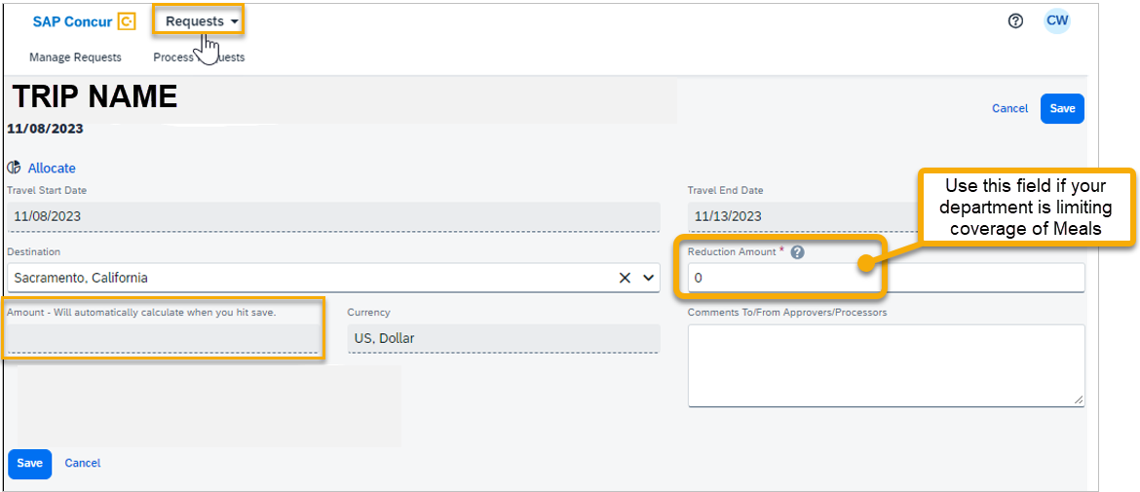

Expense Report:
- Travel Allowance > Manage Travel Allowance
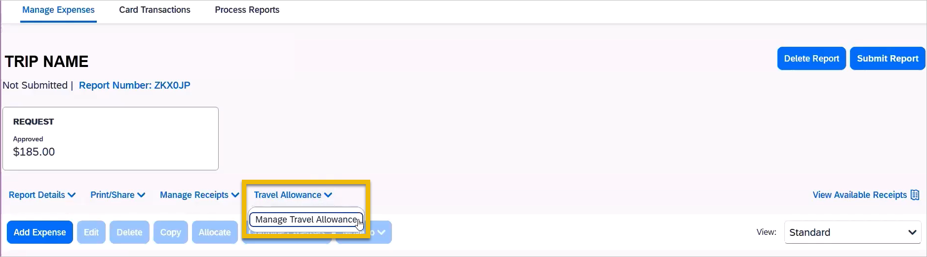
- Create New Itinerary
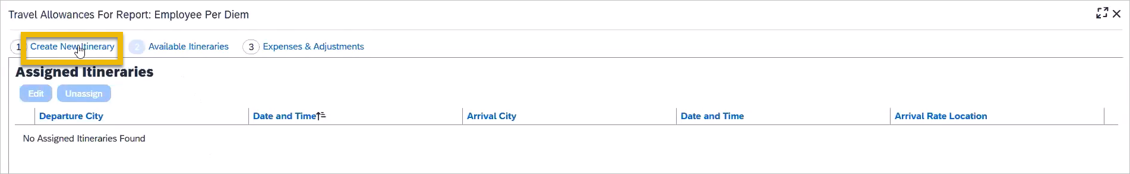
- If you booked IN CONCUR, you can import your itinerary (if you booked outside of Concur, skip to Step 5 to manually create an itinerary). To import an itinerary from a Concur booking:
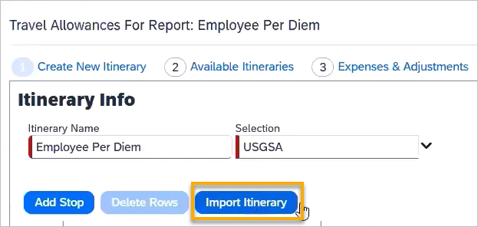
- If you booked IN CONUR, you may now skip ahead to Step 8.
- If you booked outside of Concur, you must manually create an Itinerary. Add and save each leg of the trip:
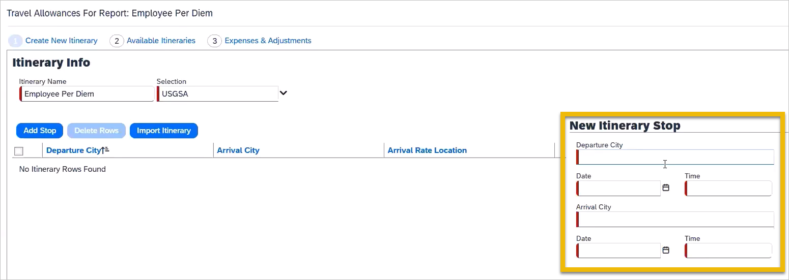
- All legs of the trip should now be listed:
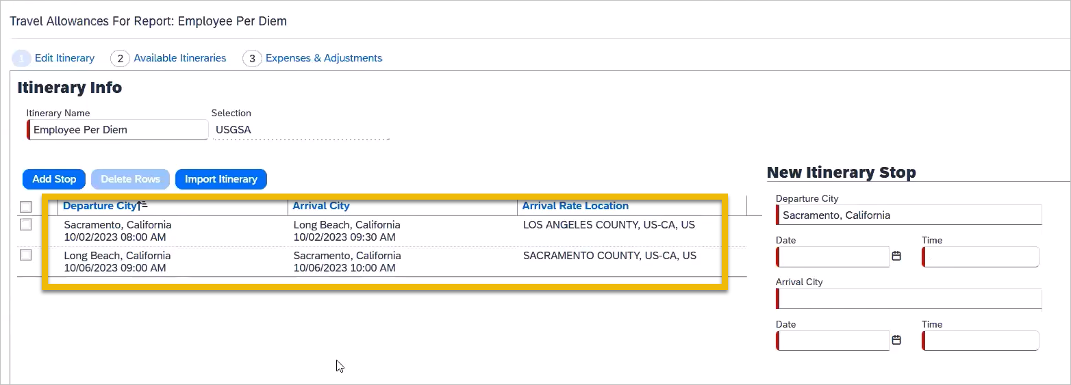
- After clicking Next, your “Available Itineraries” will be listed along with the rate location being used by each. This is automatically determined by the system. Click Next.
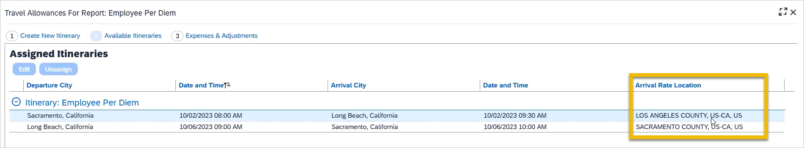
- The “Expenses & Adjustments” screen is used to exclude meals provided by a conference or similar and personal travel days. Once finished, click “Create Expenses.”
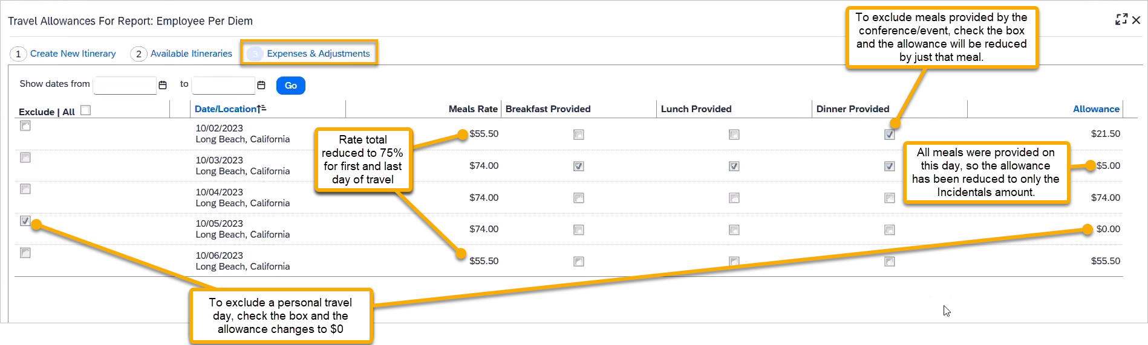
- Meal & incidentals will appear in your expense report.
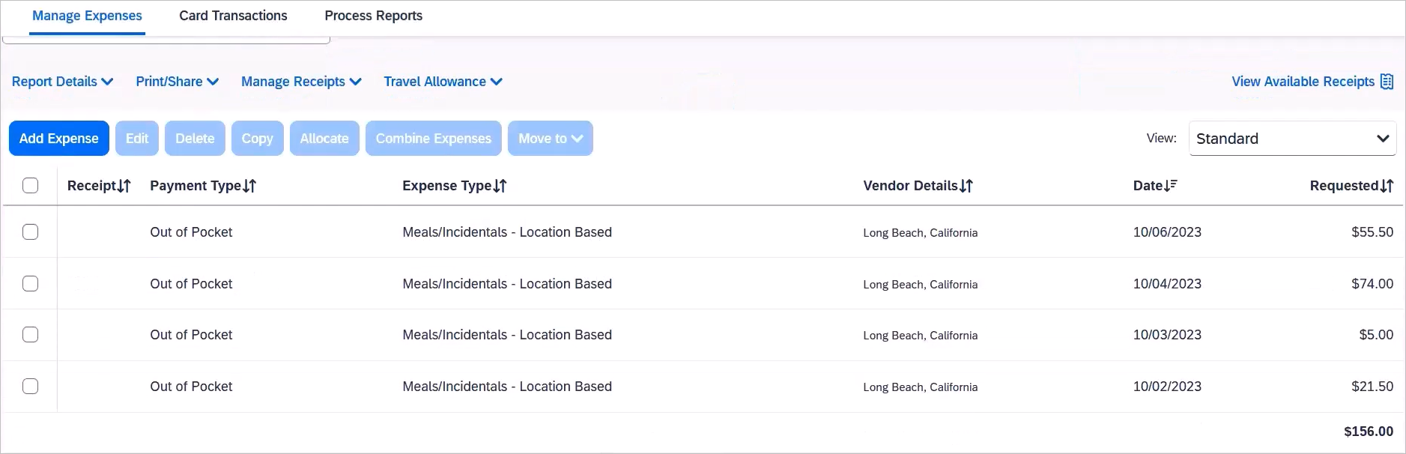
- If you purchased all meals using cash or personal cards, you are finished.
- If you purchased any meals using the Travel Card, please proceed to step 12.
- Click “Add Expense”
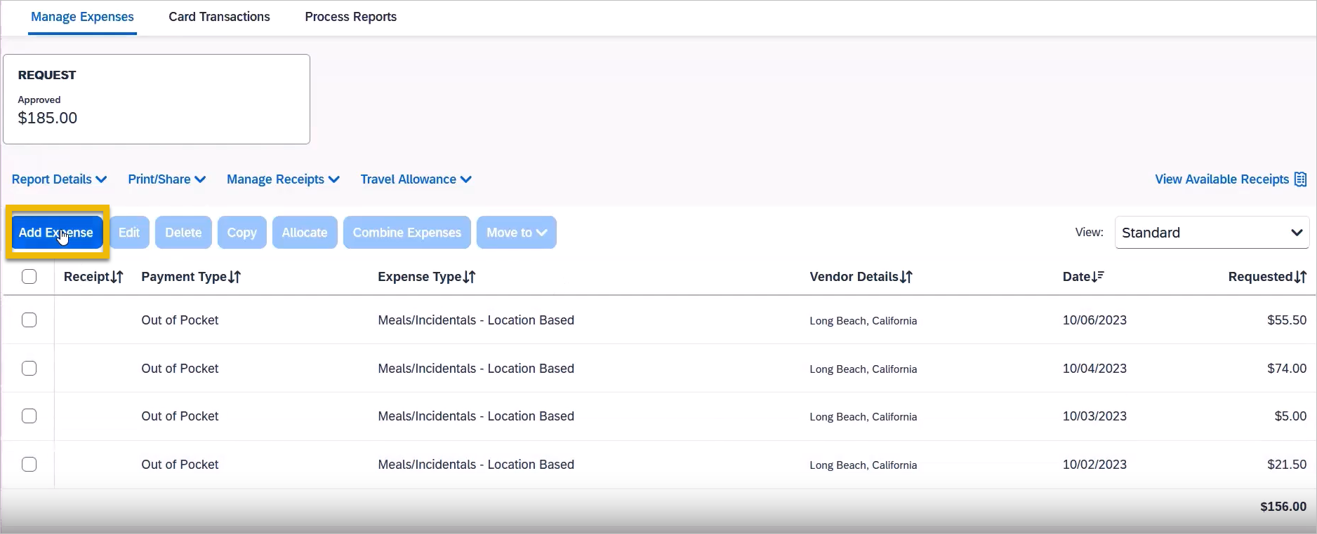
- Select the appropriate Travel Card expenses from the Available Expenses tab:
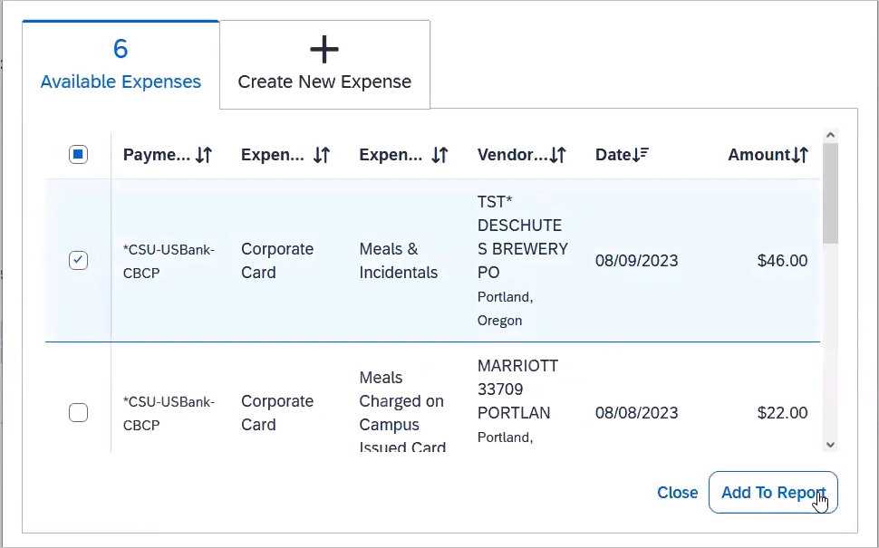
- In the next screen, click on the newly added travel card meal expense.
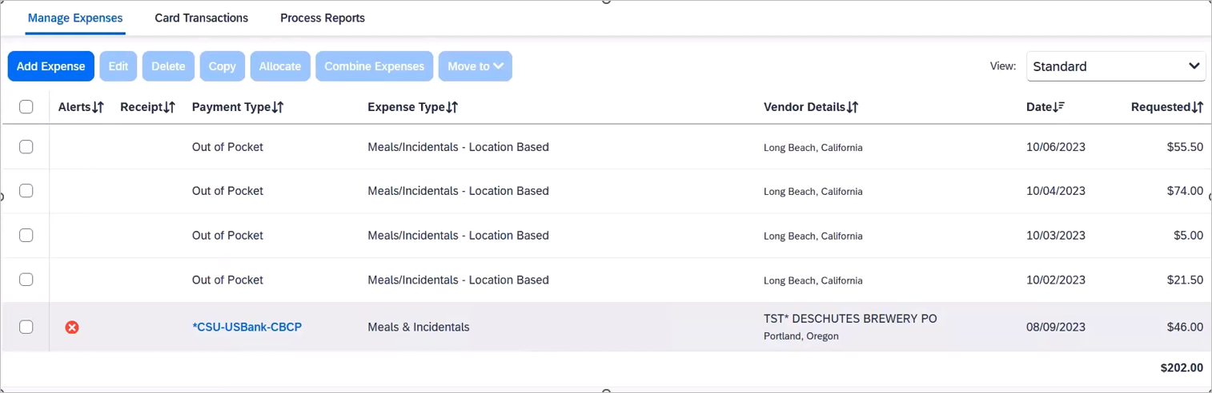
- Change the Expense Type to “Meals Charged on Campus Issued Card”
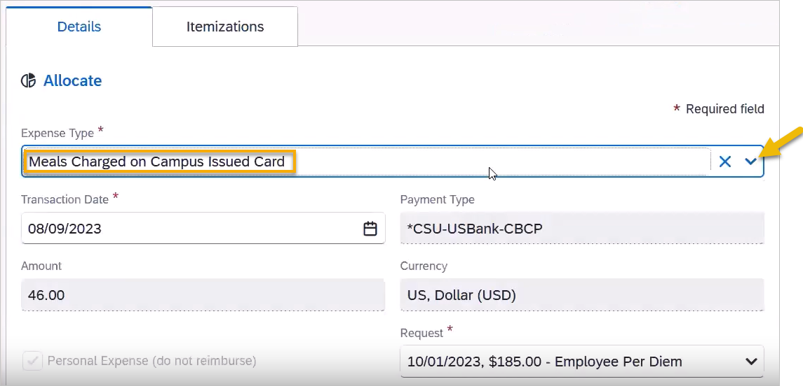
- Continue to do this for each travel card meal expense for the trip.

