Create a Wufoo Form
- Once you get your login for Wufoo from IITS, start creating a new form on the top right hand corner
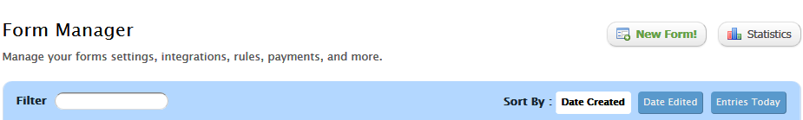

- Start adding fields
- You will see the fields listed out on the left side of your form’s page, in a golden box.
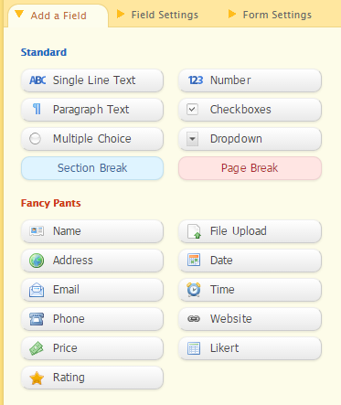
- Select what field you’d like to add to your form.

- Adding a field form will look something like the below:
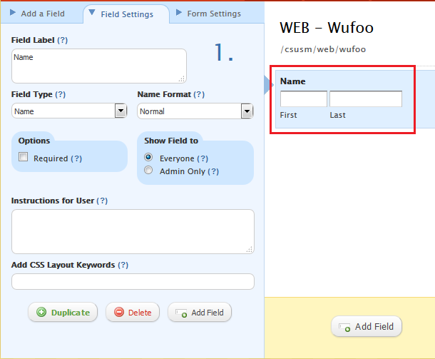
- You can make it a required field or not
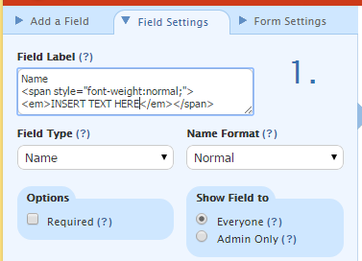
Note: If you want to add instructions for user, please do not use “Instructions for User”
  - Under “Field Label”, add the name of your field. Under the name of the field, add the html code:
<div style="font-weight:normal;"><em>INSERT TEXT HERE</em></div>
Simply change the INSERT TEXT HERE to the description/instruction you want for the user.
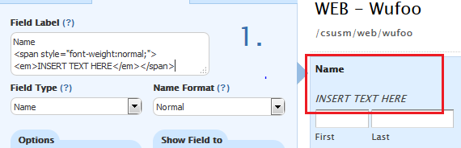
  - You can see at the bottom of the field name that the text you added is unbolded and italicize.

- You can have a defined value if you are expecting the answer to be almost the same for everyone (i.e if the phone numbers are all on campus, you can fill it with 760-750-xxxx leaving only the last cell empty)
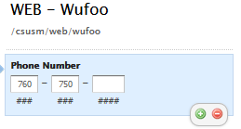

- You can always delete a field by clicking on it and click on the red circle on the bottom

- You can also duplicate the field by clicking on the green button as in the image above

- Add section break or page break when needed on the form

- For multiple choice, dropdown, checkboxes and Likert fields, there are some predefined choices as age, income, days of the week, etc..
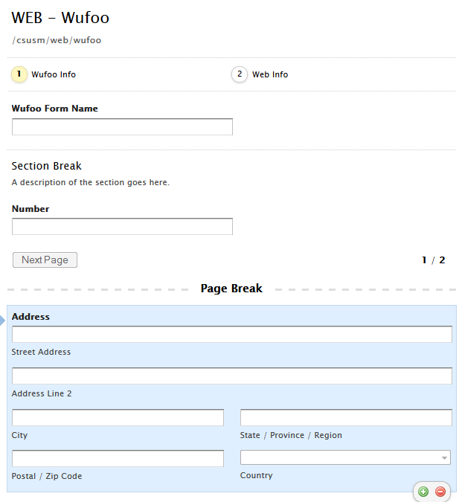
- To save your progress, click on save form at the bottom of the form editing tool and a little box will appear, click on continue editing form if you would like to make additional changes, email notifications to set up where completed forms will be directed, or back to the form manager.

