Form Settings
Change Form name and description:
- Go to Form Settings on the top menu
- Rename the form to follow the naming convention: DEPARTMENT – form name
Example: SOCIOLOY – Travel form
- In the Description paste in the URL of what page the form is to live on Cascade.
Confirmation options:
- You can send confirmation to user, first go to the form and click on “Form Settings” on the top menu.
- Under “Confirmation Options”, type the message you want the user to see once they complete the form.
- You can also send them an email if you have an email field in your form
- Check the send confirmation email to user if you want them to get an email confirmation
- From “Send to” dropdown menu, choose the email field that you want the confirmation to be sent to
If you have more than email in the form, please make sure that you select the correct one!
- You can have them only reply to one person or a different person(s) than you by typing in multiple emails in “reply to”
- Customize confirmation email is another tool that you can use to send them an email specific to this form after the user completes it
- Type in the name that will appear as a subject in the confirmation email they will get
- Type in the message for the user
- You can include a copy of the form for their reference
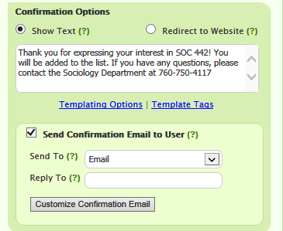
- You can redirect them to a website once they complete the form by clicking on “Redirect to website”
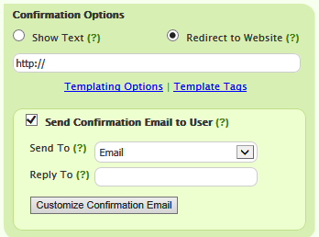

Security/using CAPTCHA:
In order to avoid email spams, it is recommended to use CAPTCHA.
- Go to the form and under the “Form settings”
- Bottom of the page, you will see “Limit Form Activity”
- It is recommended to have it on Auto but you can change it from dropdown menu to have it turned on or off.
- For forms that will not be embedded in CASCADE, you can have this feature turned off
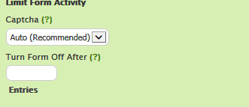
Limit the availability of the form to user:
If you want the form or survey to be available for certain days, there is an option where you turn the form off
- Go to the form
- Click on form settings
- At the bottom under limit form activity, check the “Schedule Form activity” box
- Enter the start/end date and time desired.
Note: time is set based on the time in the region where the survey creator has created it.
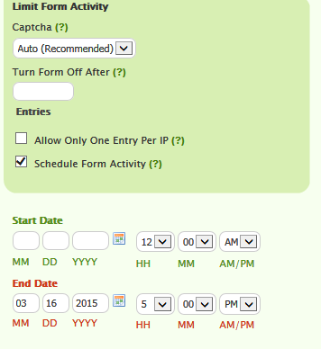
Avoid user from filling the form twice:
Some users fill out surveys more than once to ensure that they get their choices If your survey doesn't require a name, you can limit the user from filling out the survey more than once.
- Go to the form
- Click on form settings
- At the bottom under limit form activity, check the “Allow only one entry per IP”
