Form Notifications
E-mail notification to creator of the form:
Once you are done with creating the form, you can setup notifications to the creator once a user has filled the form.
- Place the cursor on the form you need to set you notifications to.
- Underneath the title of the form, you will see “Notification” button, click on it.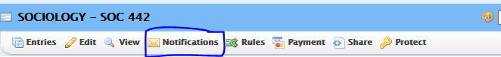
- Enter email to the “Your Email Address” field.
Note: If multiple users need a copy of the responses, separate the emails by a comma.
Example: bob@csusm.edu, jdoe@csusm.edu
- Set reply to will allow you to be able to reply to the confirmation email if there are any issues with the form.
- You can customize the notification email by giving the email a title in the “message subject”
- Save your preferences.
