Protect Your Wufoo Form
This feature is only if you want to post the form on your website but only certain individuals can fill the form with a password.
- Go to the homepage
- Place the cursor on the form that you need to create the password for
- Click the “Protect” button
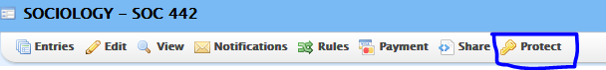
- A box will appear to instruct you to create a password for the form
- Click on save password
- And you are done!
Duplicate or delete form:
This feature is designed so you can delete and entire form or you can make an exact copy of the same form. You can also make the duplicate and then change one of the copies.
To duplicate a form:
- Go to the homepage
- Place cursor on the desired form
- On the right hand side of the floating panel, you will see “Duplicate”
- Click on the “Duplicate” button to make an exact copy, which will be names “XXX- Copy”
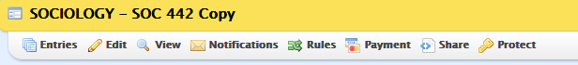
- If you wish to rename the new form, follow the following steps
- Go to the homepage
- Place cursor on the new copied form
- From the floating panel, click on “Edit”
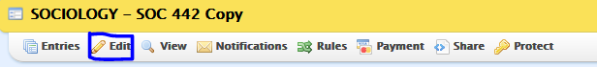
- Top panel, choose “Form Settings”
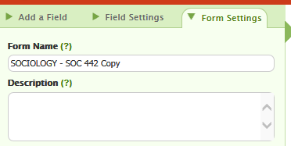
- Change the form name
- Click on “Save Form”
To delete a form:
- If the form is not desired anymore, go to the homepage
- Place cursor on the form
- From floating panel, click on “Delete”
- A new box will appear to instruct you if you would like to continue deleting the form
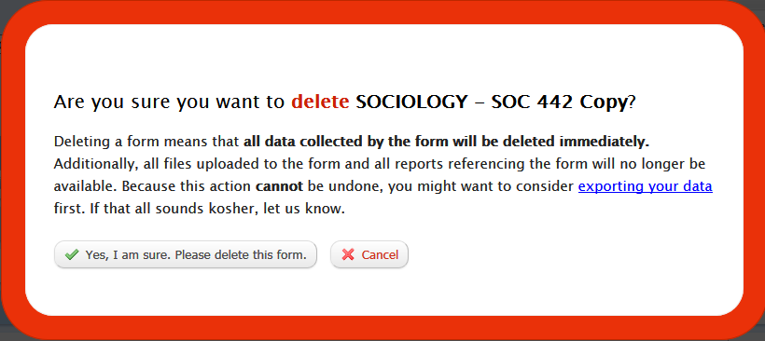
- Click on “Yes, I am sure. Please delete this form”

